**ISCG7431 – CAPSTONE PROJECT**

**Semester 2, 2024**

**Comparative Analysis of Penetration Testing Tools in Assessing Web Application Vulnerabilities**

*Prepared For:*

Course Coordinator: **Dr Masoud Shakiba**

Sponsor: **Andrew David**

*Prepared By: TARUHO*

Tanveer Ahmed Osman ID# 1421320

Jun Russell Ragasa ID# 1555646

Hope Pose-Anesone ID# 1541361

Date of Submission: 10 November 2024

Table of Contents

1.0 Document Control 1

1.1 Version History 1

1.2 Distribution List 1

1.3 Glossary 2

1.4 Contribution List 3

2.0 Executive Summary 6

3.0 Introduction 7

4.0 Problem Statement 8

4.1 Problem Scenario – Tahuro e-commerce business 8

4.2 Current State Scenario 8

4.3 Addressing the problem 8

4.4 Desired State Scenario and Solution 9

5.0 Objectives 10

5.1 Objectives for Penetration Testing 10

5.2 SMART Objective 10

5.3 Stakeholder’s Understanding 11

6.0 Scope 12

6.1 In Scope 12

6.2 Out of Scope 13

7.0 Literature Review 14

7.1 Evaluation of literature from primary and secondary sources 14

7.2 Comparison and Contrasting of Different Sources 14

7.3 Connection of Literature to the Project 14

7.4 State of the Art: Evaluation of Current Technologies 15

7.5 Comparison and Contrast of Current Technologies 15

7.6 Connection to our Project 15

7.7 Summary of literature review 15

8.0 Problem and Requirements Analysis 16

9.0 Project Management Methodology 19

10.0 Project Design 20

10.1 Structure Design 20

10.2 Conduct Initial Research on The Penetration Testing Framework 20

10.3 Review Academic and Industry Reports 21

10.4 Selection of Penetration Testing Tools 21

10.5 Setting Up Test Environments: 21

10.6 Test Implementations 22

10.7 Selection of evaluation criteria 23

11.0 Project Implementation 25

11.1 Implementation of Burp Suite Professional Tool 28

11.2 Implementation of Burp Suite Community Tool 29

11.3 Implementation of Wfuzz Tool 31

11.4 Implementation of SQL Map Tool 33

11.5 Implementation of Hydra Tool 36

11.6 Implementation of Nikto Tool 37

11.7 Implementation of ZAP Tool 39

12.0 Testing 41

12.1 Burp Suite Professional Tool Testing 41

12.2 Burp Suite Community Tool Testing 46

12.3 Wfuzz Tool Testing 51

12.4 SQL Map Tool Testing 53

12.5 Hydra Tool Testing 59

12.6 Nikto Tool Testing 60

12.7 ZAP Tool Testing 62

13.0 Results & Evaluation 66

13.1 Burp Suite Professional Tool Results 66

3.2 Burp Suite Community Tool Results 67

13.3 Wfuzz Tool Results 69

13.4 SQL Map Tool Results 71

13.5 Hydra Tool Results 72

13.6 Nikto Tool Results 74

13.7 ZAP Tool Results 74

14.0 Impacts 77

14.1 Research Benefits for New Zealand 77

14.2 Research benefits for communities such as Māori and Pacific 78

14.3 Summary of Impacts 78

15.0 Change/Risk Management 79

15.1 Change Management Plan 79

15.2 Risk Management Plan 79

16.0 Conclusion and Lessons Learned 81

16.1 Project Summary and Significant Project Outcome 81

16.2 Evaluation of current and future Projects 81

17.0 References 82

18.0 Appendices 84

18.1 Signed Individual Contribution Statement 84

18.2 Team meeting minutes 87

18.3 Meeting minutes with Project Supervisor and Sponsor 92

18.4.0 Supplementary materials relevant to the project 106

List of Figures

Figure 1 - Process of doing the Penetration testing. [6] 20

Figure 2 - Process of doing the Penetration testing [6] 22

Figure 3 - Our Performance Criteria 24

Figure 4 - Test Bed for Penetration Testing 25

Figure 5 - This figure is the login page of the DVWA with IP 108.61.212.237. 26

Figure 6 - IP Whitelisting Process 27

Figure 7 - The IP address has been whitelisted successfully 27

Figure 8 - Application's Session ID 32

Figure 9 - Command for WFuzz testing 32

Figure 10 - WFuzz Successful Attack 33

Figure 11 - SQL Injection Input 34

Figure 12 - DVWA Home Page 34

Figure 13 - Confirm Hydra is installed inside Kali Linux with updated version v9.5 36

Figure 14 - Confirm that the rockyou.txt file is available in the above directory 37

Figure 15 - For Testing on the DVWA website 37

Figure 16 - This is Nikto preinstalled within Kali Linux 37

Figure 17 - Confirm Nikto tool already implemented in Kali Linux 38

Figure 18 - Nikto Output 38

Figure 19 - Confirm Nikto implementation is ready for the Testing Session 39

Figure 20 - Installation of Zap tool version used v2.15.0 39

Figure 21 - Manual Explore Setting where the setting of the 1) targeting URL website before 2) Launch 40

Figure 22 - To set the target site before testing 40

Figure 23 - DVWA Login Page 41

Figure 24 - DVWA Security Level 42

Figure 25 - Brute Force Page 42

Figure 26 - User input 43

Figure 27 - Intercept login 43

Figure 28 - Clear preset parameters 44

Figure 29 - Sniper attack 44

Figure 30 – Payload 45

Figure 31 - Payload Grep match 45

Figure 32 - Password response length 46

Figure 33 - Password Grep match output 46

Figure 34 - Configuring Proxy 47

Figure 35 - Burp Suite CA certificate 47

Figure 36 - Download Certificate 48

Figure 37 - DVWA Homepage 48

Figure 38 - Intercept request 49

Figure 39 - Clear the preset parameters 49

Figure 40 - Payload sample list 50

Figure 41 - Start the Attack and get a response 50

Figure 42 - Session ID for WFuzz 51

Figure 43 - Copy Session ID 52

Figure 44 - WFuzz command 52

Figure 45 - Command after web address 52

Figure 46 - WFuzz successful output 53

Figure 47 - Confirmation of SQL Injection in DVWA 54

Figure 48 - Inject command in SQL Map for Penetration testing 54

Figure 49 - Testing connection to the target URL 55

Figure 50 - GET parameter appears to be MySQL 56

Figure 51 - Back-end information details were retrieved 56

Figure 52 - Cracking the hash values for every user’s password with details 57

Figure 53 - Medium security level parameters 58

Figure 54 - High security level parameters 58

Figure 55 - Wrong Password credential 59

Figure 56 - Hydra target command 59

Figure 57 - Hydra successful scan 60

Figure 58 - Port scan results through Nmap 60

Figure 59 - script of target website:108.61.212.237, script filename: iplist2.txt 61

Figure 60 - Nikto scan result of website 108.61.212.237 in CSV format 61

Figure 61 - iplist2.txt folder where scan report saves in CVS format 61

Figure 62 - Screenshot capture of DVWA Login monitoring in Zap tool 62

Figure 63 - Manual Execution of Brute Force Attack using Fuzzer 63

Figure 64 - Configure the brute force attack using Fuzzer 63

Figure 65 - Add rockyou.txt file to add payload for the initial attack 64

Figure 66 - Start Fuzzer Attack 64

Figure 67 - Brute Force Scan Result Success 65

Figure 68 - Zap Test Result of DVWA website 65

Figure 69 - Medium Level Result 73

Figure 70 - High-Level Result 73

Figure 71 - Attack start Time 12:47 pm 76

Figure 72 - High-Level scan Result 76

Figure 73 - Digital Tech Industry Statistics for Maori and Pasifika according to Digital Skill Aotearoa 77

List of Tables

Table 1 - Version History 1

Table 2 - Distribution List 1

Table 3 - Glossary 2

Table 4 - SWOT Analysis 9

Table 5 - Burp Suite Professional Tool Results 67

Table 6 - Burp Suite Community Tool Results 68

Table 7 – Both version of Burp Suite Results 69

Table 8 - Wfuzz Tool Results 70

Table 9 - WFuzz test result 70

Table 10 - SQL Map Tool Results 71

Table 11 - SQL Map Tool security level comparison 71

Table 12 - Hydra Tool Results 72

Table 13 - Security level results of Hydra Tool 73

Table 14 - Nikto Tool Results 74

Table 15 - ZAP Tool Results 75

Table 16 - Security level results of ZAP Tool 76

## 1.0 Document Control

### 1.1 Version History

Table 1 contains the list of version history.

|  |  |  |  |
| --- | --- | --- | --- |
| **Title** | Comparative Analysis of Penetration Testing Tools in Assessing Web Application Vulnerabilities | | |
| **Created By** | Tanveer, Russell, Hope (Taruho) | | |
| **Date Created** | 20/10/2024 | | |
| **For** | Final Capstone Report Document | | |
| **Version Number** | **Modified By** | **Modification Made** | **Date Modified** |
| 1.0.0 | Tanveer | Create a format for the report | 20/10/2024 |
| 1.0.1 | Tanveer | Start compiling executive part | 21/10/2024 |
| 1.0.2 | Russell | Writing Introduction | 21/10/2024 |
| 1.0.3 | Hope | Problem Statement | 22/10/2024 |
| 1.0.4 | Russell | Objectives | 23/10/2024 |
| 1.0.5 | Tanveer | Scope | 25/10/2024 |
| 1.0.6 | Hope | Literature Review | 24/10/2024 |
| 1.0.7 | Hope | Client’s Problem and Requirements | 28/10/2024 |
| 1.0.8 | Hope | Project Management Methodology | 27/10/2024 |
| 1.0.9 | Tanveer | Project Design | 25/10/2024 |
| 1.1.0 | All | Project Implementation | 29/10/2024 |
| 1.1.1 | All | Testing | 30/10/2024 |
| 1.1.2 | All | Results & Evaluation | 31/10/2024 |
| 1.1.3 | Hope | Impacts | 1/11/2024 |
| 1.1.4 | Russell | Change/Risk Management | 27/10/2024 |
| 1.1.5 | Tanveer | Conclusion | 3/11/2024 |
| 1.1.6 | Tanveer | Reference | 3/11/2024 |
| 1.1.7 | Tanveer | Formatting and Editing | 4/11/2024 |
| 1.1.8 | Tanveer & Russell | Final Checking | 5/11/2024 |

Table 1 - Version History

### 1.2 Distribution List

Table 2 contains the list of distributions.

|  |  |
| --- | --- |
| Project Role | Name |
| Capstone Co-Ordinator | Masoud Shakida |
| Project Sponsor/ Supervisor | Andrew David |
| Client/Stakeholders | Unitec| Masoud | Andrew |
| Technical Advisor | Justin Ng | Senior Penetration Tester |
| Tanveer Ahmed Osman | Project Manager |
| Jun Russell Ragasa | Penetration Tester |
| Hope Pose-Anesone | Penetration Tester |

Table 2 - Distribution List

### 1.3 Glossary

Table 3 contains the list of glossary.

|  |  |
| --- | --- |
| **Abbreviation** | **Definition** |
| PT | Penetration Testing |
| OWASP ZAP | Zed Attack Proxy tool |
| SQL Injection | Code injection attack consists of the insertion of SQL query. |
| DVWA | Damn Vulnerable Web Application |
| SWOT | Strengths, Weaknesses, Opportunities, and Threats |
| SQL Map | Pen Testing tool detecting and exploiting SQL Injection |
| IT | Information Technology |
| GUI | Graphical User Interfaces |
| SME | Small Middle Enterprises |
| GDP | Gross Domestic Product |
| FTP | File Transfer Protocol |
| HTTP | Hypertext Transfer Protocol |
| Fuzzer | An automated software technique |
| IP address | Internet Protocol Address |
| WFUZZ | Brute Force Pen Testing Tool |
| SMB | Server Message Block |
| SQL Map | Tool used for detecting and exploiting SQL injection |
| Hydra | Brute Force Pen Testing Tool |
| Burp Suite | Application Security Testing Tool Software |
| Nikto | Automatic Vulnerability Scanner |
| NCSC | National Cybersecurity Center |
| Portswigger | Company provides Web Security Software |
| Kali Linux | Open-source Linux software design for Pen Testing |
| Apache | A free open-source web server |
| ms | Millisecond |
| RTT | Real travel time |
| VMware workstation | A desktop hypervisor software used to run virtual machine |
| MacOS Sequina | Apples MacOS operating system |
| Hybrid Methodology | Blended project management combines of Waterfall and Agile |
| Wifi | Wireless network technology |
| Router | Physical or virtual appliance used in networking system |
| Kanban Jira | Framework for Agile hosted in Jira |
| PlatformPi | Ecommerce website |
| Get | Method of retrieving data |
| MySQL | Database Management System |
| CPU | Central Processing Unit |

Table 3 - Glossary

### 1.4 Contribution List

This project is a collaborative effort, and we would like to thank everyone who contributed to this project generously.

First and foremost, we would like to thank our project coordinator, Masoud Shakiba, for providing us with the necessary support throughout the project and guiding us in the right direction.

We would also thank PortSwigger Company for providing us with the paid version of the Burp Suite Professional to test the software during this capstone project. This contribution immensely helped us to find more in-depth results.

Our extended gratitude goes to Andrew David, who is our project sponsor and supervisor. We would really like to thank him for being so supportive. His guidance and mentorship were invaluable, and it would not have been possible for us without his guidance to complete our project.

We also thank Justin Ng, our technical advisor, for providing technical support and advice. His support for setting up the DVWA environment was helpful in conducting our test effectively.

Finally, to those who supported our project, directly and indirectly, we would like to convey our deepest thanks for their contribution.

**Project Confidentiality**

The following document contains confidential information intended solely for the members of the research/project team, including the sponsor and project supervisor. Unauthorised disclosure, copying, distribution, or use of this information is strictly prohibited. The contents of this document are to remain confidential until the findings are published, which is to be determined (TBD). Any release or sharing of this document's contents prior to official publication must be approved by the sponsor of the project.

**Distribution List**

This document will remain confidential until published by the sponsor and/or team. However, this document will be accessed by the Capstone Project Coordinator, Unitec internal assessors including Judging Panel members, and Unitec’s internal and external academic moderators for the purposes for ensuring that students have completed the requirements necessary to achieve the learning outcomes of the ISCG7431 Capstone Project course and any other academic requirements.

|  |  |  |
| --- | --- | --- |
| **Name** | **Role** | **Email Address** |
| Andrew David | Project Sponsor | [adavid@unitec.ac.nz](mailto:adavid@unitec.ac.nz) |
| Andrew David | Project Supervisor | [adavid@unitec.ac.nz](mailto:adavid@unitec.ac.nz) |
| Dr Masoud Shakiba  Jesse Nortey | Capstone Coordinator | [mshakiba@unitec.ac.nz](mailto:mshakiba@unitec.ac.nz) |
| Student 1 | Development/Project Team | [osmant01@myunitec.ac.nz](mailto:osmant01@myunitec.ac.nz) |
| Student 2 | [ragasj01@myunitec.ac.nz](mailto:ragasj01@myunitec.ac.nz) |
| Student 3 | [taimah01@myunitec.ac.nz](mailto:taimah01@myunitec.ac.nz) |
| All assessors and panel members | Assessor |  |
| All moderators (internal and external) | Moderator |  |

**Declaration and Individual Contribution**

|  |  |  |  |
| --- | --- | --- | --- |
| **Assignment Details** | | | |
| Course | ISCG 7431 Capstone Project | | |
| Due date and time | 10 November 2024 – 23:59 NZ time zone | | |
| Delivery | Online Moodle Submission | | |
| Semester | 2 – 2024 | | |
| Course Coordinator | Dr Masoud Shakiba | | |
| **Student Details** | | | |
| **Name / Student ID** | **Contribution to Project and Final Report** | | |
| *Tanveer/1421320* | *Planning*  *Tool Selection*  *SQL Map Tool*  *Documentation* | | |
| *Russell/1555646* | Tool Selection  Wfuzz tool  Burp Suite Professional  Burp Suite Community  Documentation | | |
| *Hope/1541361* | Problem Statement  Requirement Analysis  Literature Review  Project Analysis  Impact & Tools - Hydra, Nikto, ZAP | | |
| **Project Declaration** | | | |
| Collectively as a group, we confirm that:  This is an original assessment and is entirely our own work.  Where I have used ideas, tables, diagrams or other media of other authors, I have acknowledged the source in every situation  This assignment has not previously been submitted as assessed work for any academic course. | | | |
| **Signatures** | | | **Date Signed: 10/11/2024** |
|   *Tanveer Russell Hope* | | | |
| **Sponsor Signature** | | **Supervisor Signature** | |
|   *Andrew David – 10/11/2024* | |   *Andrew David – 10/11/2024* | |

## 2.0 Executive Summary

This research project compares various penetration testing tools for evaluating web application vulnerabilities in a secure environment. As cyberattacks grow more complex and sophisticated, selecting the best tools becomes the number one priority for accurately identifying, assessing, and mitigating security risks in web applications in the cyber world. This study focuses on the effectiveness of popular tools like Burp Suite, Wfuzz, OWASP ZAP, Hydra, and SQL Map in identifying common vulnerabilities such as SQL Injection and authentication errors with different security levels.

Each tool was assessed based on criteria including accuracy, detection capabilities, usability, integration options, and reporting features. Among the selected tools, Burp Suite and OWASP ZAP demonstrated high accuracy and adaptability, which are particularly valuable for manual testing and advanced customisation in a secure environment.

By outlining the strengths and limitations of each tool, this research guides testing professionals and businesses in making informed decisions based on project requirements, budget, and security goals. The findings emphasise the importance of a multi-tool approach to ensure comprehensive and effective vulnerability assessments, ultimately enhancing the security posture of web applications.

## 3.0 Introduction

In today’s digital world, we can see that web applications are one of the main services and interfaces of many organisations in interacting with their clients. Many hackers use this opportunity to exploit the system and get delicate data from organisations, which they use to access the system. This is why securing web applications is very important. In this project, we aim to address these issues by evaluating the most common penetration testing tools to check the effectiveness of the chosen tools in identifying vulnerabilities in web applications.

Our project’s main goal is to perform a comparative analysis of the most popular tools: the Burp Suite Professional and Community version, OWASP ZAP, Wfuzz , SQL map, and Hydra. We have chosen these tools because they are used mostly by people doing penetration testing and just people trying to test web applications. These tools have unique strengths in identifying vulnerabilities and issues in web applications. The assessment will focus on some key metrics, detection accuracy, performance speed, and whether they have a feature to generate reports. We have set up a real-world-like simulated testing environment to determine how well these tools perform. We tested each tool on DVWA (Damn Vulnerable Web Application) multiple times and recorded each result, and tested them in low, medium, and high levels of security.

By conducting an in-depth analysis, our project will provide insights about each tool and recommend the most effective and reliable tools for cybersecurity professionals seeking to secure web applications. Furthermore, the study will highlight which tools are the most balanced regarding speed, accuracy, and reliability, which would guide securing web interfaces for any security threats.

Ultimately, this project will help cybersecurity professionals and organisations by presenting a thoroughly researched comparison of the chosen penetration testing tools. This resource will contribute to providing information to help web applications be more secure through all the insights shared in this project for practitioners and the selection of tools recommended for web application security.

## 4.0 Problem Statement

### 4.1 Problem Scenario – Tahuro e-commerce business

Identifying vulnerabilities in web applications is crucial, specifically for a small startup business proliferating and concerned about its online platform's security. Organisations often face challenges with selecting practical tools in the context of penetration testing, leading to compatibility issues and operational inefficiencies.

### 4.2 Current State Scenario

**Tool Selection**: The IT manager is responsible for various penetration testing tools but finds the information scattered and inconsistent. Many tools need comprehensive documentation, and there are no clear comparisons available. After spending several hours sifting through user reviews and outdated articles, the IT manager selects a tool based on positive user comments despite needing to understand its features or limitations fully.

**Execution**: The penetration test is conducted, but the results show a mix of critical and minor vulnerabilities. The IT manager notices several alerts that indicate potential issues, but without proper documentation or a clear understanding of the tool’s accuracy, there’s confusion about which vulnerabilities are legitimate.

**Outcome**: Relying on the tool’s findings, the IT team prioritises remediation efforts based on what they assume to be the most critical vulnerabilities. However, some flagged vulnerabilities are false positives, while significant issues are overlooked. This oversight leaves the web application exposed to potential exploits. Also, current manual testing methods are time-consuming and inconsistent.

### 4.3 Addressing the problem

To understand and address the security challenges facing Taruho’s IT Team, the problem is analysed through SWOT analysis, which helps to visualise the current state, identify gaps, and establish a structured approach for improving the penetration testing process [1].

Table 4 shows the identified challenges in our team using SWOT analysis.

|  |  |
| --- | --- |
| **Strengths** | **Weaknesses** |
| Growing e-commerce platform | Inconsistent penetration testing methods |
| Access to various testing tools | Reliance on unverified information sources |
| Motivated IT, team | Limited tool documentation and guidance |
| **Opportunities** | **Threats** |
| Improved tool selection framework | Rising cyber threats targeting web application |
| Streamlined testing and remediation | False positives leading to resource waste |
| Enhanced platform security | Undetected vulnerabilities |

Table 4 - SWOT Analysis

### 4.4 Desired State Scenario and Solution

With proper updated research review and reliable resources, the IT team could confidently conduct and analyze the penetration test, ultimately enhancing the security of the web application platform. Access to evaluation frameworks for penetration testing tools and could make an informed decision, ensuring the selected tool is well suited for their specific needs. Comprehensive documentation and recommendations would clarify how to interpret the test results, minimizing the chances of false positives and ensuring that all critical vulnerabilities are addressed.

A defined comparison of performance metrics, test accuracy, and evaluation of tools is necessary to ensure efficiency and security gaps. Establishing performance metrics will allow the IT team to systematically evaluate the effectiveness of penetration testing tools, streamline their processes, and enhance the platform's overall security posture.

## 5.0 Objectives

### 5.1 Objectives for Penetration Testing

**Objectives for Comparative Analysis of Web Application Tools**

The project assesses the efficiency of selected penetration testing tools, including Hydra, Burp suite professional and community, OWASP ZAP, Wfuzz, and SQL Map, in identifying web application vulnerabilities, mainly brute force technique and SQL injection. The tools will be evaluated with performance metrics such as accuracy, ease of use, and report-generated features. Using the structured framework for guidance in comparison. The result will then be analyzed, and recommendations will be provided for cybersecurity professionals and organizations to enhance web application security.

### 5.2 SMART Objective

**Specific:**

Produce a well-researched report comparing multiple penetration testing tools, including Hydra, Burp suite professional and community, OWASP ZAP, and SQL Map. Detailed information on each tool’s capabilities will be provided to recommend which tool has the best features in detecting web application flaws. The ultimate goal is to guide cybersecurity professionals and organizations in securing web applications by selecting the most effective tools.

**Measurable:**

The tools are evaluated on:

* The accuracy of each tool in detecting web application vulnerabilities
* The ease of use of each tool
* Reporting capabilities
* The speed performance of each tool

The structured framework will guide the comparison, and each tool will check the success rate of identifying security flaws and ensure that the result is consistent in the test environment.

**Achievable:**

We can achieve this objective by choosing highly used penetration testing tools and known methodologies. We used simulated web application environments that we will use to test web application vulnerability. We will use DVWA (Damn Vulnerable Web Application), which is hosted by our stakeholder Justin Ng (Spark Senior Penetration tester), and the Platform PI application. We ensure a controlled and practical approach while testing. The project's scope is well within reach, with the right people and available resources.

**Realistic:**

The analysis will focus on several penetration testing tools we can analyze for three months of the project, ensuring a thorough comparison and research and that we achieve the project's scope. Recommendations will be provided after testing real-world web security scenarios. Making the testing more realistic and beneficial to stakeholders.

**Time-Bound:**

The project will be completed and presented in 15 weeks. The key phases include tool testing, which is done in 4-8 weeks. Framework development, performance criteria, and metrics are created during Weeks 9-11, and the final report will be on weeks 12-14; the final presentation is scheduled for November 15, 2024.

### 5.3 Stakeholder’s Understanding

This project aims to provide a comprehensive analysis of the efficacy of selected penetration testing tools to stakeholders or anyone seeking some practical tools that they might use to assess the vulnerabilities of web applications. This report focuses on the most used penetration testing tools: Burp Suite versions, OWASP ZAP, SQLMap, and Hydra. By carefully evaluating these tools with testing and performance criteria created by the team, we aim to provide insights into each tool’s strengths and limitations and how they are suitable in any scenario. These results can help stakeholders select appropriate tools for testing web applications and secure them by providing mitigations. A structured framework and detailed document creation will guide stakeholders in understanding each tool, making it easier to adopt recommendations for enhancing cybersecurity in their organization.

## 6.0 Scope

### 6.1 In Scope

* **Analysis of at least five widely used penetration testing tools for web applications.**

This project will include five popular penetration testing tools to assess their effectiveness in identifying web vulnerabilities. Each tool's capabilities, efficiency, and limitations will be evaluated to determine its functionality.

* **The selected tools will be used in a controlled web application environment (DVWA) with known vulnerabilities.**

A secure and isolated testing environment is Damn Vulnerable Web Application (DVWA). The testing will be held in this controlled environment to allow consistent and reproducible testing conditions and to accurately compare the testing tools.

* **The tools used in the project are open-sourced and possible commercial penetration testing tools if the company provides them in the analysis.**

Both open-source and paid commercial tools will be used to analyze different functionalities.

* **Develop a test plan for comparing the tool’s performance.**

A structured testing plan will be outlined with specific testing criteria, including detection accuracy, ease of use, and other parameters.

* **Data collection from testing and proper documentation.**

Data collected from each tool will be documented to identify vulnerabilities and possible overall efficiency.

* **Preparation of presentation and provide recommendations.**

The final summarization of the findings is where each tool’s performance is evaluated. The project will include recommendations on which tools are best for specific types of web testing and their strengths.

### 6.2 Out of Scope

* **Testing the penetration tools in a Live Production Environment.**

The testing will not be implemented in real-world environments as some legal issues are involved.

* **Creation or Modification of new tools.**

No creation or modification of the tools will be executed.

* **Mitigation of identified Vulnerabilities.**

No security patches or configurations will be altered while testing.

* **Creation of Web application for testing.**

No new web application will be created for testing purposes.

* **Long-term monitoring and maintenance of web applications.**

There will be no long-term monitoring and vulnerability check on the web application.

* **Assessing the overall security of the system.**

Only the web application vulnerability will be assessed.

* **Cost-benefit analysis of the tools.**

This penetration testing phase will not include a cost-benefit analysis of different paid tools.

## 7.0 Literature Review

Taruho’s literature review illustrates primary and secondary sources to enhance understanding of the crucial tools in assessing vulnerabilities and the necessity to improvise. Penetration testing is a critical set of tools for checking system security vulnerabilities. As web-based services and applications grow, significant security concerns have also developed.

### 7.1 Evaluation of literature from primary and secondary sources

Primary sources emphasize the urgent need for continuous assessment and adaptation as the ongoing evolution of cyber threats is advanced. A study by Albahar [2] Accounts for empirical research on tools' performance in identifying vulnerabilities. [3]​ Research on the unique challenges that arise within virtual environments. Study by Khan/bang [4] Emphasizes the importance of standardized reporting. In secondary sources, all papers above combine findings from primary sources to provide a broader perspective on the capabilities and limitations of different pen-testing tools.

### 7.2 Comparison and Contrasting of Different Sources

Literature reviews from the sources above offer distinct but complementary insights into PT; Kim and Lee's work specializes in a virtualized context. [3]. In contrast, research studies aid in tool selection for specific needs. Moreover, the MDPI study presents an overall performance benchmark, making it ideal for general web security assessments.

### 7.3 Connection of Literature to the Project

The literature review is related and understood to be relevant to the Taruho project in recognition of the need for a comprehensive evaluation process that includes multiple tools or methodologies to ensure proficiency.

Ultimately, integrating the findings and recommendations enhances its effectiveness, ensuring that chosen penetration testing strategies are well-suited to the complexities of the web applications being assessed and provide reliable insights for improving overall security. [2].

### 7.4 State of the Art: Evaluation of Current Technologies

1. Testing Environment - Modern Virtualization enables maximizing resource utilization. However, it is still prone to complications that testers must be aware of.
2. Tools Platform – Commercial tools like Burp Suite simulate real-world attacks, but the free community provides an excellent alternative for low-budget organizations.
3. Tool Integration – Modern PT tools are increasingly incorporated to stay updated. However, allowing proper evaluation documentation and software updates can optimize testing efforts based on their specific environment.
4. Evaluation Criteria – The diversity of Penetration Test Technology can cater to the needs of SMEs; however, several criteria should be considered

* Ease of use
* Integration
* Scalability
* Cost-effectiveness

### 7.5 Comparison and Contrast of Current Technologies

The state-of-the-art analysis reveals a distinct contrast in the current PT technologies compared to the Taruho project approach, evaluating the efficacy and comparative analysis of tools, such as OWASP ZAP, reduced the learning curve and made them accessible even to less experienced testers.

### 7.6 Connection to our Project

Similarly, understanding the trade-offs between free tools like ZAP and commercial options like Burp Suite Pro helps align the tool selection with the project's budget constraints to individuals.

### 7.7 Summary of literature review

The literature review and state-of-the-art analysis underscore the urgency of addressing the comparative study of penetration testing tools in web applications, which is paramount. The value of virtualized environments and precise tool selection enhances testing accuracy and creates a safe, scalable framework for cybersecurity assessment and training. Please refer to the “Literature Review” appendix for a literature overview.

## 8.0 Problem and Requirements Analysis

Breakdown of Project Objectives into Requirements

The initial project analysis requirement follows these phases.

1. Planning, Research, and Tool Selection
2. Design Testing and Environment Setup
3. Implementation, Testing, and Document
4. Analysis and Reporting
5. Deployment and Presentation

To achieve the above phases, objectives were divided into detailed requirements below:

1. Select practical penetration testing tools.

* Conduct a literature review and comparative analysis to evaluate tool suitability.
* Establish selection criteria, such as detection accuracy, latest updates, performance speed, and feature completeness.

1. Create a safe environment for vulnerability testing

* Set up a controlled web application (e.g., DVWA) with intentional security flaws.
* Isolate the environment from production to avoid interference with the live system.

1. Ensure testing accuracy and minimize false positives

* Track and analyze metrics like false positive rate, vulnerability detection accuracy, and execution speed for each tool.
* Provide clear documentation on tool usage and interpretation of test results.

1. Provide actionable and recommendation insights and recommendations.

* Document a detailed report of findings, including each tool's strengths, weaknesses, and suitability of each tool
* Compile a set of recommendations to address critical based on priority

1. Share findings with stakeholders effectively.

* Prepare a presentation summarising the key findings, tools, comparison insights, and recommended security improvements.

Aligns with the initial objectives and addresses specific challenges:

* The Taruho IT Team will have a structured selection process, minimizing reliance on outdated or inconsistent information
* Setup of a controlled testing environment allows for repeatable vulnerability analysis.
* Performance metrics ensure tool accuracy and reliability, reducing false positives and undetected vulnerabilities
* Comprehensive documentation and a final presentation ensure stakeholders are well informed, guiding future security strategies effectively.

Software, Hardware, and Tools Used

**Software**: Testing Virtual Environment

* Operating Systems: Windows 10/11 64-Bit,
* Kali Linux Version 2024
* VMWare Workstation

**Software:** Pen Testing Tool (some tools already installed within Kali)

* Burp Suite Professional
* Burp Suite Community
* Hydra
* Wfuzz
* Nmap
* Zap
* SQL Map

**Testing Web Application:**

* DVWA (enable to whitelist and host online privately on Cloud Server for Testing purposes)
* Web Server Installation: Apache 2.1

**Hardware:**

* HP Laptop - Intel core i5
* Apple Laptop – MacOS Sequoia
* HP Laptop – Elitebook
* Router
* Wi-Fi

**Rationale for selected technology**

The selected testing tools and software were based on their ability to:

* **Enhance Security Assessment:** Tools like Burp Suite and ZAP provide in-depth testing capabilities using the Brute Force attack, allowing the team to assess web application security comprehensively.
* **Support Automation and Efficiency:** Tools like SQL map and Hydra streamline repetitive tasks, allowing the team to focus on analysis and remediation.
* **Provide Isolation and Safety:** Virtualization ensures testing activities are isolated from live systems, minimizing risks to production environments and reliable testing scenarios.
* **Facilitate Documentation and Reporting:** Tools that offer structured output, such as Burp Suite, make documenting findings easier and provide transparent reporting to stakeholders.

## 9.0 Project Management Methodology

Hybrid Methodology

Taruho project employs a hybrid project management approach as we utilise Gantt Charts to monitor and ensure each phase is complete.

Also, we prioritise SecSDLC as our foundational framework in which we also utilise OWASP Pen Testing workflow to guide our PT testing activities that emphasise on phases below [5].

1. Information Gathering

Purpose: This stage sets the penetration test's foundation, which helps identify potential entry points.

1. Review Possible Test Method  
   Purpose: This is the critical stage where different testing tools can be compared based on their ability to detect various vulnerabilities.
2. Have the Attack Methods been Analyzed and Investigated?  
   Purpose: Executing an attack, the Tester evaluates whether potential methods have been explored.
3. Did the Attack succeed?  
   Purpose: To confirm that the vulnerability is real and exploitable rather than a false positive.
4. Evaluate the Tool /Risk Assessment of the Attack  
   This stage can be used to compare how different tools are prioritized, which is essential for practical evaluation.

With the Agile structure, we utilized the Kanban Jira Platform as an ideal methodology required in our implementation testing phase, with continuous testing, research, and evaluation as essential when dealing with evolving threats and vulnerabilities. Please see the appendix for the Project Gantt Chart and Jira board.

## 10.0 Project Design

### 10.1 Structure Design

The structural design of this penetration testing project includes a Damn Vulnerable Web Application (DVWA) environment setup is a safe mode and critical analysis of the web application vulnerabilities. Within a controlled environment, DVWA allows penetration testers to test weaknesses in the system with different levels of security. Different penetration testing tools such as Hydra, OWASP ZAP, Wfuzz, Burp Suite and SQL Map can be implemented to test the system’s vulnerability through SQL Injection and brute force attacks.

Each tool has a different approach and reacts to this controlled and secure structure. The penetration tester controls each tool’s functionality to initiate the attack based on the situation. The attack is done on the Web application – DVWA. The appropriate response comes from the vulnerable website, where the security levels are determined. Based on the response, it is analysed, weakness is discovered, and the loophole is identified. Finally, the report and documentation are done with the help of a structured design.

Figure 1 shows how our testing is done using a systematic approach.

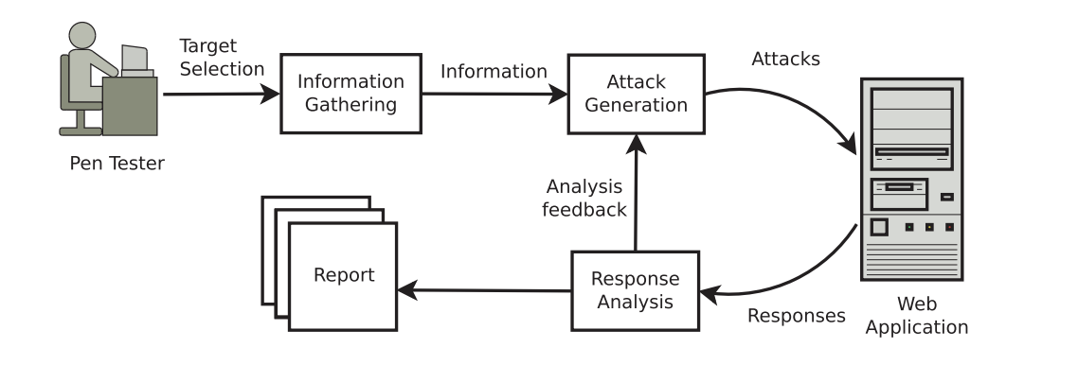

Figure 1 - Process of doing the Penetration testing. [6]

This structured approach provides detailed insight into the weaknesses and strengths of each tool, along with the enhancement of the testing. This project will help security professionals to choose the right tool to assess the web application in a secure environment.

### 10.2 Conduct Initial Research on The Penetration Testing Framework

To understand the development of Penetration Tests over the last few years, various researchers in the field examine different aspects of web application testing where most projects implement the OWASP Framework guidelines [7].

### 10.3 Review Academic and Industry Reports

We have conducted a literature review based on the work done by various researchers in Web Application Testing tools. Our Research Methodology for comparing and evaluating the selected Web application pen testing tools was developed following the criteria below.

### 10.4 Selection of Penetration Testing Tools

Selecting and implementing the right penetration testing tools is crucial to carry out the expected result when it comes to testing web applications. When selecting the appropriate tool, there must be a balance between usability and functionality, which will meet project requirements. Supporting a range of applications and finding specific vulnerabilities within security levels are also considered when selecting tools. For example, as there are automation features, SQL Map can be used for SQL injection attacks on the database.

Security experts may customise attacks and conduct in-depth analysis of HTTP/S traffic with the help of Burp Suite and OWASP ZAP, which are well-known for thorough web application scanning and include proxy-based testing, interception, and custom payload choices [3].

Furthermore, some penetration testing tools come in both paid and open-source versions. Open-source tools such as ZAP, Nikto, Hydra, Wfuzz, and SQL Map have different functionalities, and paid tools such as Burp Suite have some more features compared to the community version. The paid version includes some automation and improved reporting functionality.

### 10.5 Setting Up Test Environments:

Effective and efficient penetration testing projects require setting up a secure test environment, which enables testers to recreate actual attacks on online applications without endangering live data. The Damn Vulnerable Web Application (DVWA) is one of the controlled environments where testers may safely practice exploiting deliberate flaws. To prevent any security threats, installing DVWA usually entails setting it up on a local or virtual server. This setup is separated from any live production environment. This secure and stable environment provides insight into how vulnerabilities react to different attack tactics and may be adjusted by the tester from low to high-security levels [8].

Setting the environment along with the tools is a crucial and important task. For example, intercepting HTTP requests through Burp Suite and setting up login credentials for testing with Hydra is a step-by-step process. In order to work properly, these tools need to be set in such a way that on different security levels, they can perform at their best effort. A properly configured testing environment helps the security team to identify weaknesses in the system and mitigate future exploitation [9].

Figure 2 shows the team’s design and implementation of the project, having 3 different virtual machines and tools used to test web applications.

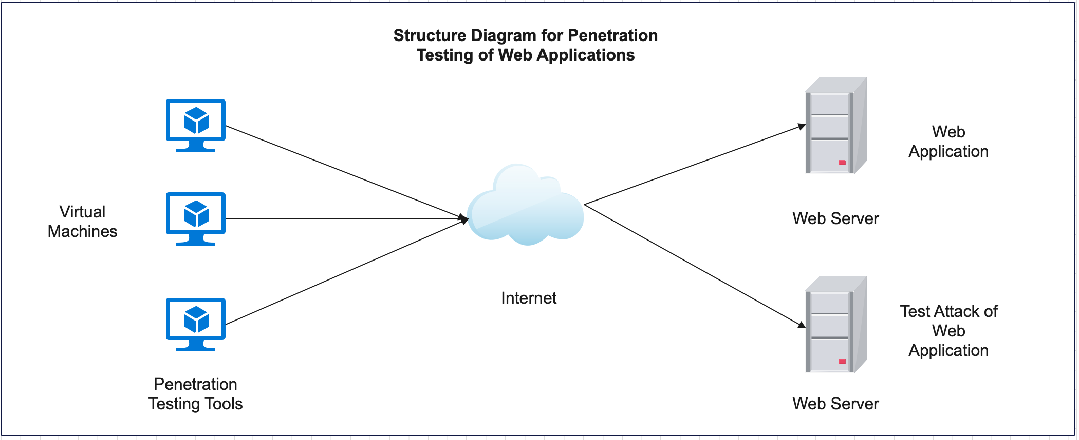

Figure 2 - Process of doing the Penetration testing [6]

### 10.6 Test Implementations

In penetration testing projects, test implementation entails prearranged steps to find, exploit, and record security flaws in an online site with a secured and controlled environment. The first step in this phase is to choose the target regions in a controlled setting, such as a Damn Vulnerable Web Application (DVWA), which is designed to highlight typical security vulnerabilities at different levels. Tools are tested with commands relevant to each attack for every vulnerability found. For instance, Burp Suite or OWASP ZAP allow both automatic and manual scanning to find hidden vulnerabilities and analyse HTTP/S requests. At the same time, SQL Map may automate SQL injection testing by focusing on fields with known vulnerabilities [10].

Penetration testers investigate how programs or applications react to harmful inputs during implementation using various strategies, including input manipulation. Every test has thorough documentation that includes information on successful exploits, unsuccessful efforts, and unexpected system reactions. Testers mostly use a variety of factors and variables to validate results from various approaches, assuring comprehensive and reliable outcomes for each test. Collecting screenshots and other evidence at every stage thoroughly records the application's security posture [11].

### 10.7 Selection of evaluation criteria

Assessment criteria are one of the important factors to choose when it comes to evaluating the efficiency of the penetration testing tools. Based on the testing, the assessment criteria are categorised into different factors. The assessment criteria for each tool are:

**Tool Type:** It defines open-source or paid version

**Version No:** It defines the version of the tool.

**Latest Update:** It defines the date of the newest update

**Cost Effective:** It defines if the tool is a paid version and how much it costs.

**Integration:** It defines whether this tool can be implemented with other web application penetration testing tools.

**Ease of Use:** Comprehensive and needs tutorials or a manual to use the application.

**Accuracy:** This gauges how consistently a tool detects real vulnerabilities without producing false positives.

**Performance/speed:** It defines how quickly it can perform its operation.

**Usability:** It defines how the tool is used in terms of installation.

**Scalability:** It refers to the adaptability of the tool in different operating systems.

**Reporting:** It defines the reporting format and understandability of the outcome.

Out of these criteria, accuracy, integration, performance, and scalability are most important. In addition to these, usability is also important because when it comes to complex testing, usability becomes the prime factor. Performance criteria could be very effective in terms of identifying vulnerabilities in a customised environment, which explains how it can adjust according to the needs [12].

Furthermore, the tool's integration capacity evaluates if it can complement other systems or tools to improve testing workflows for different test environments. Reporting features are also crucial since they enable penetration testers to record their results thoroughly to identify actual output. Testers may choose to use the finest technologies to do precise, thorough, and effective security assessments that are adapted to particular project requirements and circumstances for any project by using these evaluation criteria [6].

We ensured the most recent versions of each tool were used for evaluation, verifying updates until the project deadline. The base model of our performance criteria is below. Figure 3 shows the design of our performance criteria used to test each tool used in the project.

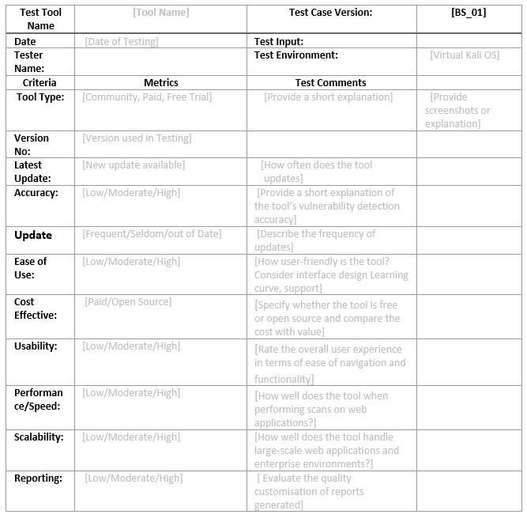

Figure 3 - Our Performance Criteria

## 11.0 Project Implementation

Figure 4 shows detailed information on the settings used in our testing. Hardware and software used and tools to test web applications.

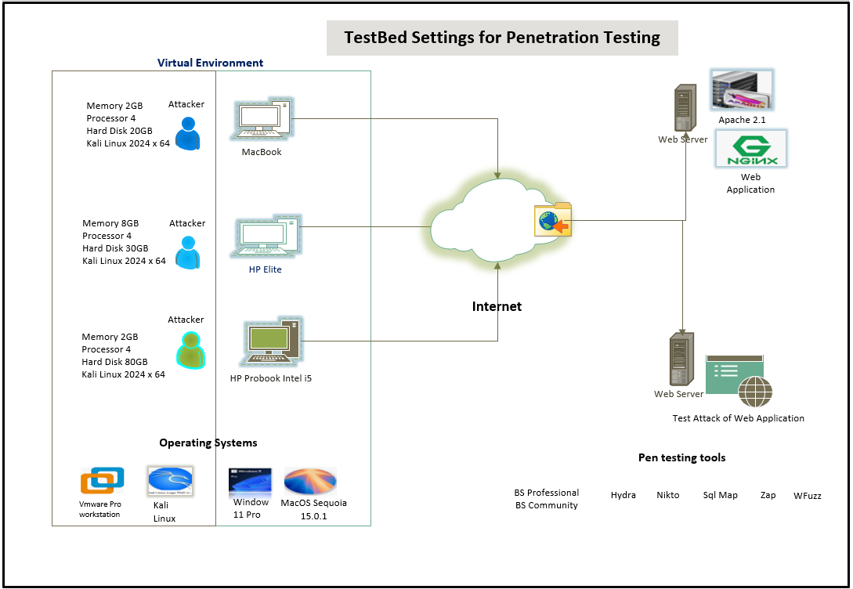

Figure 4 - Test Bed for Penetration Testing

**Environment Setup:**

Virtualisation and OS Setup

This project will have a testing environment setup. A Kali Linux operating system will be installed in a virtual machine, specifically VMware Fusion, and will be dedicated to this project for penetration testing. Kali Linux is a famous operating system for security professionals because it has pre-installed security and penetration testing tools. By deploying this to VM, we ensure an isolated environment where the tools we tested do not affect other network devices. Also, using virtualisation, there is a feature where we can reverse to a previous state if issues arise during testing.

Separately, DVWA (Damn Vulnerable Web Application) will be installed on a distinct VM which is handled and hosted by our stakeholder, who is working as a Senior Penetration tester Justin Ng. DVWA is a known vulnerable application that is ideal for penetration testing. It allows a real-world simulation of web application vulnerabilities. DVWA is in another VM to protect the other system by not exposing its vulnerabilities.

Figure 5 shows the log-in page of our target web application for testing, which is hosted by our stakeholders.

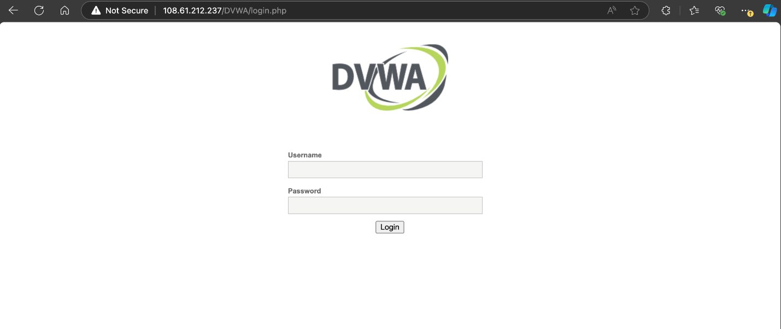

Figure 5 - This figure is the login page of the DVWA with IP 108.61.212.237.

**Network Configuration:**

Our stakeholders have whitelisted our IP addresses so that we are the only ones who can test the web application he created. We can provide reliable results from all our testing with the selected tools. It also prevents any unauthorised access to the web application. By limiting team members to test the web application, we are confident that we can execute penetration testing without the risk of exposing other network assets.

Figure 6 shows the login page where our stakeholders whitelisted our IP address, which means that we are the only authorised person to test the system.

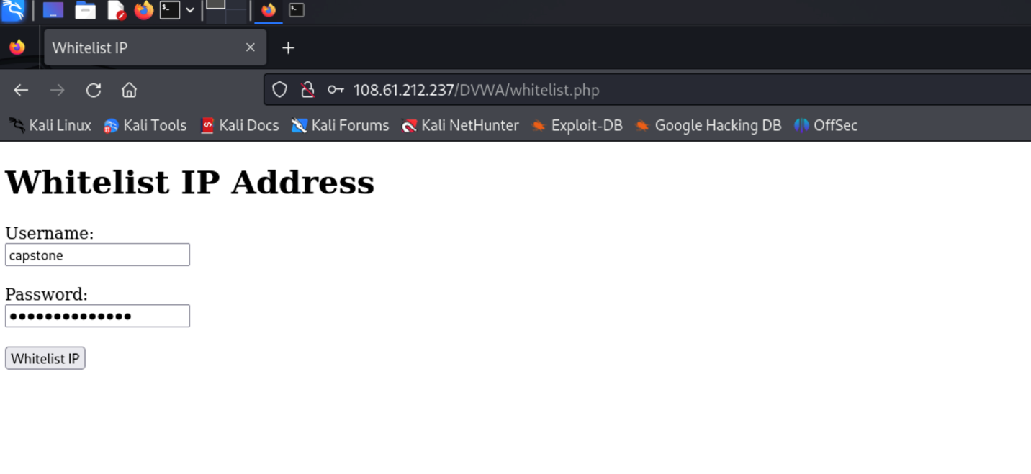

Figure 6 - IP Whitelisting Process

Figure 7 shows that after we log in then our IP already been whitelisted.

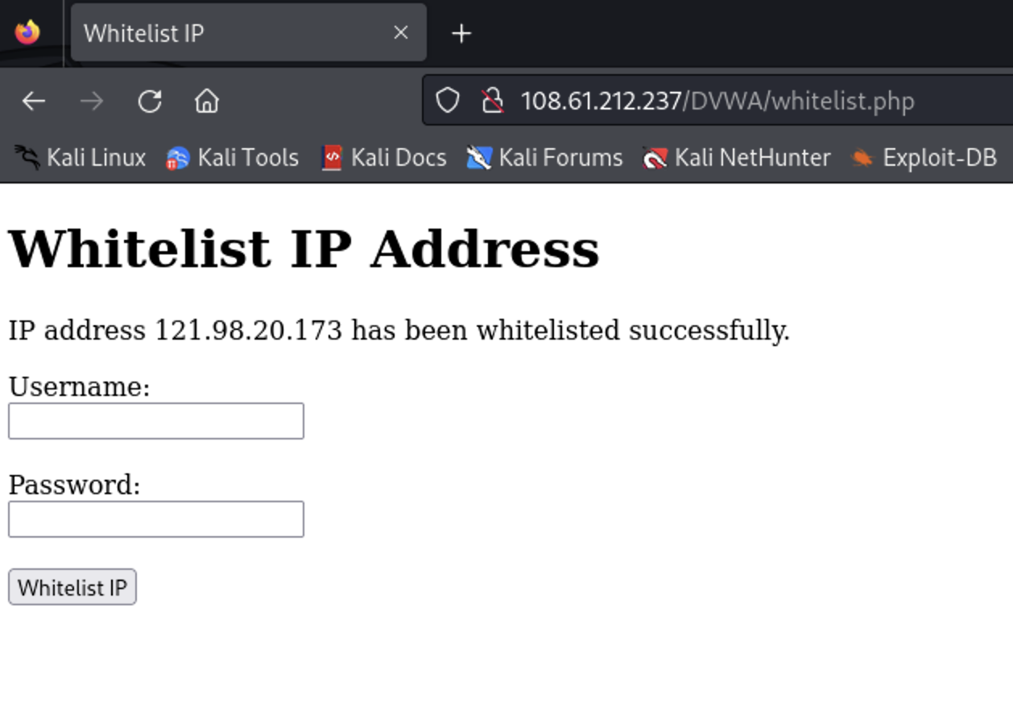

Figure 7 - The IP address has been whitelisted successfully

### 11.1 Implementation of Burp Suite Professional Tool

**Implementation of Burp Suite Professional**

**The project implementation for the Burp Suite Professional tool will include the following steps:**

* Set up Burp Suite Professional
* Login into DVWA
* Capture the Login Request
* Set Attack Positions in the Intruder
* Configure Payload for Brute-Force Attack
* Start the Attack and Analyze the Results
* Document the findings and generate a report

**Set up Burp Suite Professional**

To start, we need to install Burp Suite Professional from Portswigger website. This version is a paid version with advanced features like automated scanning and detailed reporting of result findings and is ideal for penetration testers and individuals. For this project, we emailed Portswigger support to access the software, and they provided us with three months to use the full version of the Burp Suite Professional. After installation of the software in Kali Linux, configure the proxy settings to listen to a specific port (usually 127.0.0.1:8080). With this setting, Burp Suite can intercept HTTP between the browser and the web application target. The professional version has its own configured browser to save the time of manually changing settings on another web browser.

**Login into DVWA**

Open the DVWA web application in the browser and log in with the test credentials. The login page is the primary target because it has information vulnerable to brute-force attacks. This step will help us establish a session, and we can identify the request for testing. It is also essential to set the level of security in the DVWA from low security to high to test each successful result at every level of security.

**Capture the Login Request**

When the Burp Suite’ proxy intercept feature is turned on, an attempt to log in will be captured to the Burp Suite interface, which includes login credentials. This capture request is an essential step because we need to have a structure for launching brute-force attacks, and we can define parameters. (e.g. username and password) that the intruder will target. These capture requests need to be sent to the intruder for further analysis.

**Set Attack Positions in the Intruder**

In the Intruder section, defining the attack position is essential by selecting specific parameters like username and password and choosing password fields as attack positions; when a password is highlighted and added, it allows Burp Suite to substitute values during the attack. This setup is a critical element in the login process during brute forcing.

**Configure Payload for Brute-Force Attack**

When the login credential is added to the payload, input a list of potential usernames or passwords. For this project, we use password lists provided by Burp Suite Professional. Using a text file with a possible password is also allowed. This version allows multiple payload types and configurations to be added, which maximises the tool's effectiveness and reliable results.

**Start the Attack and Analyze the Results**

When the payload is set, Click “Start Attack.” Burp Suite will try to brute force the login credential by attempting to combine usernames and passwords from payload lists. By analyzing the results, we can identify the successful login attempts by character length that differ from other parameters.

**Document the findings and generate a report**

Record all relevant information, which includes the successful login parameters with each level of security and speed of the testing. This tool can generate reports of known vulnerabilities.

### 11.2 Implementation of Burp Suite Community Tool

**Implementation of Burp Suite Community**

**The project implementation for the Burp Suite Community tool will include the following steps:**

* Set up Burp Suite Professional
* Login into DVWA
* Capture the Login Request
* Set Attack Positions in the Intruder
* Configure Payload for Brute-Force Attack
* Start the Attack and Analyze the Results
* Document the findings and generate a report

**Set up Burp Suite Community**

First, download and install Burp Suite Community Edition from Portswigger website. This free version has essential tools for manual testing, including Proxy, Intruder, and Repeater. This version lacks some features that are only available to the professional version. After installation of the software in Kali Linux, configure the proxy settings to listen to a specific port (usually 127.0.0.1:8080). Configuring the website manually and getting certificate installed in the browser and Burp Suite can then listen and capture requests back to the tool interface.

**Login into DVWA**

Open the DVWA web application in the browser and log in with the test credentials. The login page is the primary target because it has information vulnerable to brute-force attacks. This step will help us establish a session, and we can identify the request for testing. It is also essential to set the level of security in the DVWA from low security to high to test each successful result at every level of security

**Capture the Login Request**

Upon enabling Intercept in the Burp Suite, open the configured browser to log in to DVWA. Upon login, the Burp Suite will capture the request log, which is shown as raw request data in Burp Suite. This step is essential as the capture details are needed in brute force attacks. This captured request will then be submitted to the intruder to highlight the parameter for inserting payloads.

**Set Attack Positions in the Intruder**

In the Intruder section, defining the attack position is essential by selecting specific parameters like username and password and choosing password fields as attack positions; when a password is highlighted and added, it allows Burp Suite to substitute values during the attack. This setup is a critical element in the login process during brute forcing.

**Configure Payload for Brute-Force Attack**

In this edition, additional configurations are required to handle the payload effectively. Password lists for testing are not readily available. Looking for a compiled password list from GitHub is essential and copying it to the Payload section is necessary for brute forcing.

**Start the Attack and Analyze the Results**

Launching the attack by pressing the Attack button, Burp Suite will attempt each combination from the list of passwords provided. The community version needs to monitor the response of codes to manually identify successful attacks. It lacks automated analysis features.

**Document the findings and generate a report**

Document the results after brute force and record the speed for each level of security. Successful brute force will show unusual characters from other password lists. The community edition now has built-in reporting, so every finding is manually compiled. Results from testing are essential for further review and remediation efforts.

### 11.3 Implementation of Wfuzz Tool

**The project implementation for the Wfuzz tool will include the following steps:**

* Define the Target and Test Scope
* Prepare Wordlist
* Brute Force Login credentials
* Brute Force command in the terminal
* Document Findings

**Define the target**

First, we need to identify the target web application we can test. For this project our website is <http://108.61.212.237/DVWA/login.php>. Determining the test scope could be identifying hidden directories and files or brute-forcing login credentials. For this testing, we tried to brute force the system. Ensure that you are permitted to test the target when doing web fuzzing.

**Prepare Wordlists**

You can create a wordlist suitable for each type of test. In this testing, we use the wordlists that are available in Kali Linux, which is in the rockyou.txt file that consists of passwords that can be used to brute force the web application.

Example: /usr/share/seclists/Discovery/Web-Content/common.txt

**Brute Force login credentials**

This step should only be used on a permitted website upon logging into the DVWA by providing credentials. We need to get the Session ID, which is a unique character that can be found when you right-click the space in the web application, go to the “Inspect” tab, and then click Storage. This is where you will find the “Value”, the web application's session ID.

Figure 8 shows where to get the application session ID.

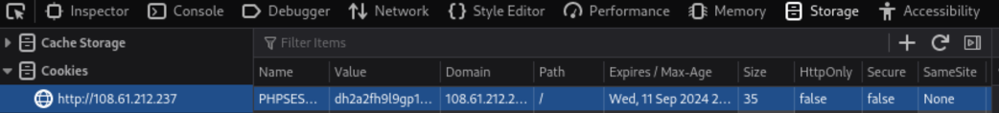

Figure 8 - Application's Session ID

**Brute force command in the terminal**

Correct use of wfuzz command is very important to generate successful brute forcing on a web application. There are important commands that need to be put into the terminal, which is the directory of the wordlist, setting up the security level, providing PHP session ID, the web application address, special command use in this tool /?username=admin&password=FUZZ&Login=Login.

Sample image:

Figure 9 shows the whole command use in testing the brute force for the web application.

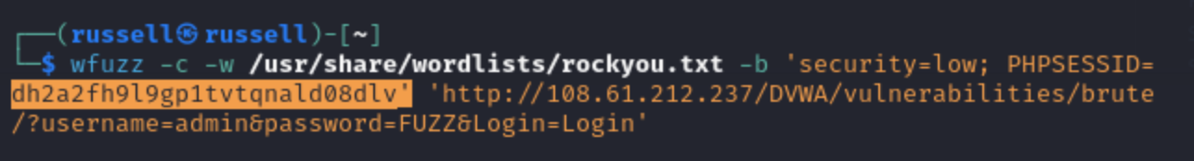

Figure 9 - Command for WFuzz testing

**Document Findings**

Successful credentials have unique parameters among other wordlists or different status codes or response lengths. Document report if successful in each level of security, which are the low, medium, and high.

Figure 10 shows the result of the successful attack and shows that the length of the correct password is different from other passwords.

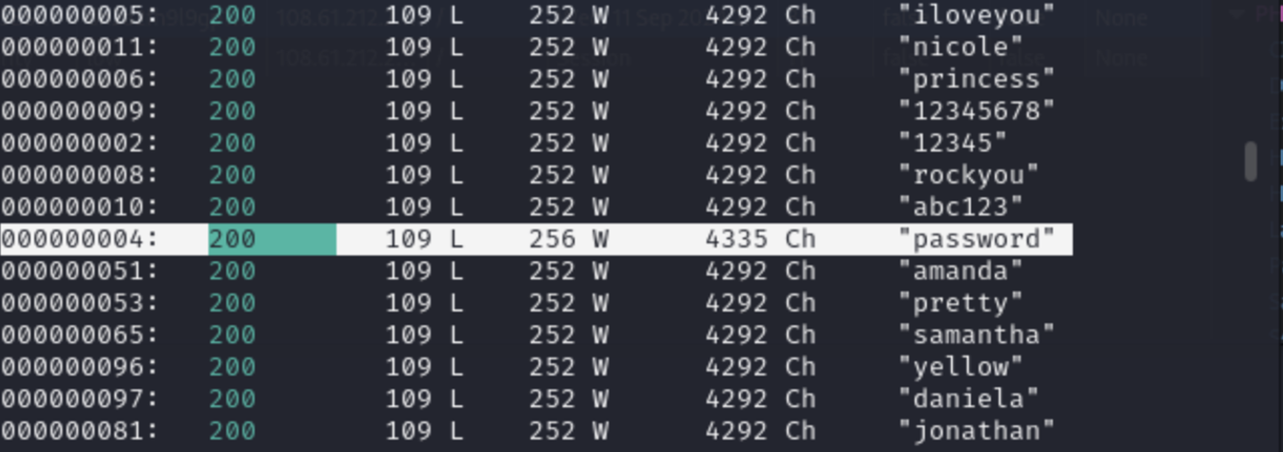

Figure 10 - WFuzz Successful Attack

### 11.4 Implementation of SQL Map Tool

The project implementation for the SQL Map tool will include the following steps:

* Environment Setup for SQL Map
* Installation and Verification of SQL Map
* Identify Vulnerable in DVWA with URL
* SQL Map Basic test run
* Database Enumeration Performance
* Extraction of Table names from the database
* Retrieve information from a specific table
* Export the result and save the output file
* Documentation and reporting

**Environment Setup for SQL Map:**

Security Level Configuration: From the homepage, DVWA’s security level needs to be set to low, medium, and high from the “DVWA Security” settings tab. This configuration will allow SQL Injection to be accepted on DVWA, which will be ideal for testing SQL Map.

Connectivity with database: To ensure DVWA can connect to the database, we need to check that it can connect with MySQL Database by injecting a command in the field.

Figure 11 shows where the user id field for injection input.

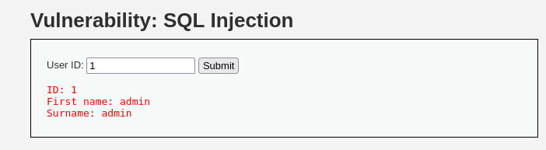

Figure 11 - SQL Injection Input

**Installation and Verification of SQL Map:**

As we are using Kali Linux, SQL Map has already been installed on the testing machine. In order to verify SQL Map in the testing system, we need to run the command in the terminal: “sqlmap – h”. It will confirm the installation.

**Identify Vulnerable in DVWA with URL**

To access DVWA’s SQL Injection section, navigate to the left side of the menu and select “SQL Injection”. To test user input, we need to insert a command in the input field: “1' OR '1'='1”

Figure 12 shows the input of SQL command to the field to generate some information from the database.

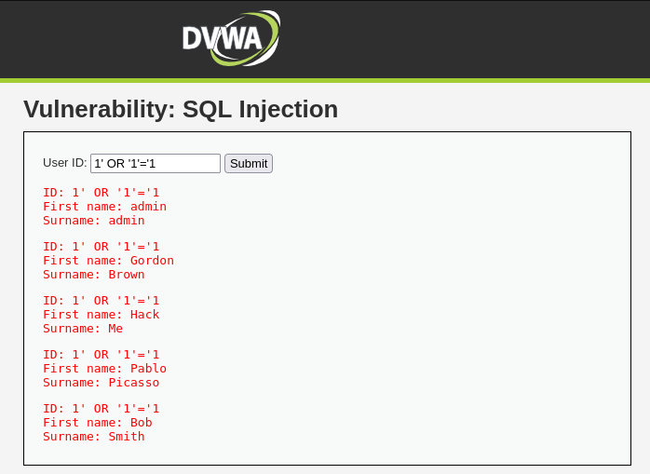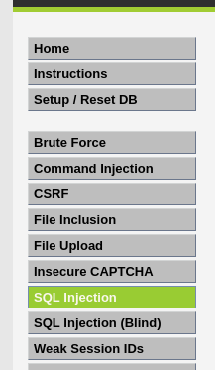

Figure 12 - DVWA SQL Injection on the home Page

**SQL Map Basic test run**

To test the SQL injection vulnerability, we need to run a basic command in Kali Linux for SQL Map:

“sqlmap -u "http://108.61.212.237/DVWA/vulnerabilities/sqli/?id=1&Submit=Submit#" --cookie="PHPSESSID=2gbp16c0a7lngtkbhe681cm23g; security=low" --banner --current-user --current db –dump”

Explanation: The -u option determines the target URL, and cookies are utilized to maintain the current session token in DVWA.

**Database Enumeration Performance**

If the detection of SQL Injection exists, the enumeration of database names will appear next. It will list all the available database names, which confirms the vulnerability.

**Extraction of Table names from the database**

Once the name of the database is available, the extraction of table names can be gathered with the following command:

“sqlmap -u "http://108.61.212.237/DVWA/vulnerabilities/sqli/?id=1&Submit=Submit#" --cookie="PHPSESSID=2gbp16c0a7lngtkbhe681cm23g; security=low" -D dvwa --tables”

**Retrieve information from a specific table**

To retrieve data from a specific table, SQL Map will display data from the user table with the following command:

“sqlmap -u "http://108.61.212.237/DVWA/vulnerabilities/sqli/?id=1&Submit=Submit#" --cookie="PHPSESSID=2gbp16c0a7lngtkbhe681cm23g; security=low" -D -T users --dump”

As the retrieved information will be used for brute force attack, the value for each user will be in hash values, which will be decrypted by the dictionary attack on that specific output. It will display the user and other details from the database table, and the passwords will be displayed in hash values. SQL Map will be able to crack the hash values during the testing phase.

**Export the result and save the output file**

To save the output file, we need to run the command in the terminal during the same session. The command for saving the output file:

“sqlmap -u "http://108.61.212.237/DVWA/vulnerabilities/sqli/?id=1&Submit=Submit#" --cookie="PHPSESSID=2gbp16c0a7lngtkbhe681cm23g; security=low" --dump -o”

**Documentation and reporting**

After executing the command in the terminal, we review the output results. A thorough analysis is performed to determine the most effective way to gather all relevant information, followed by recommendations based on our findings.

### 11.5 Implementation of Hydra Tool

Hydra is a type of Brute-Force tool used by Penetration Testers. It is designed to crack passwords for various network services, including FTP, HTTP, HTTPS, and SMB databases. More info about this tool can be found at <https://github.com/vanhauser-thc/thc-hydra>.

Figure 13 shows that Hydra is installed in Kali and provided some key information that will help using the tool.

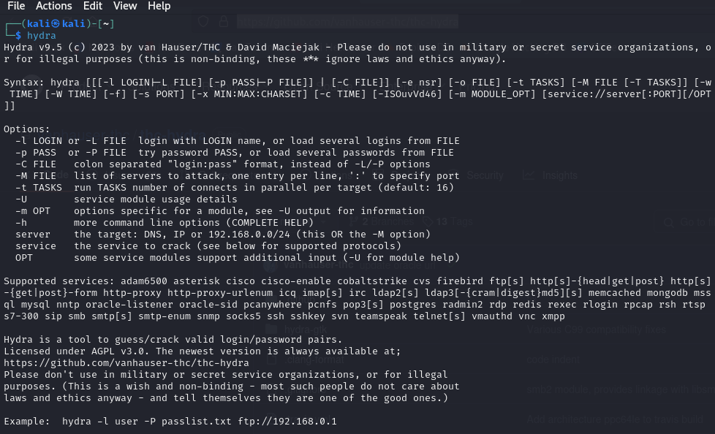

Figure 13 - Confirm Hydra is installed inside Kali Linux with updated version v9.5

1. For Hydra’s implementation to fully function, it must implement a) a username list, b) the password, and c) a remote port to be attacked.

2. In this implementation, the rockyou.txt file is utilised, and ensure it is already installed.

Figure 14 shows the location of the text file that will be used to brute force the target web application.

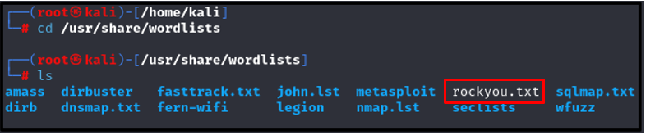

Figure 14 - Confirm that the rockyou.txt file is available in the above directory

Figure 15 shows the command used to brute force the web application.

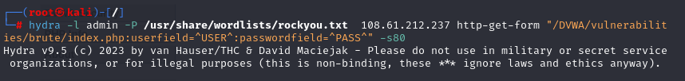

Figure 15 - For Testing on the DVWA website

### 11.6 Implementation of Nikto Tool

Nikto is an open–source Web Server scanner that identifies vulnerabilities, outdated server software, and security misconfiguration. It also has comprehensive testing and security issues [13].

Figure 16 shows that the tool Nikto is already installed in Kali Linux as a free tool for penetration testing.

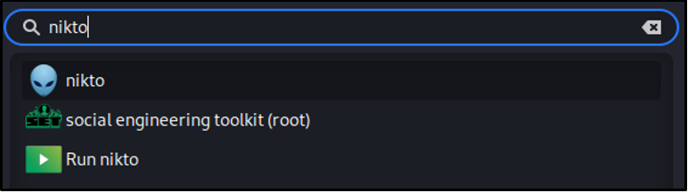

Figure 16 - This is Nikto preinstalled within Kali Linux

Nikto tool can be accessed by using the Terminal command in Kali. At the time of this implementation, the tool version is shown below in Figure 17:

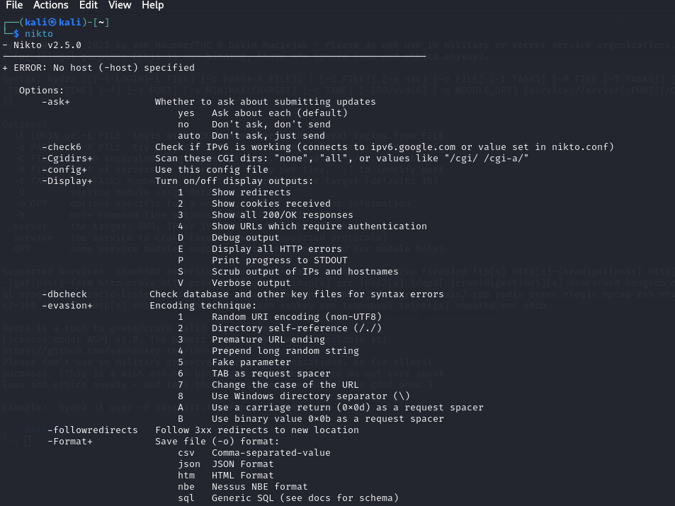

Figure 17 - Confirm Nikto tool already implemented in Kali Linux

Figure 18 provide us information about the target web application and open ports in the system.

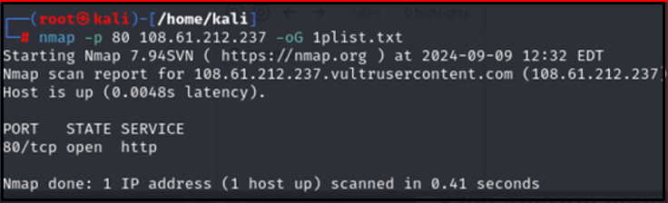

Figure 18 - Nikto Output

For testing purposes of the DVWA website using Nikto, we also utilize the Nmap command to scan open ports in the DVWA website address (108.61.212.237), targeting port use(p80), and report files (1plist).

Figure 19 shows some report findings from the web application and show signs that the web application is ready for testing.

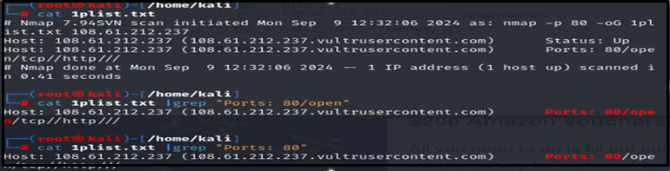

Figure 19 - Confirm Nikto implementation is ready for the Testing Session

### 11.7 Implementation of ZAP Tool

ZAP is an open-source web application security testing tool developed by OWASP. Preinstalled within Kali Linux or can be downloaded from the OWASP download website, available in Windows or Linux [14].

Figure 20 shows the front page of the Zap tool after installation and with the tool version.

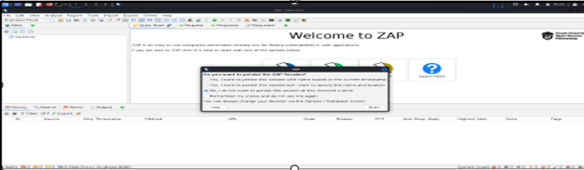

Figure 20 - Installation of Zap tool version used v2.15.0

Figure 21 shows the Manual Explore section, where settings are configured to test the web application.

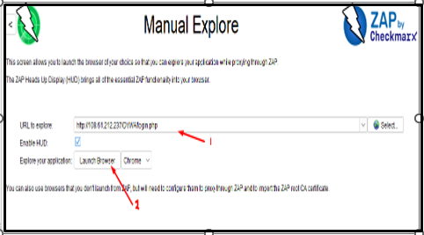

Figure 21 - Manual Explore Setting where the setting of the 1) targeting URL website before 2) Launch Browser is entered either Chrome or Firefox platform

Browser is entered either Chrome or Firefox platform

Figure 22 shows some folder locations of the target and getting parameters.

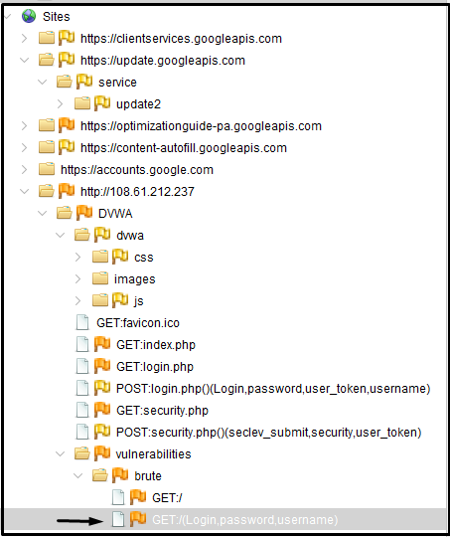

Figure 22 - To set the target site before testing

## 12.0 Testing

### 12.1 Burp Suite Professional Tool Testing

Few steps to follow in Burp Suite Community Testing

* Prerequisite and setup
* Testing Step

**Prerequisites and setup**

The Burp Suite Community should be installed in Kali Linux inside Vmware Fusion for testing.

**Testing Steps:**

**Step 1: Set up Burp Suite Professional**

1. Open the Burp Suite Professional and go to the “Proxy” section.
2. Burp Suite has its browser, which has already configured the settings and has a default port of 8080.
3. If using a different browser (e.g., Firefox or Chrome), use Burp’s proxy. The setting should be changed with HTTP Proxy to 127.0.0.1; the port number is 8080.
4. Additionally, in different browsers, install the Burp Suite CA certificate in the browser for HTTPS interception, which is under the “Proxy” > “Options” section.

**Step 2: Login into DVWA**

1. Open the DVWA website in the Burp Suite Browser and log in using the provided credentials (admin/password).

Figure 23 shows the main page of the DVWA web application and provides credentials to access the web.

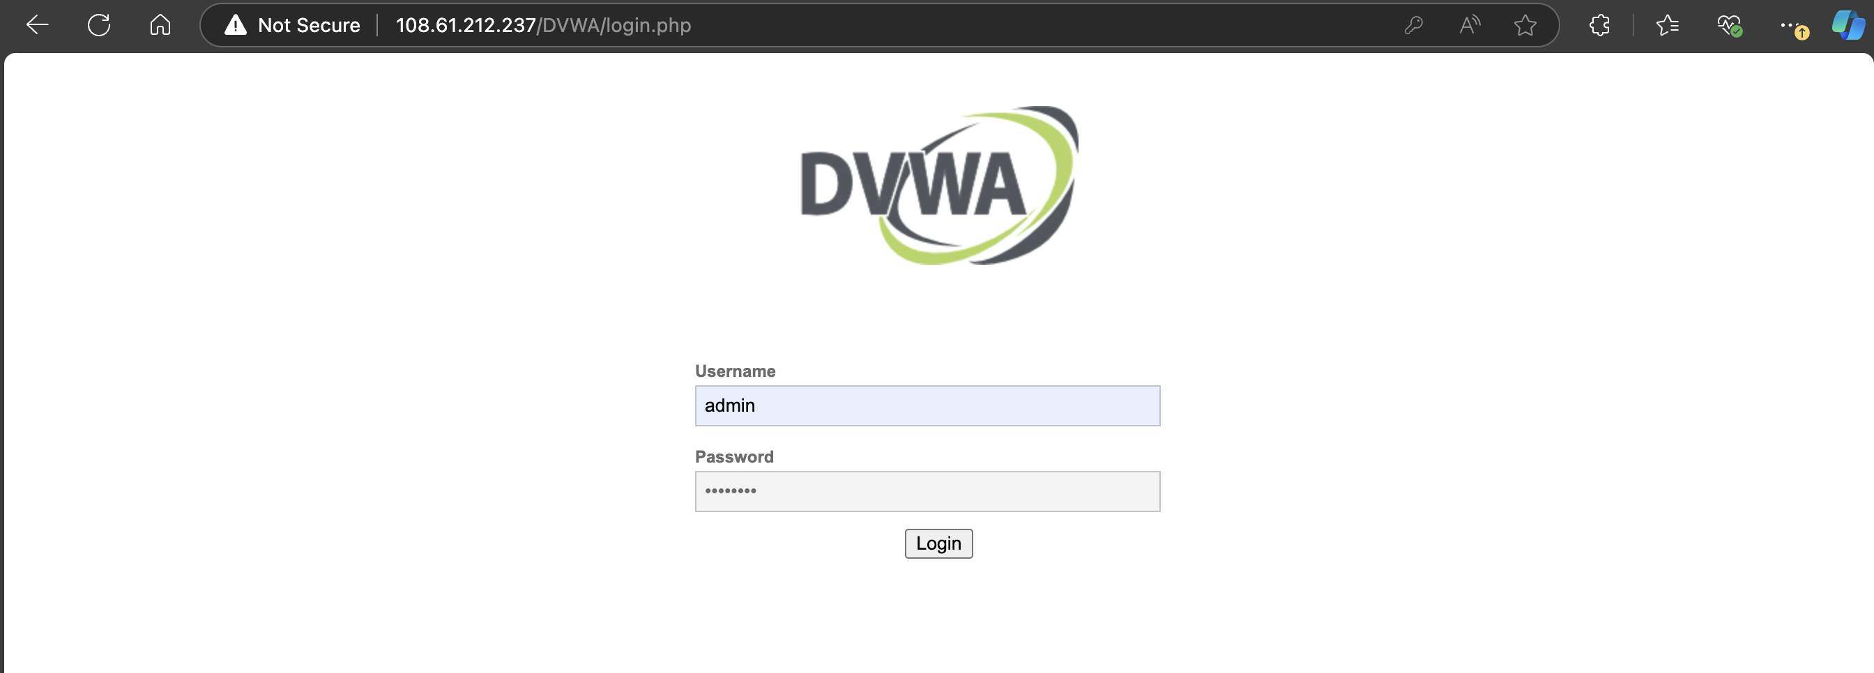

Figure 23 - DVWA Login Page

1. For the initial testing, we put the DVWA security level in the “Low” setting to check vulnerabilities and for testing purposes.

Figure 24 shows that the web application allows us to change security level for testing.

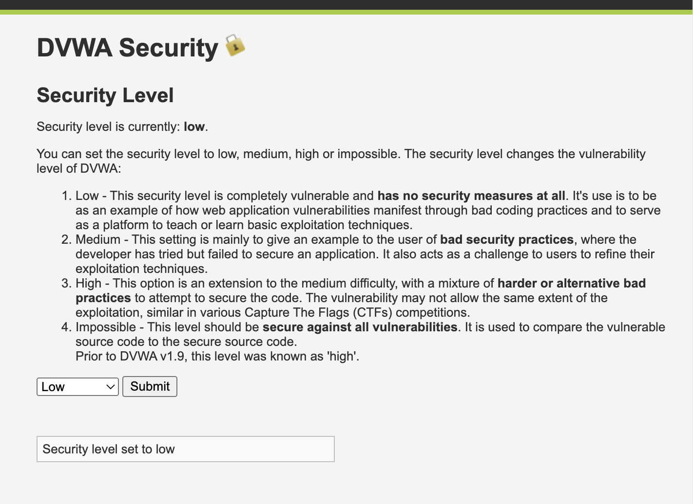

Figure 24 - DVWA Security Level

1. Under “Brute Force” on the DVWA main page, the Brute-force testing takes place.

Figure 25 shows where brute force section for testing and input of credentials.

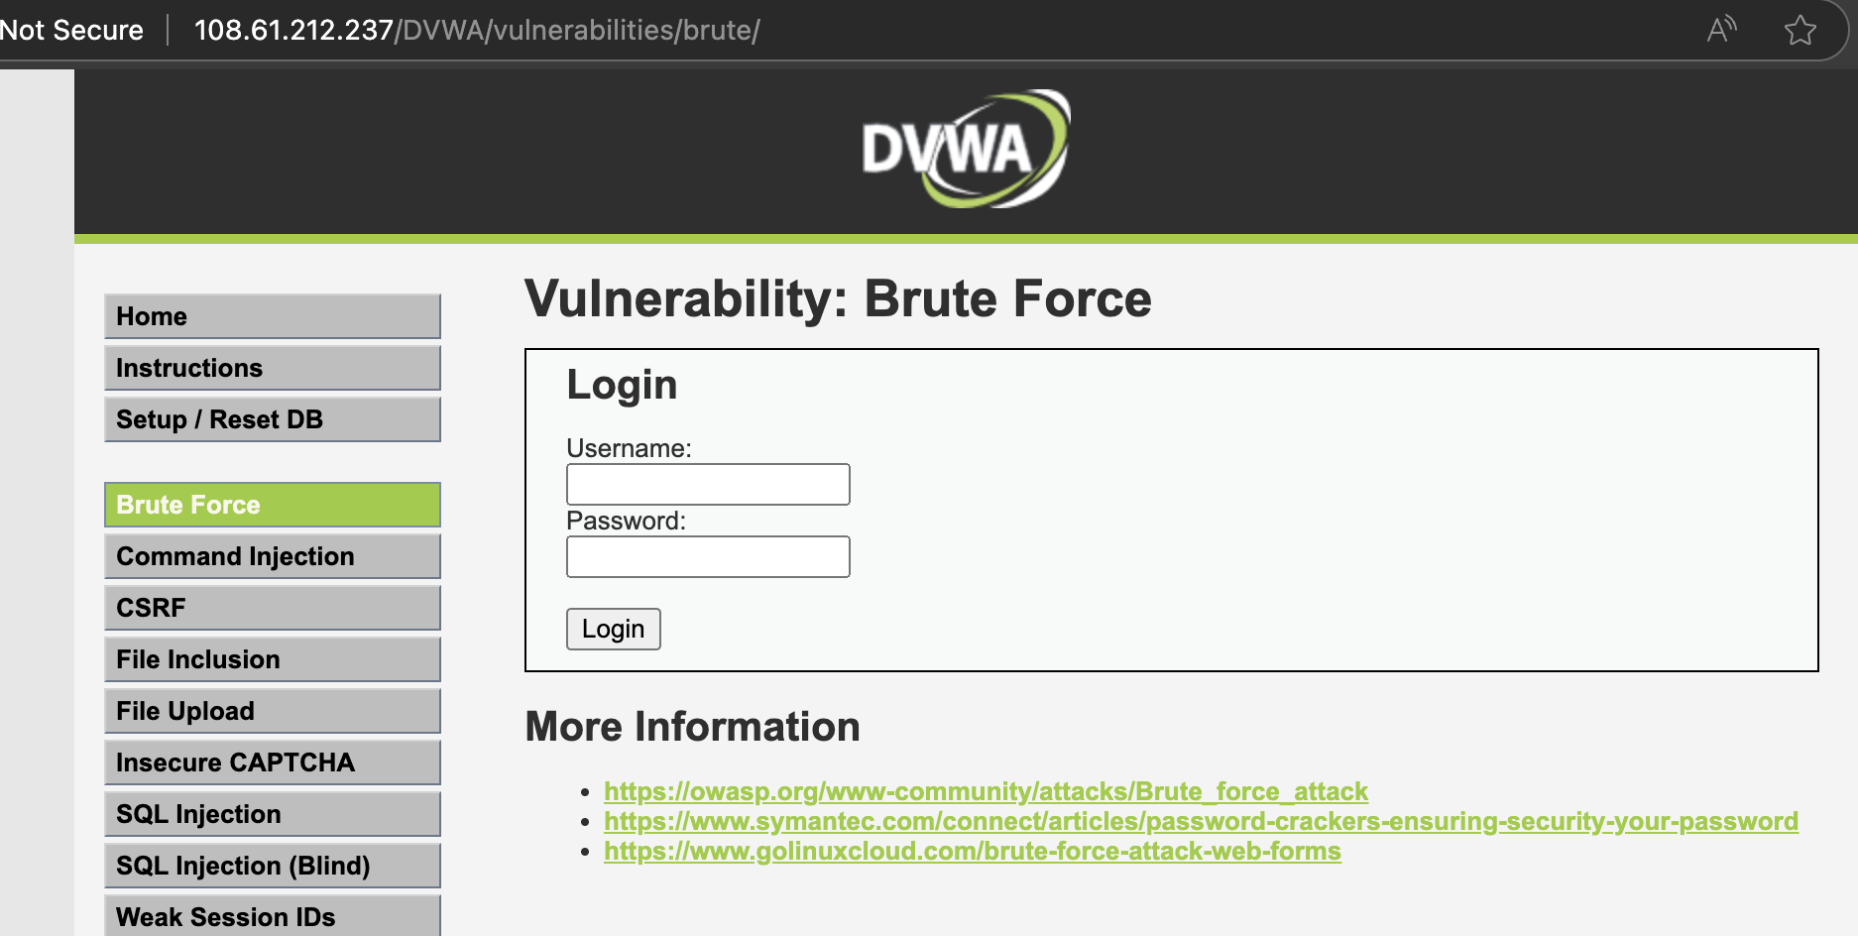

Figure 25 - Brute Force Page

**Step 3: Capture the Login Request**

1. Under Burp Suite, make sure that “Intercept” is on by clicking the “Intercept” button under the “Proxy” section.
2. In DVWA, under Brute Force, insert the credentials (e.g., admin/password), then click “log in.”

Figure 26 shows where we need to input the credentials for brute forcing the system.

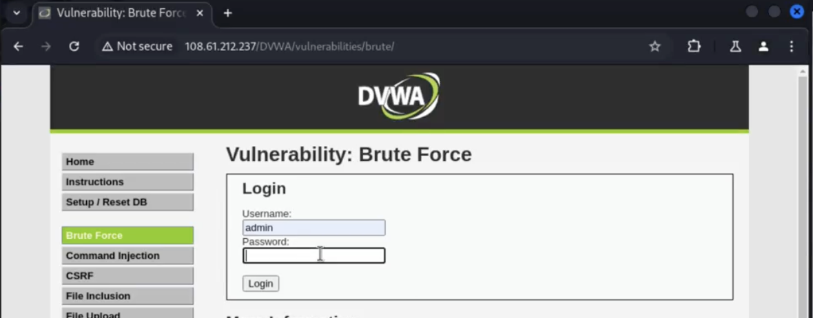

Figure 26 - User input

1. Burp Suite Professional will then intercept the request under the “Proxy” > “Intercept” section; we can check that we have already captured the HTTP request.

Figure 27 shows that after the login, it was then captured to the Burp Suite for further analysis.

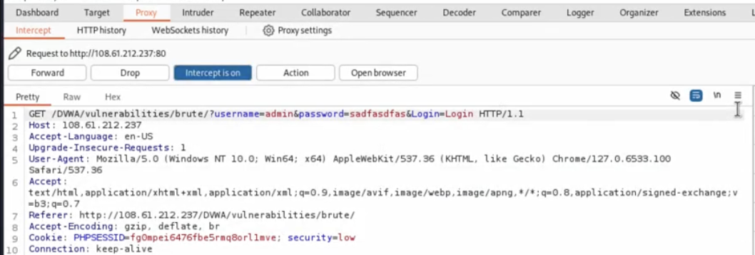

Figure 27 - Intercept login

1. Right-click on the page and select “Send to Intruder” to begin the brute force attack.

**Step 4: Set Attack Positions in the Intruder**

1. Under the “Intruder” section, open the request that is sent from the proxy.
2. Click the “Position” tab to check attack points. On this page, we can see the request placeholder for username and password parameters.
3. We should clear the preset parameters and manually highlight the password parameters to set it as the attack parameter.

Figure 28 shows after the captured information was sent to the intruder section to highlight important parameters.

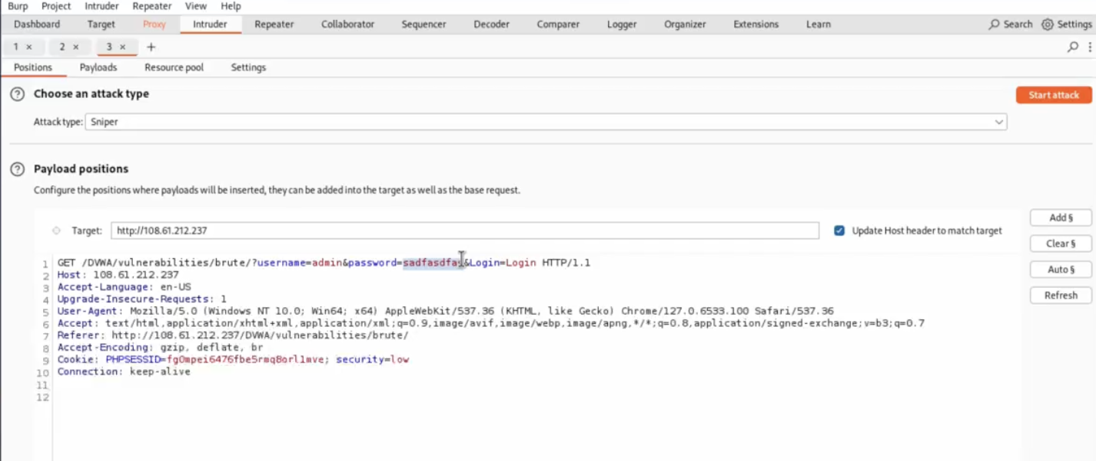

Figure 28 - Clear preset parameters

1. After highlighting the password, click the add icon and set this attack as a “sniper” attack.

Figure 29 shows that we used sniper attack for brute force method.

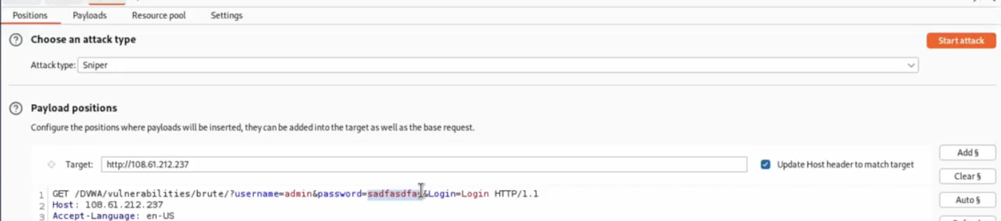

Figure 29 - Sniper attack

**Step 5: Configure Payload for Brute-Force Attack**

1. Click the “Payload” section and choose a list of common passwords. (e.g., from Burp’s list of passwords, or you can use your own wordlist of passwords).
2. In the “Payload Option” section, add the password list that you want to use and then begin the testing.

Figure 30 shows sample of a payload that is used for web testing.

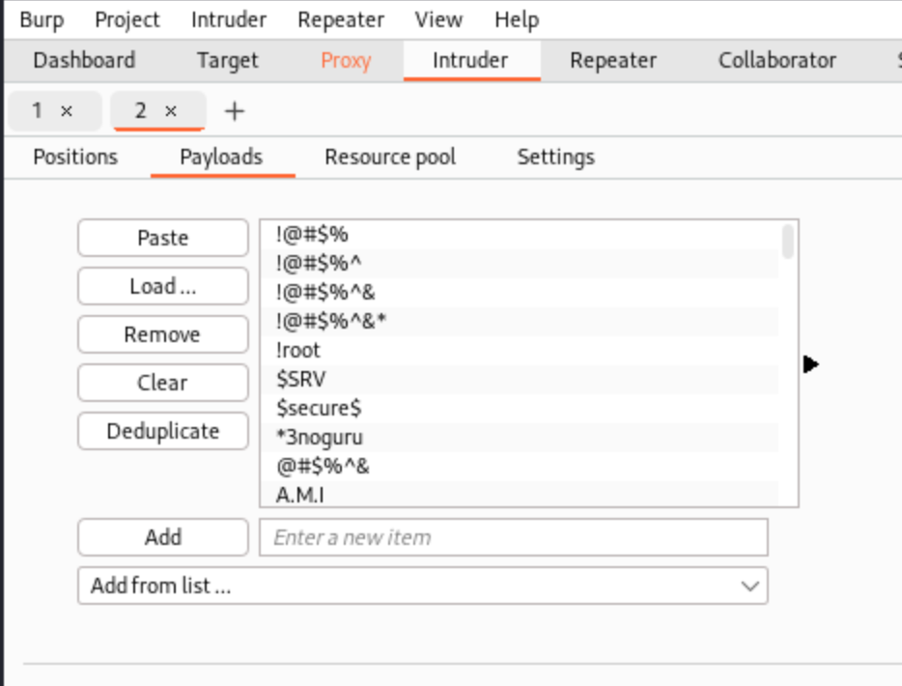

Figure 30 – Payload

Figure 31 shows another payload that is getting some error phrases that can be used to analyze and get more reliable results.

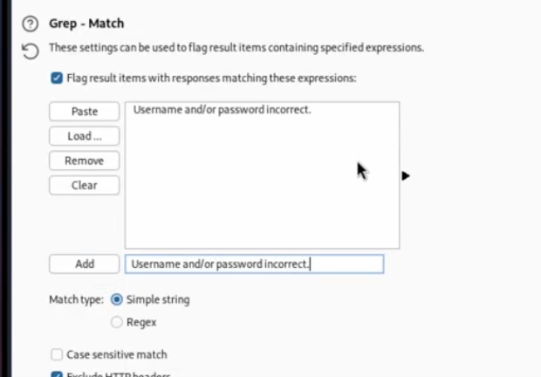

Figure 31 - Payload Grep match

**Step 6: Start the Attack and Analyze the Results**

1. Upon clicking “Start Attack,” it will begin the process of brute force.
2. Burp Suite Professional will attempt each list and display it in the status field.
3. We can Identify if it is successful by checking the HTTP response code and response length. The correct password will show a different response length than other failed attempts.

Figure 32 shows the result of a successful password attack where the length of the character is different from other password lists.

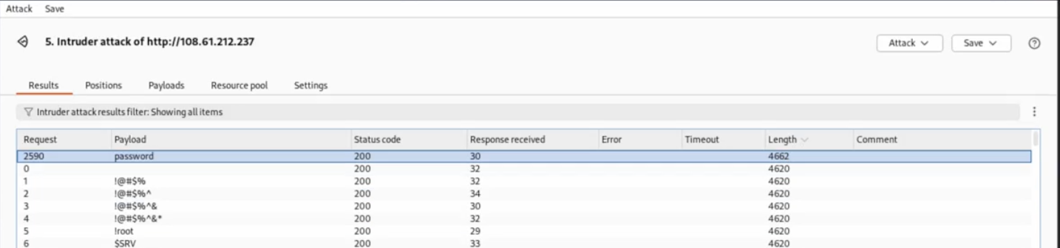

Figure 32 - Password response length

Figure 33 shows another result, which includes another payload to confirm the password is reliable.

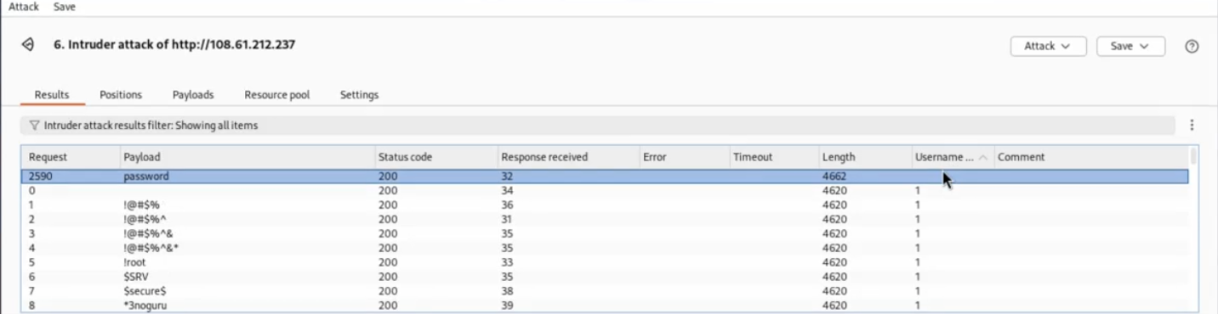

Figure 33 - Password Grep match output

**Step 7: Document the finding and generate a report**

1. Once we get the password verified. Document it using the performance metrics created in this project.
2. Include recommendations for the application and securing log-in from brute force attacks.

### 12.2 Burp Suite Community Tool Testing

Few steps to follow in Burp Suite Community Testing

* Prerequisite and setup
* Testing Step

**Prerequisites and setup**

The Burp Suite Community should be installed in Kali Linux inside Vmware Fusion for testing.

**Testing Steps:**

**Set up Burp Suite Community**

1. Open the Burp Suite Community and go to the “Proxy” section.
2. Set up the proxy for interception to port 8080.
3. Configure the browser proxy setting and use HTTP proxy to 127.0.0.1 and port 8080. During interception, click Manual.

Figure 34 shows the browser's manual method of configuring before the testing in the Burp Suite.

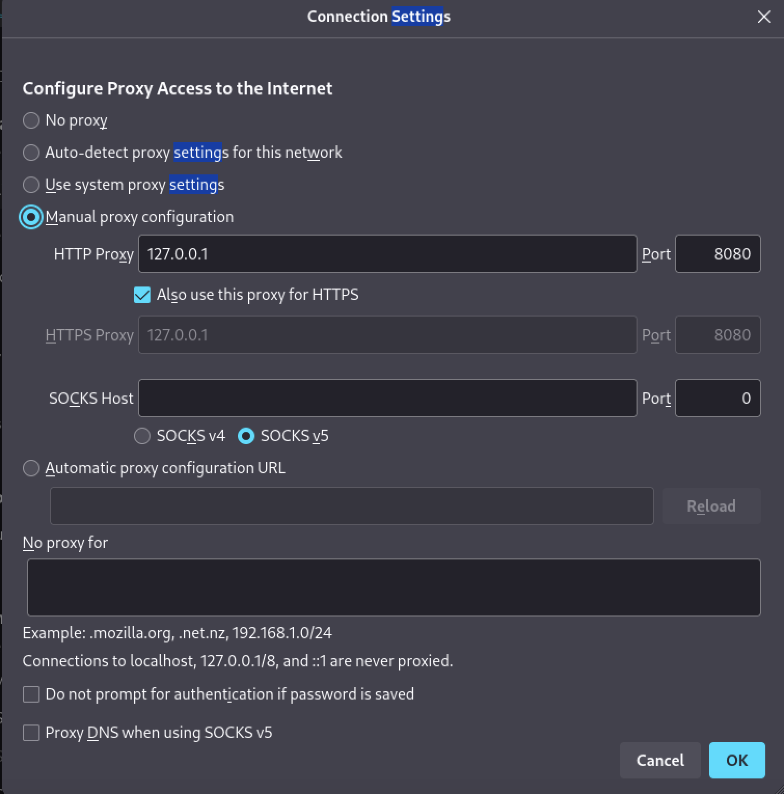

Figure 34 - Configuring Proxy

1. Install the Burp Suite CA certificate in the browser for HTTPS interception, which is under the “Proxy” > “Options” section.

Figure 35 shows the certificate location that is essential to capture request to the Burp Suite tool.

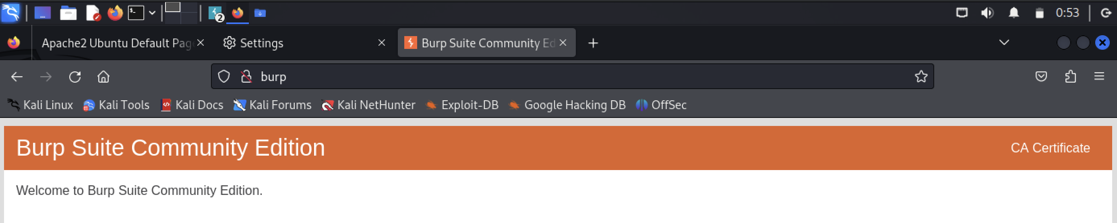

Figure 35 - Burp Suite CA certificate

1. 6. Go to Download and find the download certificate /downloads/cacert, then pre ok

Figure 36 shows that the certificate is downloaded and provides authorization for collecting requests from the web application.

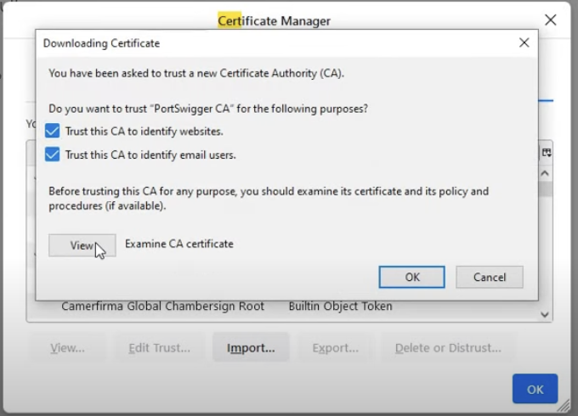

Figure 36 - Download Certificate

**Login into DVWA**

1. Open the DVWA website in the Burp Suite Browser and log in using the provided credentials (admin/password).

Figure 37 shows the location of the section for the Brute Force technique in the Burp Suite Community.



Figure 37 - DVWA Homepage

1. For the initial testing, we put the DVWA security level in the “Low” setting to check vulnerabilities and for testing purposes.
2. Under “Brute Force” on the DVWA main page, the Brute-force testing takes place.

**Capture the Login Request**

1. Under Burp Suite Community, make sure that “Intercept” is on by clicking the “Intercept” button under the “Proxy” section.
2. In DVWA, under Brute Force, insert the credentials (e.g., admin/password), then click “log in.”
3. Burp Suite Community will then intercept the request under the “Proxy” > “Intercept” section; we can check that we have already captured the HTTP request.

Figure 38 shows that the intercept is on to collect or capture request from the target web application.

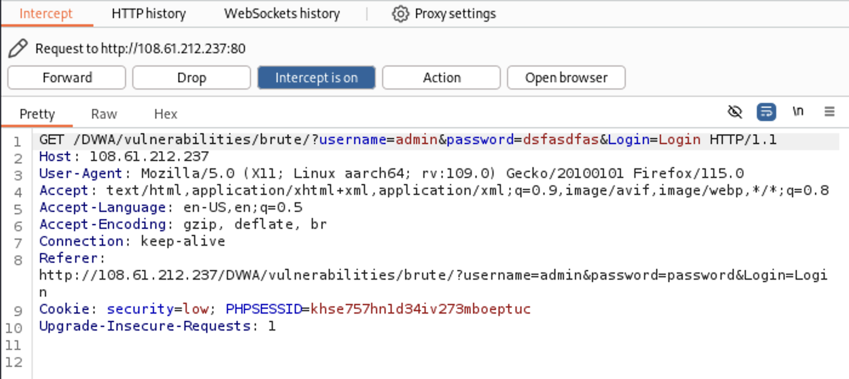

Figure 38 - Intercept request

1. Right-click on the page and select “Send to Intruder” to begin the brute force attack.

**Set Attack Positions in the Intruder**

1. Under the “Intruder” section, open the request sent from the proxy.
2. Click the “Position” tab to check attack points. On this page, we can see the request placeholder for username and password parameters.
3. We should clear the preset parameters and manually highlight the password parameters to set them as attack parameters.

Figure 39 shows the parameters cleared and then highlights the credentials that are going to be used for brute force.

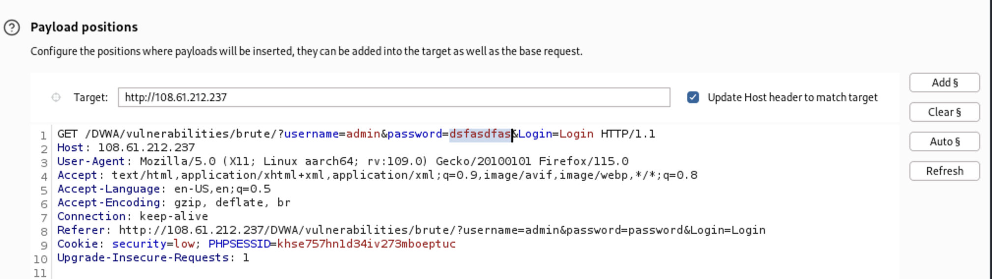

Figure 39 - Clear the preset parameters

1. After highlighting the password, click the add icon and set this attack as a “sniper” attack.

**Configure Payload for Brute-Force Attack**

1. Click the “Payload” section and choose a “Simple list” as a payload type. (e.g. can get from github user content password list and only a simple list due to the limitation of the community version).

Figure 40 shows that the payload is pasted from website lists that are used in this testing.

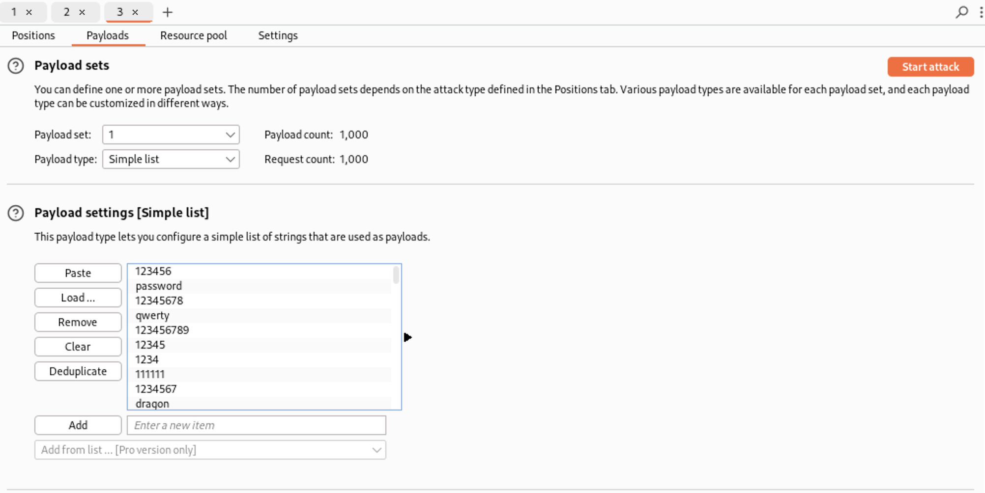

Figure 40 - Payload sample list

1. In the “Payload Option” section, add the password list that you want to use and then begin the testing.

**Start the Attack and Analyze the Results**

* 1. Upon clicking “Start Attack,” it will begin the process of brute force.
  2. Burp Suite Community will attempt each list and display it in the status field.
  3. We can Identify if it is successful by checking the HTTP response code and response length. The correct password will show a different response length than other failed attempts.

Figure 41 shows some details about the attack, and the results are successful.

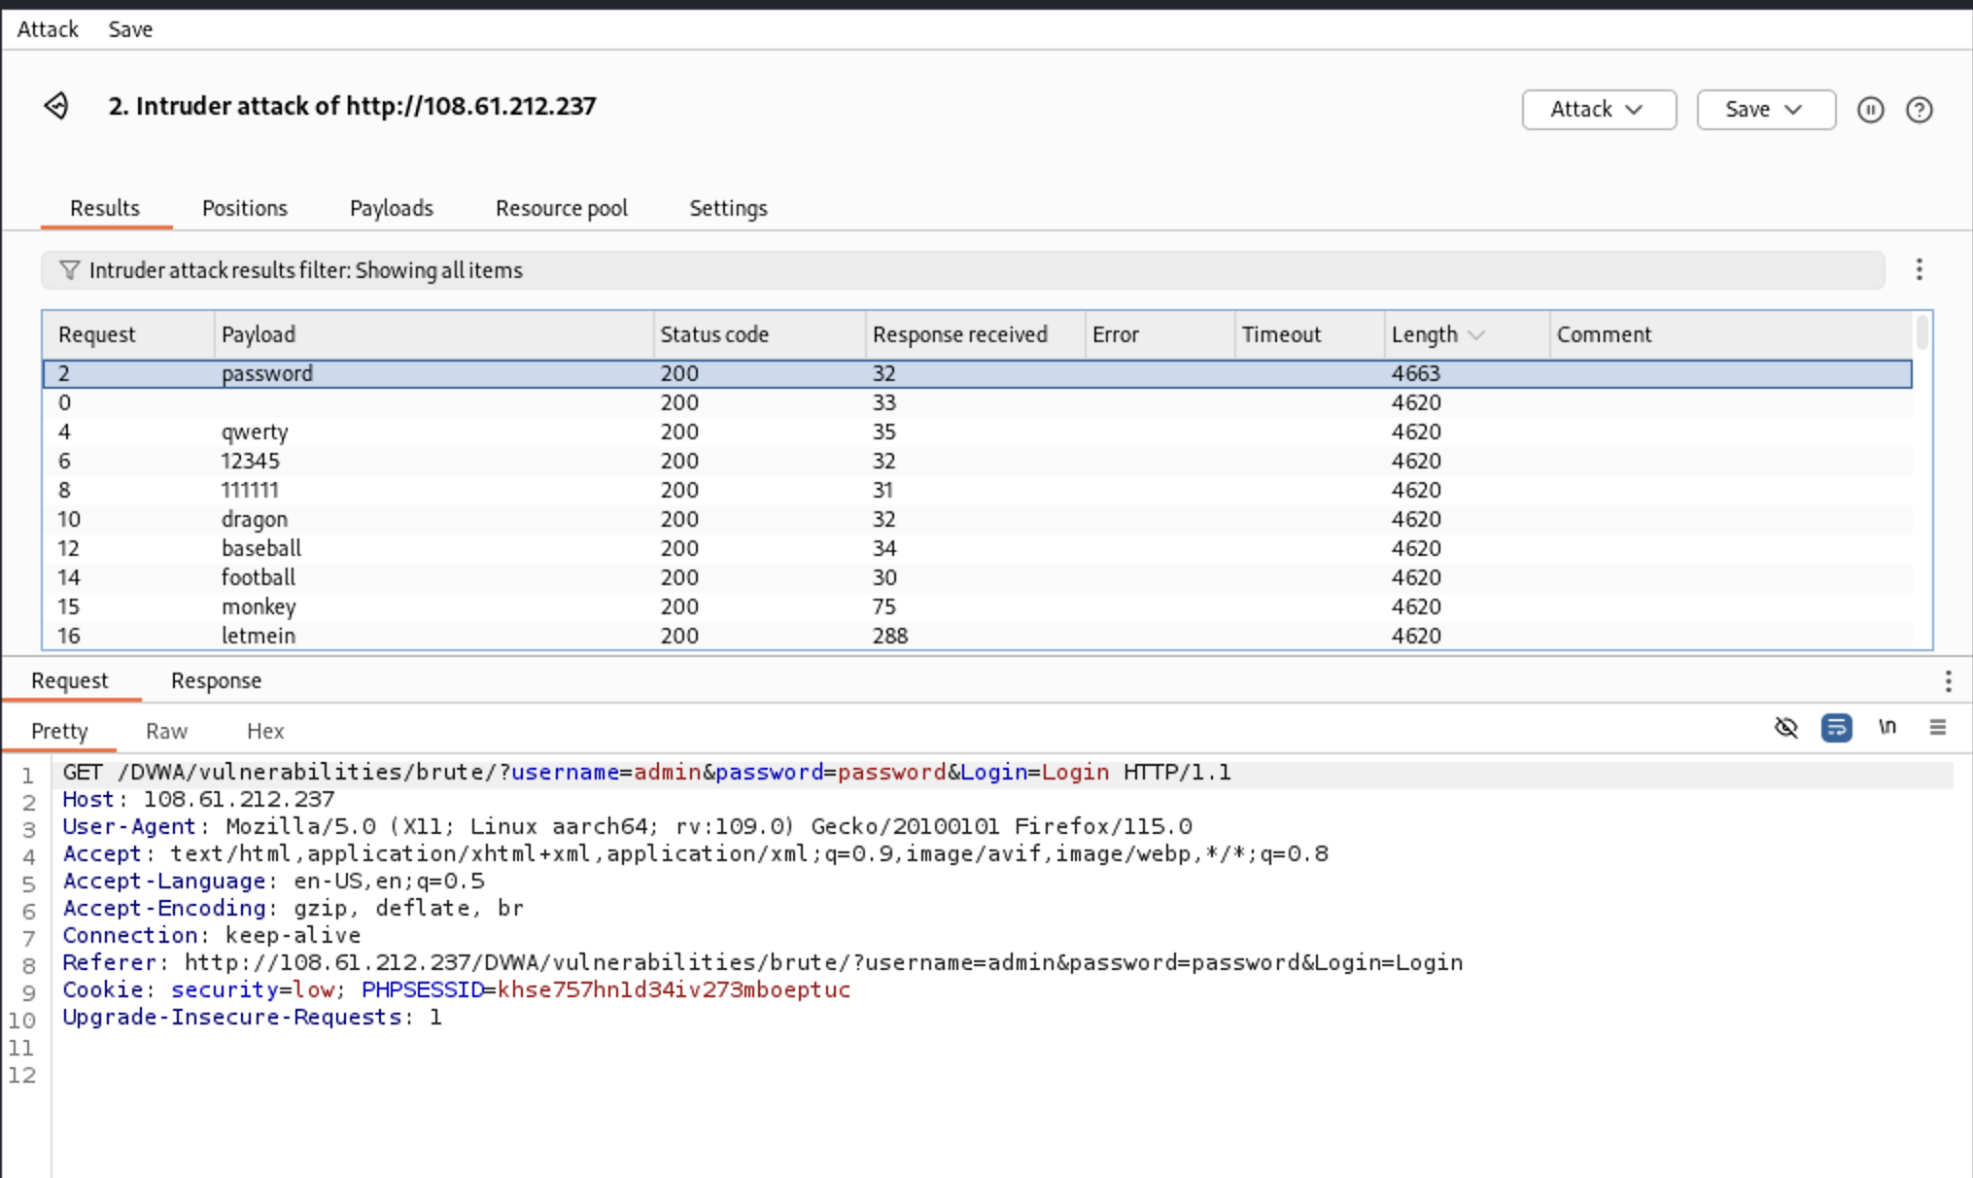

Figure 41 - Start the Attack and get a response

Document the findings and generate a report

1. Once we get the password verified. Document it using the performance metrics created in this project.
2. Include recommendations for the application and securing log-in from brute force attacks.

### 12.3 Wfuzz Tool Testing

Steps of use:

1. Open terminal
2. Select a password list in the drive.

/usr/share/wordlist/rockyou.txt

1. Log in to DVWA and provide credentials.
2. Under security, change the security level to low for this testing to check vulnerabilities.
3. Get the session ID by right-clicking somewhere on the screen. Select Inspect and click in the storage section.

Figure 42 shows the location of the session ID that is essential for using Wfuzz.

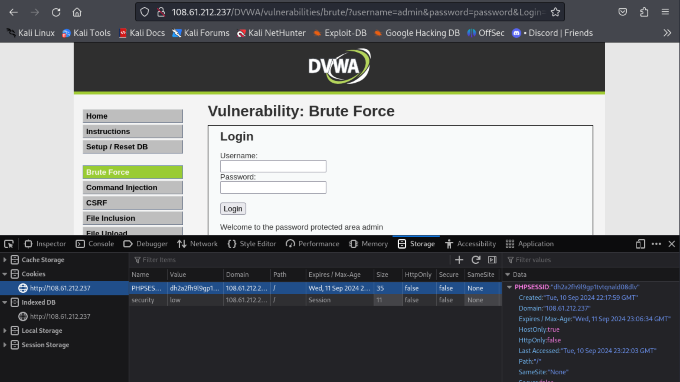

Figure 42 - Session ID for WFuzz

1. Copy the session ID that need to be put on the command in the terminal for web fuzzing.

Figure 43 shows that the session ID is under the “Value” section and copying it to the Wfuzz command.



Figure 43 - Copy Session ID

1. In the terminal use the command wfuzz -c -w /usr/share/wordlist/rockyou.txt followed by the security level, session id, and the web application address to begin the brute forcing.

Figure 44 shows the command used in the testing where we put the location of the text lists of passwords and setting security level, providing session ID, address of the target, and some commands used in Wfuzz.



Figure 44 - WFuzz command

1. Add this command after the web address.

Figure 45 shows the web fuzzing command used in Wfuzz.



Figure 45 - Command after web address

1. Result will be shown, parameters are different for the correct password.

Figure 46 shows the successful result where the character length is different from the rest of the password list.

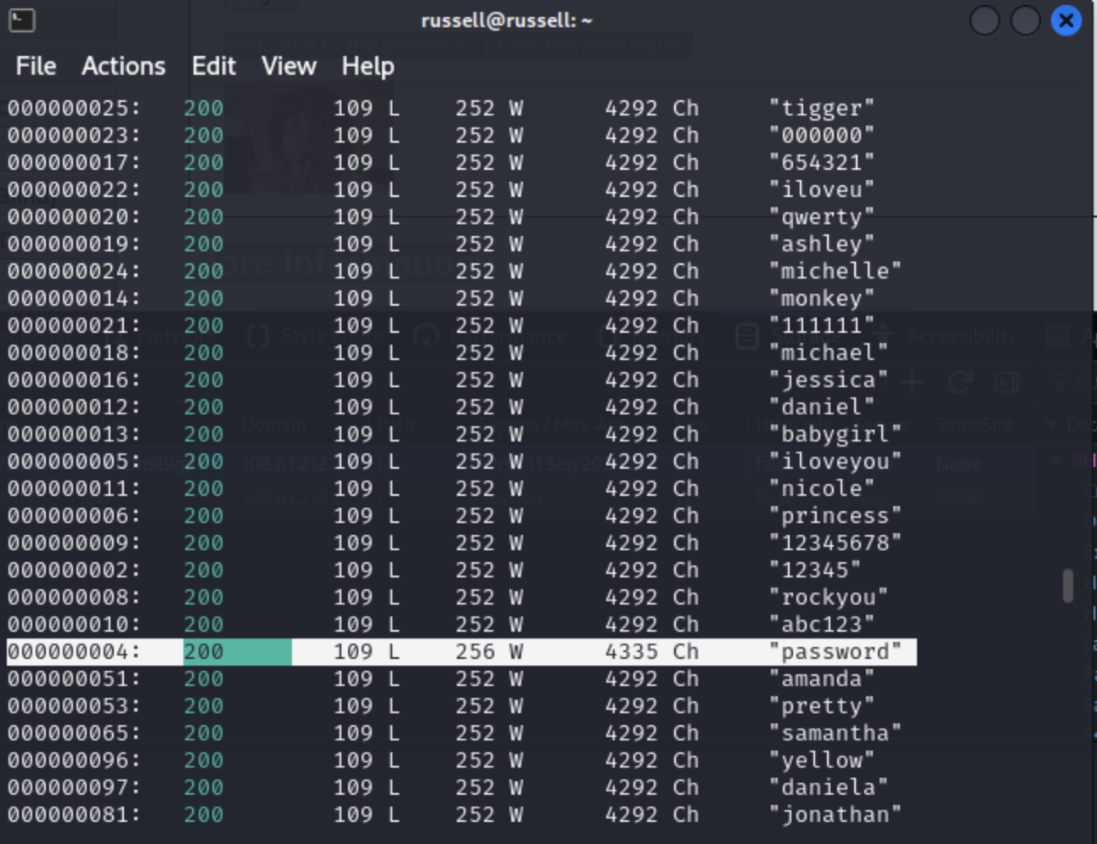

Figure 46 - WFuzz successful output

### 12.4 SQL Map Tool Testing

There are a few steps for SQL Map Testing.

* Prerequisites and setup
* Testing Steps

**Prerequisites and setup**

The current session ID is required while testing on DVWA. Also, the SQL Injection command field needs to be tracked to use in SQL Map.

**Testing Steps:**

**Step 1:**

Confirmation of SQL Injection in DVWA and retrieve the URL for further testing.

URL: http://108.61.212.237/DVWA/vulnerabilities/sqli/?id=1&Submit=Submit#

Figure 47 shows the successful injection in DVWA.

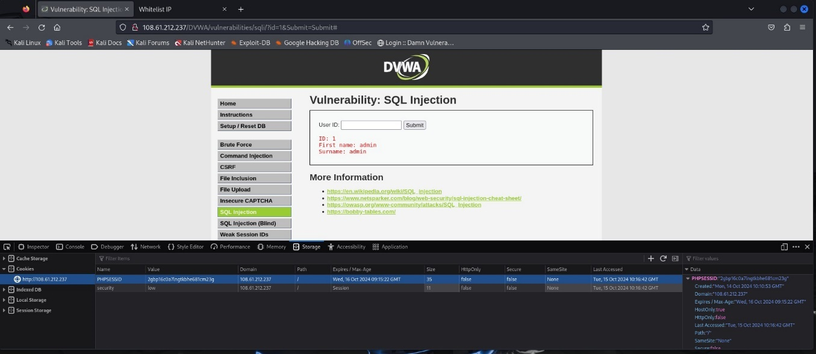

Figure 47 - Confirmation of SQL Injection in DVWA

**Step 2:**

Inject command in SQL Map for Penetration testing.

Command: sqlmap -u "http://108.61.212.237/DVWA/vulnerabilities/sqli/?id=1&Submit=Submit#" --cookie="PHPSESSID=2gbp16c0a7lngtkbhe681cm23g; security=low" --banner --current-user --current db –dump

Figure 48 shows that in the terminal, this command is use to activate SQL Map tool and injecting command for collecting information from the web application.

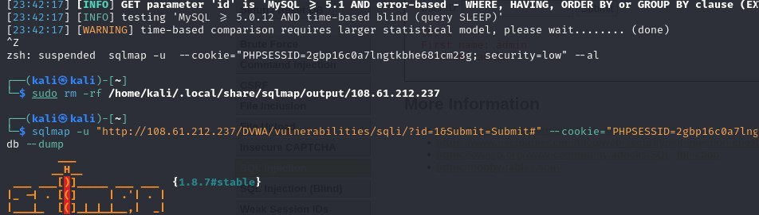

Figure 48 - Inject command in SQL Map for Penetration testing

**Step 3:**

Testing connection to the target URL

Testing if GET parameter is dynamic

Basic test shows that GET parameter might be injectable – MySQL

GET parameter appears to be Boolean based blind – injectable

Figure 49 shows that the tool is connected to the target web application using some GET parameters.

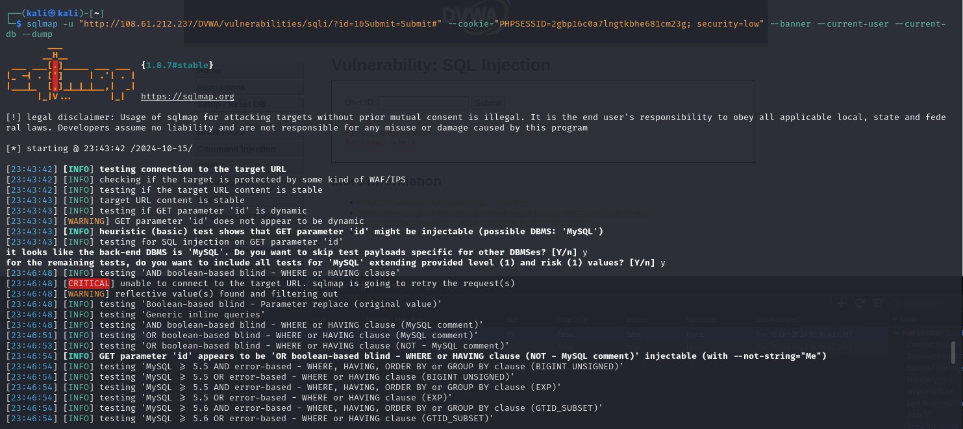

Figure 49 - Testing connection to the target URL

**Step 4:**

GET parameter appears to be MySQL >5.0.12 and time-based blind – injectable

GET parameter is MySQL Union query – 1 to 20 columns – injectable

System asking for other vulnerabilities – Yes

Figure 50 shows information about the Get parameter and “id” vulnerable and uses MySQL. The system asks if the user wants to get more information or further testing.

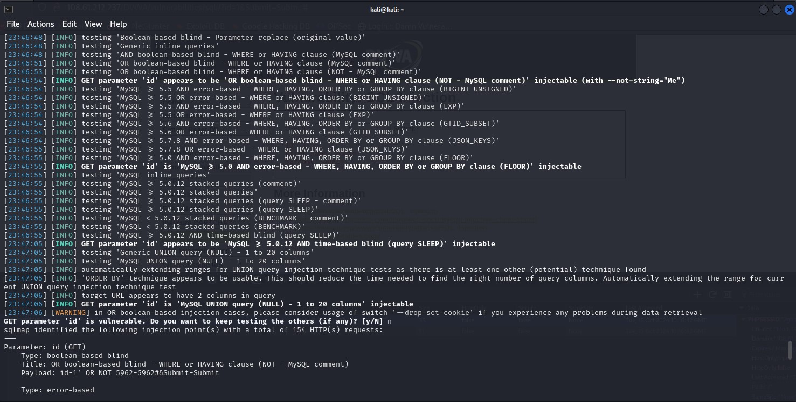

Figure 50 - GET parameter appears to be MySQL

**Step 5:**

Back-end information details were retrieved.

Storing hash values to a temporary file - yes

Cracking via dictionary-based attack – Yes

Figure 51 shows information about the hash value that is stored temporarily in a file location and asks if you want to proceed to crack the hash value into the correct password.

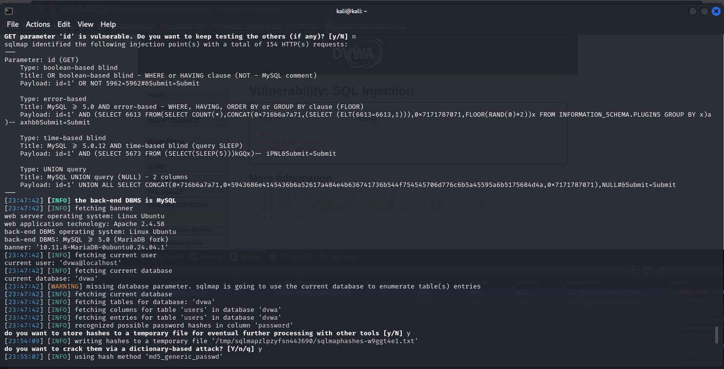

Figure 51 - Back-end information details were retrieved

**Step 6:**

Default dictionary file: ‘/usr/share/sqlmap/data/txt/wordlist.txt

Use common password suffix – Yes

Output:

Database: DVWA

Tables: users

Entries: 5

Hash Values: the password is retrieved as hash values for every user.

Cracking the hash values for every user’s password with details.

Figure 52 shows that the hash value has been converted to the correct password and successfully penetrated the system with the tool.

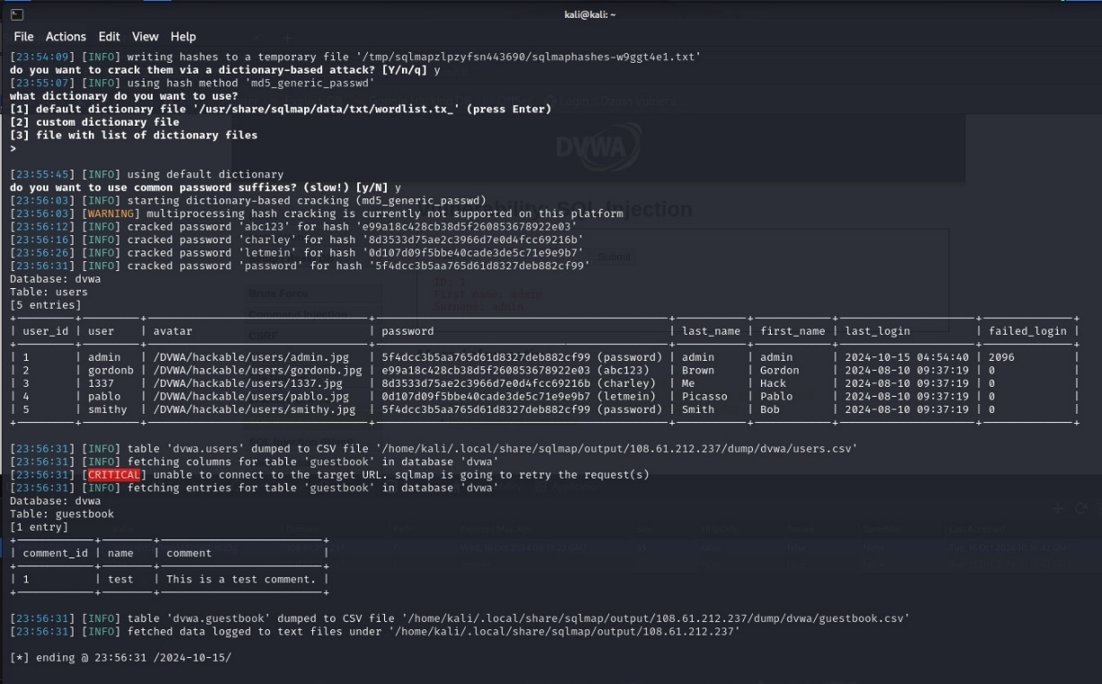

Figure 52 - Cracking the hash values for every user’s password with details

**Step 7:** To locate and remove the directory file for SQL Map output result (if required):

Command: sudo rm -rf /home/kali/.local/share/sqlmap/output/108.61.212.237

For Medium and High Security, “--data="id=1&Submit=Submit"” specifies HTTP Post parameters which is sent in the request. SQL Payload will try to inject into the id parameter. Submit=Submit is really important if this parameter is expected to process.

For Medium and High Security the command is:

sqlmap -u "http://108.61.212.237/DVWA/vulnerabilities/sqli/" --cookie="PHPSESSID=9e6mnhtrmkfco5v4e3o1i9nnkg; security=medium" --data="id=1&Submit=Submit" --batch db -dump

Figure 53 shows the medium security level parameters.

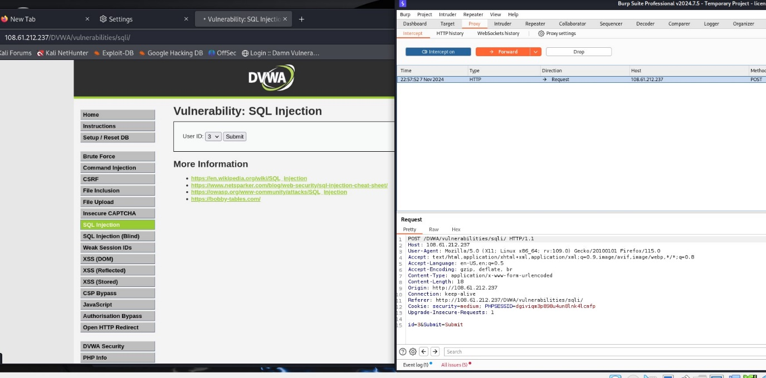

Figure 53 - Medium security level parameters

Figure 54 shows the high security level parameters.

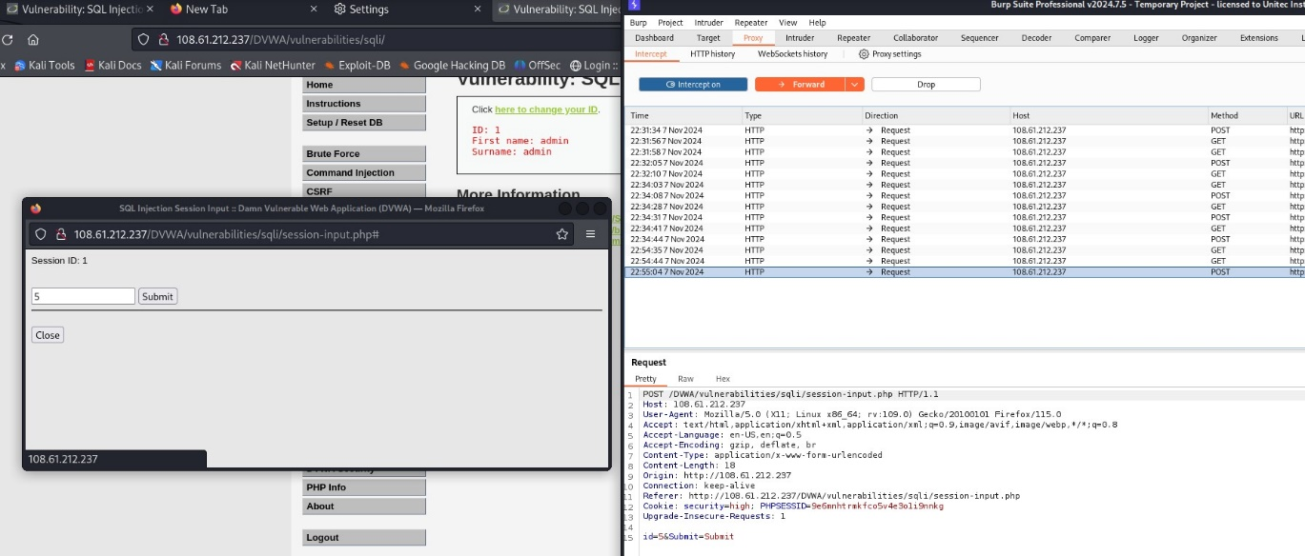

Figure 54 - High security level parameters

### 12.5 Hydra Tool Testing

Brute Force testing of the DVWA website using the Hydra tool

**Prerequisites:**

1. Hydra tool with rockyou.txt file preinstall in Kali Linux

2. DVWA website access login

3. Wifi access login

**Steps use:**

1. Set up the target website and launch the hydra tool in the Kali terminal.

2. Target **Login**: Admin **Password**: Admin

Figure 55 shows that the tester provides some wrong credentials to check system credentials and security.

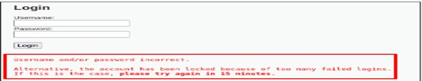

Figure 55 - Wrong Password credential

3. Configure and use command

Type: hydra -l admin -P /usr/share/wordlists/rockyou.txt 108.61.212.237 http-get-form “/DVWA/vulnerabilities/brute/index.php: userfield=USER:passwordfield=PASS -s80

Figure 56 shows the command used in the testing to brute force the system admin password credential.

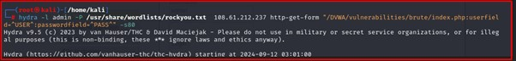

Figure 56 - Hydra target command

Figure 57 shows the successful attack and time it was started and it was finished.

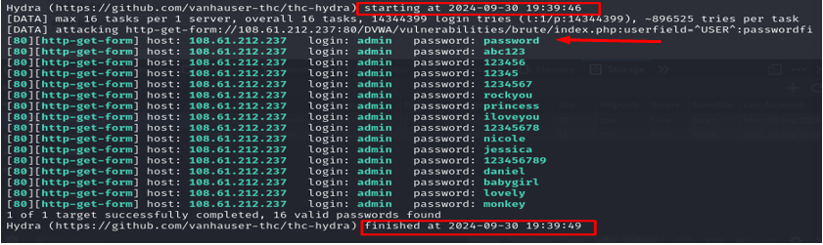

Figure 57 - Hydra successful scan

### 12.6 Nikto Tool Testing

**Prerequisites**

1. http://108.61.212.237/DVWA/login.php

2. Launch Nikto in Kali Terminal

3. Wifi login access

**Testing Steps:**

1. Set up

**Action**: Login to <http://108.61.212.237/DVWA/login.php>

**Type**: nikto -h scanme, nmap.org

2. Find port scan

**Type**: Nmap 108.61.212.237 -oG iplist.txt

**Type**: cat iplist.txt |grep “Ports: 80/open”

Figure 58 shows the command to use to get open port in the system.

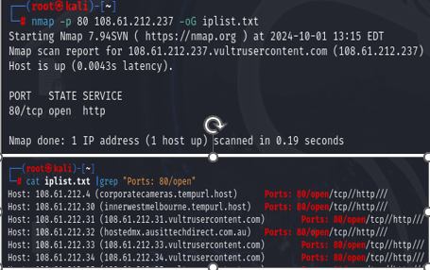

Figure 58 - Port scan results through Nmap

3. Create a script file using nano as seen below

Figure 59 command used to create script that will be use in the scanning.

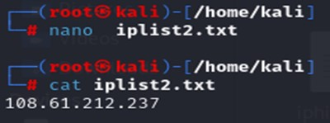

Figure 59 - script of target website:108.61.212.237, script filename: iplist2.txt

4. Initial Target Scan

Type Command: nikito -h iplist2.txt -o nikto_result.csv -Format csv

Figure 60 shows information about the target IP, Hostname, Port and time and date of the scan.

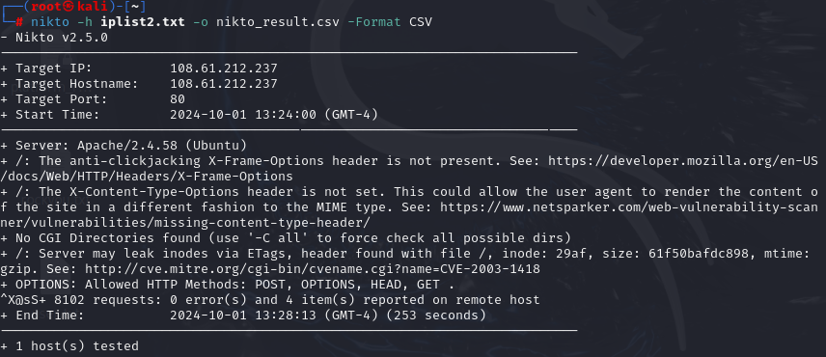

Figure 60 - Nikto scan result of website 108.61.212.237 in CSV format

5. Report and Review

Figure 61 shows the scanned results from the target web application, and the report was formatted in CVS.

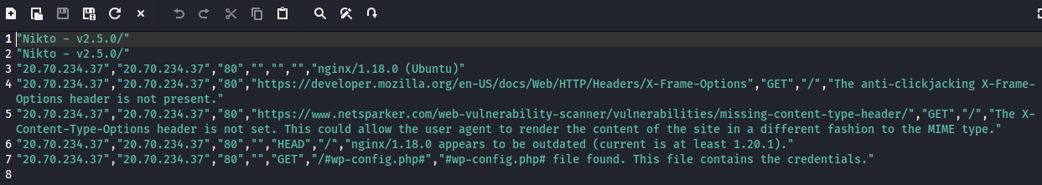

Figure 61 - iplist2.txt folder where scan report saves in CVS format

### 12.7 ZAP Tool Testing

To perform Testing using the ZAP tool, the steps as follows below:

**Prerequisites:**

1. DVWA website access login: https

2. OWASP Zap tool launch and rockyou.txt file implemented in Kali Linux/Window

3. Wifi Access:

**Steps use:**

1. Set up Launch Zap and load the target website to log in with the wrong credential below

2. Target Inputs: username: **admin** password: **admin**

Figure 62 shows the location of captured information from DVWA.



Figure 62 - Screenshot capture of DVWA Login monitoring in Zap tool

3. Launch Brute Force attack as follows: a) In the Sites tab, find the login URL b) Right-click and select **Attack>Fuzze**r function

Figure 63 shows the Manual Execution of a brute-force attack

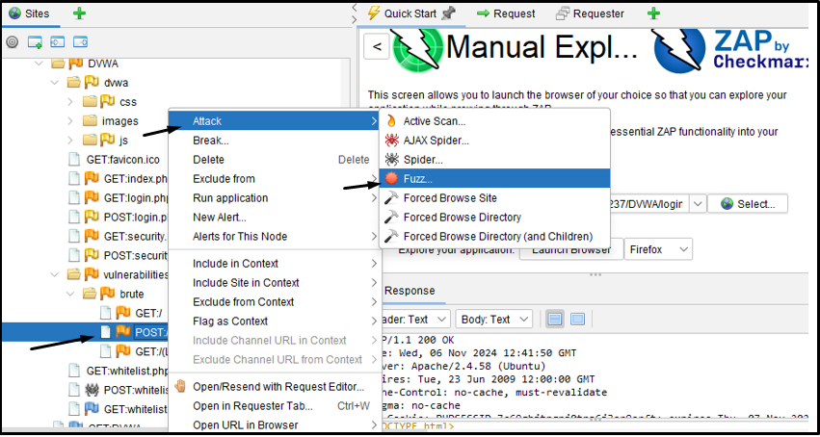

Figure 63 - Manual Execution of Brute Force Attack using Fuzzer

4. Highlight 1) username and password parameter. 2) Add to the Fuzz Location 3) Add Payload

Figure 64 shows that Zap uses a Fuzzer technique to brute force the system.

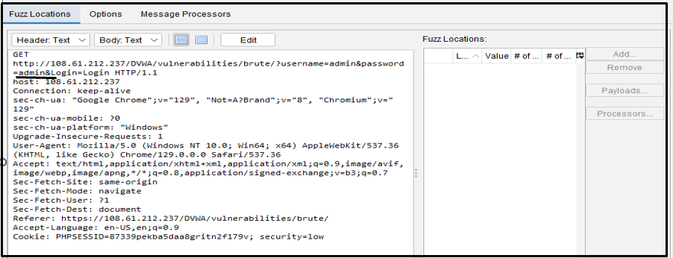

Figure 64 - Configure the brute force attack using Fuzzer

Initial scan

5. Steps: a) Browse to rockyou.txt. file. b) Select Add Payload. c)Select Start Fuzzer

Figure 65 shows where the location of the text file used for brute force attack.

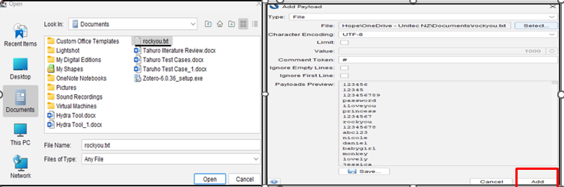

Figure 65 - Add rockyou.txt file to add payload for the initial attack

Figure 66 shows that after everything is configured then, click “Start Fuzzer” to proceed with the attack.

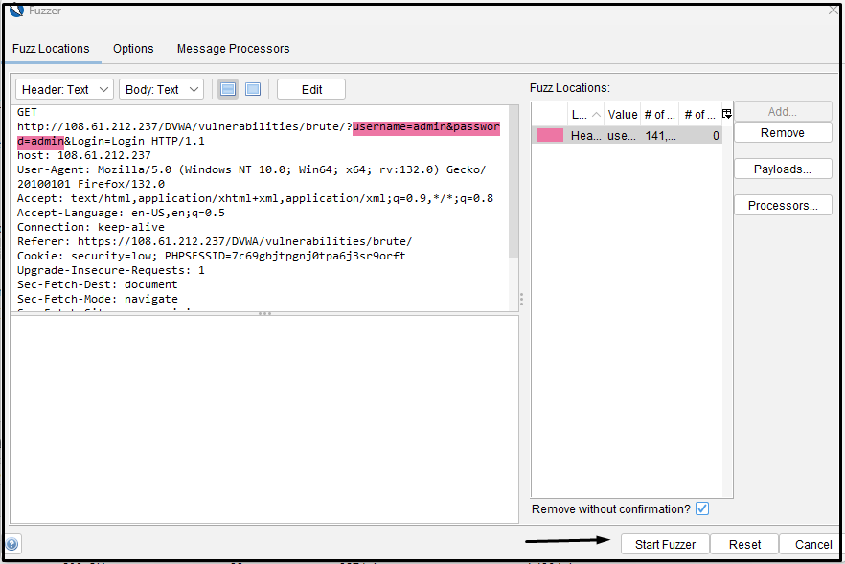

Figure 66 - Start Fuzzer Attack

Figure 67 shows the successful brute force of the web application using the Zap tool.

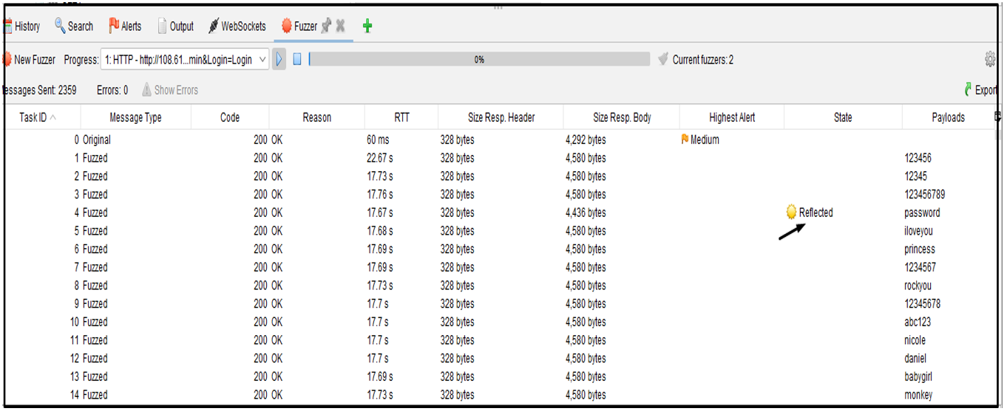

Figure 67 - Brute Force Scan Result Success

Figure 68 shows the scanning report of the Zap tool from the target web application including alerts and version of the tool during the testing.

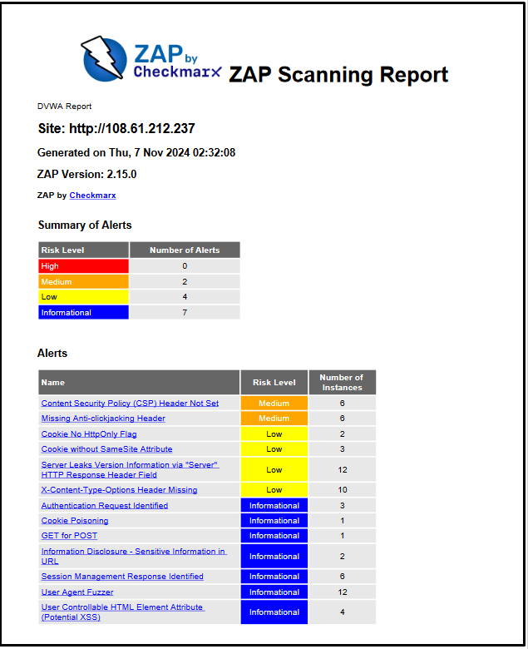

Figure 68 - Zap Test Result of DVWA website

## 13.0 Results & Evaluation

### 13.1 Burp Suite Professional Tool Results



Burp Suite Professional is an advanced penetration testing tool and web vulnerability scanner version of a Burp Suite. IT security professionals use it to identify and exploit security weaknesses in web applications. This version offers extra features for automated scanning and a toolkit for manual testing. Additionally, it offers customizable scan configuration and a powerful intruder for brute-force attacks and detailed reporting.

Table 5 provides detailed results and information from the Burp Suite Professional tool testing.

|  |  |  |  |  |
| --- | --- | --- | --- | --- |
| **Test Case Type:** | **Performance Criteria Evaluation** | **Test Case Version:** | | BurpSuite_01 |
| **Test Environment:** | Virtual Testing using Kali Operating System in VMWare Professional Machine | **Test Input:** | **Target Website:** IP: 108.61.212.237  <http://108.61.212.237/DVWA> | |
| **Tester Name:** | **Russell** | **Date of Testing:** | 3/10/2024 | |
| **Criteria Type** | **Tool Name: Burp Suite Professional** | **Test Comments** | |  |
| **Tool Type:** | Paid | This is license under PortSwigger Company | |  |
| **Version No:** | Used version for testing 2024.6.6  New Version 2024.8.3 | Latest Version automatically pop up when the app is opened. The new update is also available in the website. New version requires authorization from PortSwigger for our trial version. | |  |
| **Latest Update:** | October 7, 2024 | Frequently updated. Monthly or Bi-monthly | |  |
| **Cost Effective:** | Licensed $449 USD | Need to manually Download and install in Kali for testing. | |  |
| **Integration:** | **High** | Can implement with other web application penetration testing tools. | |  |
| **Ease of Use:** | **Moderate** | Comprehensive and needs tutorials or manual to use the application. | |  |
| **Accuracy:** | **High** | Identified web vulnerabilities thru brute force attack in web application DVWA. | |  |
| **Performance/Speed:** | **High** | Started 11:20:21  Finished 11:20:32 | |  |
| **Usability:** | **Moderate** | Installation in Kali is done using a command after downloading .sh installer. | |  |
| **Scalability:** | **High** | Burp Suite Professional can be install with different OS like Windows, macOS and Linux | |  |
| **Reporting:** | **High** | Detailed reporting sample from PortSwigger website. | |  |
| **Tool Strengths** | | **Tool Weaknesses** | | |
| * Comprehensive toolset * Automated scanning * Customizability * User-Friendly interface * Real-time result | | * Cost for the tool is expensive * Resource Intensive that cause low end computer to get issues * With too much features it requires lot of time to study and learn all. * Limited support for non-limited web application. * A possible false positive result and need other verification tools to get the right findings. | | |

Table 5 - Burp Suite Professional Tool Results

### 3.2 Burp Suite Community Tool Results



Burp Suite Community Edition is a free version of the penetration testing tool. This is primarily used by beginners and individuals doing basic web security testing. This tool includes core tools like intercepting proxy, repeater, and manual testing features. There is a lack of advanced features, such as automated scanning, extension tools, and customizable options only offered to the professional version, limiting the tool's scope.

Table 6 provides detailed results and information from the Burp Suite Community Edition tool testing.

|  |  |  |  |  |
| --- | --- | --- | --- | --- |
| **Test Case Type:** | **Performance Criteria Evaluation** | **Test Case Version:** | | BurpSuite_02 |
| **Test Environment:** | Virtual Testing using Kali Operating System in VMWare Professional Machine | **Test Input:** | **Target Website:** IP: 108.61.212.237  <http://108.61.212.237/DVWA> | |
| **Tester Name:** | **Russell** | **Date of Testing:** | 2/10/2024 | |
| **Criteria Type** | **Tool Name: Burp Suite Community Edition** | **Test Comments** | | **Artifacts** |
| **Tool Type:** | Free Version | This is free download on Portswigger website https://portswigger.net/burp/communitydownload | |  |
| **Version No:** | Latest Version: 2024.8.4 | Latest Version redownload from the website | |  |
| **Latest Update:** | October 8,2024 | Frequently updated, monthly of bi-monthly | |  |
| **Cost Effective:** | **Free** | Download free on Portswigger Website | |  |
| **Integration:** | **High** | Can implement with other web application penetration testing tools | |  |
| **Ease of Use:** | **Moderate** | Need to follow reliable tutorials and steps to use it. | |  |
| **Accuracy:** | **High** | Identified web vulnerabilities thru brute force attack in web application DVWA. | |  |
| **Performance/Speed:** | **High** | Started: 12:16:00  Finished: 14:33:39 | |  |
| **Usability:** | **High** | Burp Suite Professional can be install with different OS like Windows, macOS and Linux | |  |
| **Scalability:** | **High** | Used by beginners and individual for basic test of web application vulnerabilities. | |  |
| **Reporting:** | **Moderate** | Limited compared to Professional version | |  |
| **Tool Strengths** | | **Tool Weaknesses** | | |
| * Free and Accessible * Comprehensive Manual testing capabilities * Proxy for Intercepting traffic * Intruder for brute force * Support for basic web vulnerabilities * Platform for multiple OS (Windows, macOS, Linux) | | * No Automated scanning * Limited Intruder functionality * No extension support * No save and load functionality * No report generation * Manual testing only * No collaborator client * Limited project and task management | | |

Table 6 - Burp Suite Community Tool Results

Table 7 shows the test results and during each test. Each test was manually timed as the tool does not have a start and finish timer.

|  |  |
| --- | --- |
| **Burp Suite Professional** | **Test Duration and Result** |
| Low Security | Successful after 11 secs |
| Medium Security | 33minutes and 35 secs |
| High Security | Unsuccessful after 1 hour and 25 minutes and 33 seconds |
| **Burp Suite Community** |  |
| Low Security | Successful after 2 hours and 15 mins |
| Medium Security | Successful after 3 hours and 33 minutes |
| High Security | Unsuccessful after 1 hour and 25 minutes and 33 seconds |

Table 7 – Both version of Burp Suite Results

### 13.3 Wfuzz Tool Results

Table 8 provides detailed results and information from the Wfuzz tool testing.

|  |  |  |  |  |
| --- | --- | --- | --- | --- |
| **Test Case Type:** | **Performance Criteria Evaluation** | **Test Case Version:** | | 1 |
| **Test Environment:** | Virtual Testing using Kali Operating System in VMWare Fusion software | **Test Input:** | **Target Website:** IP: 108.61.212.237  <http://108.61.212.237/DVWA> | |
| **Tester Name:** | **Russell** | **Date of Testing:** | 10/10/2024 | |
| **Criteria Type** | **Tool Name: Webfuzz** | **Test Comments** | | **Artifacts** |
| **Tool Type:** | Open source | Already Installed in Kali Linux Operating system | |  |
| **Version No:** | Version 3.1.0 | Command in the terminal to check the version is wfuzz --version | |  |
| **Latest Update:** | August 2024 | <https://www.edge-security.com/wfuzz.php> | |  |
| **Cost Effective:** | Free | Package software application and brute-forcing tool | |  |
| **Integration:** | **High or moderate** | Can be integrated with another penetration testing tools. | |  |
| **Ease of Use:** | **High** | Need to get proper command to run and collect data from the application | |  |
| **Accuracy:** | **High** | Data was collected from providing proper command in the terminal | |  |
| **Performance/Speed:** | **Moderate** | 15:01  15:14  With multiple crashing the sytem. | |  |
| **Usability:** | **Moderate** | Only available in Kali Linux. | |  |
| **Scalability:** | **High** | Need to know commands in Linux terminal to use this tool. | |  |
| **Reporting:** | **Moderate** | Collection of data by screenshot in the terminal to get the password cracked. Parameter length of the correct password is different from other password lists. | |  |
| **Tool Strengths** | | **Tool Weaknesses** | | |
| * Multiple Injection points capability with multiple dictionaries * Recursion (When doing directory bruteforce) * Post, headers and authentication data brute forcing * Output to HTML * Colored output * Hide results by returning code, word numbers, line numbers, and regex. * Cookies fuzzing * Multithreading * Proxy support * SOCK support * Time delays between requests * Authentication support (NTLM, Basic) * All parameters brute forcing (POST and GET) * Multiple encoders per payload | | * Challenging beginners with the proper command line * No GUI * Limited in reporting * No SSL certificate handling * Slower than other alternatives. * Multiple crashes when testing the tools | | |

Table 8 - Wfuzz Tool Results

Table 9 shows the test results and during each test. Each test was manually timed as the tool does not have a start and finish timer.

|  |  |
| --- | --- |
| **Wfuzz** | **Test Duration and Result** |
| Low Security | Successful after 14 minutes, tested a few times with few system crashes. |
| Medium Security | Successful after 20 minutes, tested a few times with multiple crashes in the system. |
| High Security | Unsuccessful after 30 minutes, no filtering of parameters. |

Table 9 - WFuzz test result

### 13.4 SQL Map Tool Results

Table 10 provides detailed results and information from the SQL Map tool testing.

|  |  |  |  |  |
| --- | --- | --- | --- | --- |
| **Test Case Type:** | **Performance Criteria Evaluation** | **Test Case Version:** | |  |
| **Test Environment:** | Live Test using Windows Desktop and SQL Map Application | **Test Input:** | **Target Website**: 108.61.212.237 (DVWA) | |
| **Tester Name:** | **Tanveer** | **Date of Testing:** | 20/10/2024 | |
| **Criteria Type** | **Tool Name: SQL Map** | **Test Comments** | |  |
| **Tool Type:** | **Free** | Open-Source tool | |  |
| **Version No:** | Test version: 5.0.12 | This was the latest update available at the time of testing | |  |
| **Latest Update:** | N/A | N/A | |  |
| **Accuracy:** | **High** | Highly accurate for common vulnerabilities and manual verification | |  |
| **Integration:** | **High** | With multiple databases | |  |
| **Ease of Use:** | **Medium** | Available in Linux – easy to use | |  |
| **Cost Effective:** | **Free** | Free to Linux | |  |
| **Performance/Speed** | **Medium** | Success attempt 5.5 minutes | |  |
| **Usability:** | **Medium** | Operation through command | |  |
| **Scalability:** | **Medium** | Medium adaptable | |  |
| **Reporting:** | **High** | Output Details have many information | |  |
| **Tool Strengths** | | **Tool Weaknesses** | | |  |
| * Automation * Multiple database support * Free and Open-source | | * Limited customisation * Detection risk | | |  |

Table 10 - SQL Map Tool Results

For SQL Map, the most important part is getting the HTTP post parameters after injecting them. After the parameter is received, the SQL Map tool is able to get information with different security levels at the same time.

Table 11 compares different security level results of SQL Map Test.

|  |  |
| --- | --- |
| **SQL Map Tool – Security Level** | **Test Duration and Result** |
| Low Security | Successful after 5.5 minutes |
| Medium Security | Successful after 8.5 minutes |
| High Security | Successful after 12 minutes |

Table 11 - SQL Map Tool security level comparison

### 13.5 Hydra Tool Results

Tester Experience – The Hydra scan result was noted as the fastest to complete; however, multi-testing is to be considered and requires manual comparison of result if not false positive.

Table 12 provides detailed results and information from the Hydra tool testing.

|  |  |  |  |  |
| --- | --- | --- | --- | --- |
| **Test Case Type:** | **Performance Criteria Evaluation** | **Test Case Version:** | | Hydra_01 |
| **Date of Testing:** | 1/10/2024 | **Test Input:** | Target Website: 108.61.212.237  Tool use: Hydra | |
| **Tester Name:** | **Hope** | **Test Environment:** | VMWare Kali Machine | |
| **Criteria Type** | **Tool Name: HYDRA** | **Test Comments** | | **Artifacts** |
| **Tool Type:** | Open-Source Tool | This is Licensed AGPLv3 | |  |
| **Version No:** | Hydra 9.5 | Latest Version found in GitHub | |  |
| **Latest Update:** | Jun 12, 2023 | Frequently updated by the Developer | |  |
| **Accuracy:** | **High** | Identified valid credentials without false positive | |  |
| **Integration:** | **High** | Automate can brute-force, with Nmap, to find the open port -s80 | |  |
| **Ease of Use:** | **High** | Requires understanding of command syntax | |  |
| **Cost Effective:** | **Free** | It is already installed in Kali | |  |
| **Performance/Speed:** | **High** | Started 2024-09-30 19:39:46  Finished 2024-09-30 19:39:49 | |  |
| **Usability:** | **High** | Also available in the Hydra-graphical feature | |  |
| **Scalability:** | **Moderate** | Not natively designed for commercial or large distributed system | |  |
| **Reporting:** | **Moderate** | For CLI only | |  |
| **Tool Strengths** | | **Tool Weaknesses** | | |
| * Hydra Supports Multiple Protocols * Fast and efficient * Open Source * Integration with other tools * Supports Large Wordlists | | * Limited Reporting and Output * Consumes significant CPU, Memory, and Network bandwidth * Requires careful ethical/legal consideration * Requires Manual Handling of Complex Logins | | |

Table 12 - Hydra Tool Results

Table 13 compares different security level results of Hydra Tool.

|  |  |  |  |  |
| --- | --- | --- | --- | --- |
| Performance Criteria on DVWA Website Level of Security | | | | |
| Description: Testing scan of Level of Security | **Preconditions:**   * VMware Kali Linux * Internet Access * DVWA website login | | **Target Method:** Brute Force on weak password | |
| Tool Type | **Low** | **Medium** | **High** |  |
| Hydra | **Success attempt** Start 09:05:54  Done 09:05:56 | **Success** attempt  Start 09:06:55  Done: 09:06:58 | **Success** attempt  Start 09:08:47  Finished 09:08:49 |  |

Table 13 - Security level results of Hydra Tool

Figure 69 shows medium level results for Hydra tool

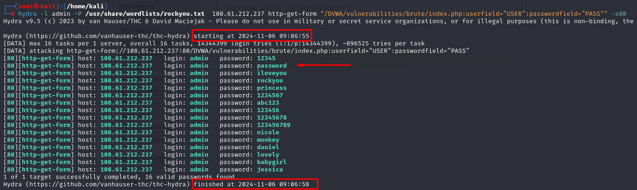

Figure 69 - Medium Level Result

Figure 70 shows medium level results for Hydra tool



Figure 70 - High-Level Result

### 13.6 Nikto Tool Results

Table 14 provides detailed results and information from the Nikto tool testing.

|  |  |  |  |  |
| --- | --- | --- | --- | --- |
| **Test Case Type:** | **Performance Criteria Evaluation** | **Test Case Version:** | |  |
| **Test Environment:** | Virtual Testing using Kali Operating System in VMWare Professional Machine | **Test Input:** | **Target Website:** 108.61.212.237  Scanme.nmap.org  Iplist.txt, iplist2.txt, nikto_result.csv | |
| **Tester Name:** | **Hope** | **Date of Testing:** | 2/10/2024 | |
| **Criteria Type** | **Tool Name: Nikto** | **Test Comments** | |  |
| **Tool Type:** | Open-Source Tool | This is licensed under the GNU copyright | |  |
| **Version No:** | Nikto 2.5.0 | Latest Version found in GitHub | |  |
| **Latest Update:** | Dec 4, 2023 | Not Frequently updated | |  |
| **Cost Effective:** | **Free** | It is already installed in the Kali | |  |
| **Integration:** | **High** | It can be implemented with Burp Suite, Nmap | |  |
| **Ease of Use:** | **High** | Requires understanding of command syntax | |  |
| **Accuracy:** | **High** | We identified web vulnerabilities but required manual validation of the findings. | |  |
| **Performance/Speed:** | **High** | Started 13:24:00  Finished 13:28:13 | |  |
| **Usability:** | **Moderate** | Easy to install, CLI operates only, which may be a disadvantage to beginners. | |  |
| **Scalability:** | **Moderate** | Not natively designed for commercial or large distributed system | |  |
| **Reporting:** | **High** | Available in HTML, text as well | |  |
| **Tool Strengths** | | **Tool Weaknesses** | | |
| * Open-Source tool * Supports various output format * Integrate with other tools, systems, and reporting platform * Fast Set up run with Windows, Linux, MacOS | | * Prone to False Positives needs to verify the result manually * Can be time-consuming and slow * No Graphic User interface * Outdated Findings might miss the latest vulnerabilities | | |

Table 14 - Nikto Tool Results

### 13.7 ZAP Tool Results

Tester experience – Before the full scan was completed, high-level results in 69ms RTT success attempts faster than low-security results; however, it does not fully tell whether a password has been found.

Scan completion was long; unfortunately, the resulting output didn’t record a start or finish time.

Table 15 provides detailed results and information from the Zap tool testing.



|  |  |  |  |  |
| --- | --- | --- | --- | --- |
| **Test Case Type:** | **Performance Criteria Evaluation** | **Test Case Version:** | |  |
| **Test Environment:** | Live Test using Windows Desktop and Zap Application | **Test Input:** | **Target Website**: 108.61.212.237   Rockyou.txt file   Low-Level Security | |
| **Tester Name:** | **Hope** | **Date of Testing:** | 15/10/2024 | |
| **Criteria Type** | **Tool Name: ZAP** | **Test Comments** | |  |
| **Tool Type:** | **Free** | Open-Source tool | |  |
| **Version No:** | Test version: 2.15.0 | This was the latest update available at the time of testing | |  |
| **Latest Update:** | Oct 1,2024 | Introduced new features support for third-party | |  |
| **Accuracy:** | **High** | Highly accurate for common vulnerabilities and manual verification | |  |
| **Integration:** | **High** | Has a GitLab CI and Jenkins plugin | |  |
| **Ease of Use:** | **High** | Available in Windows, macOS, and Linux. It is recommended for both beginners and professionals. | |  |
| **Cost Effective:** | **Free** | Free to download on WinOS, macOS and Linux | |  |
| **Performance/Speed** | **High** | Success attempt 4.04 secs | |  |
| **Usability:** | **High** | GUI is user-friendly compared to other tools | |  |
| **Scalability:** | **High** | Highly adaptable, allows functions add-ons, and can suit more complex testing. | |  |
| **Reporting:** | **High** | Customisable Reports details in low, medium, high | |  |
| Report Findings | Go to **Reports > Generate Report** | **Successful brute force attempts** return a **200 OK status** | |  |
| **Tool Strengths** | | **Tool Weaknesses** | | |  |
| * Free and Open Source * Ease of use – also has Quick Start feature * Enabling automated testing * Active Community and Regular updates | | * False Positives where vuln are flagged but do not exist * Performance limitations depth for advanced exploits * Consume a lot of system resource | | |  |

Table 15 - ZAP Tool Results

Table 16 compares different security level results of the ZAP Tool.

|  |  |  |  |
| --- | --- | --- | --- |
| Performance Criteria on DVWA Website Level of Security | | | |
| Description: Testing scan of Level of Security | **Preconditions:**   * VMware Kali Linux * Internet Access * DVWA website login | | **Target Method:** Brute Force on weak password |
| Tool Type | **Low** | **Medium** | **High** |
| ZAP | **Success attempt**  in 78ms RTT  Start 12.47 pm  Completed scan 75% 12 am | **Success** attempt  In 65ms RTT | **Success** attempt  in 69ms RTT  Start 3.30 with 1% scan complete |

Table 16 - Security level results of ZAP Tool

Figure 71 shows the start Time 12:47 pm of the attack.

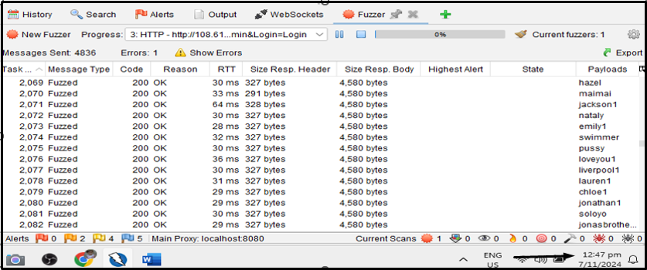

Figure 71 - Attack start Time 12:47 pm

Figure 72 shows the high-level scan of the attack.

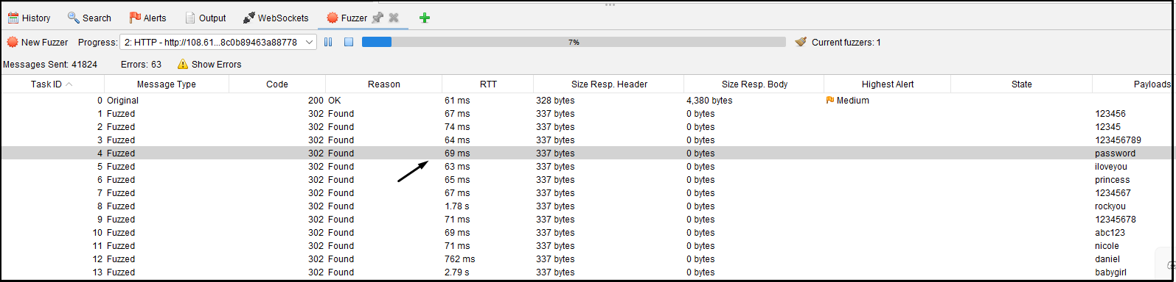

Figure 72 - High-Level scan Result

## 14.0 Impacts

### 14.1 Research Benefits for New Zealand

Our project design aims to empower New Zealand organisations in selecting appropriate testing tools, a critical step toward strengthening cybersecurity frameworks for individuals and small to medium-sized enterprises [15] [16], which account for 97% of all businesses and contribute approximately 28% of the country’s GDP to defend against the growing risks of cyber threats [17].

As 43% of cyberattacks target SMEs globally, Taruho's research identifies and assesses practical, user-friendly tools to enhance penetration testing for web application vulnerabilities and support scalable best practice-aligned security [18]. By focusing on free and open-source tools, this project is designed to support a pathway for small businesses to protect digital assets affordably.

Figure 73 shows Industry statistics for Maori and Pasifika community.

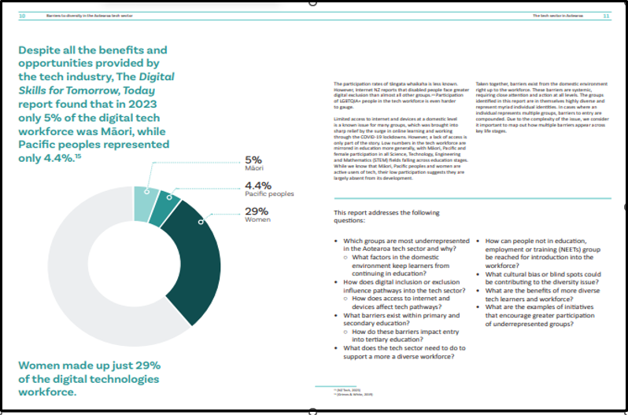

Figure 73 - Digital Tech Industry Statistics for Maori and Pasifika according to Digital Skill Aotearoa

### 14.2 Research benefits for communities such as Māori and Pacific

There is a more vital need for education and upskilling in cybersecurity. Statistics show that Maori comprise 5% of the IT workforce, while Pacific people account for 4.2%. [19]. Furthermore, our research strives to build and be incredibly impactful for Maori and Pacific communities, who face increased risks due to limited access to cybersecurity resources and are also part of the SME innovations. [20]

### 14.3 Summary of Impacts

Beyond technology, this initiative addresses New Zealand's social landscape by working to bridge the digital divide, promoting a more inclusive, skilled, and resilient digital ecosystem. Through this approach, we strengthen cybersecurity frameworks for SMEs and individual startups and contribute to developing a diverse talent pipeline essential for New Zealand’s broader economic and social resilience. Please refer to the “Impact” section of the appendix for more charts.

## 15.0 Change/Risk Management

### 15.1 Change Management Plan

The purpose of a Change Management plan is to manage and control any adjustments that might occur in our project scope, timeline, or resources and to maintain the aim of the project objectives. We have established a structured Change Request Process if we need to change something. This begins with Initiation, which is done when team members or stakeholders submit a Change Request Form and explain the detailed reason for the change and a proposal for the new scope. It is then evaluated during the evaluation phase, during which the project manager will assess the impact of the proposal change's scope, timeline, budget, and resources. If this needs approval, it will be presented to the project sponsor, Andrew David, and key stakeholders for review and authorisation.

When the changes are approved, implementation can take place, which involves the adjustment of the project plan, and documents should also be updated with the new scope. Lastly, the changes should be communicated to all the team members, and a meeting should be held to discuss the changes in the project's scope.

The plan should monitor some key areas: first is the adjustment of the project scope, which could involve adding or removing tools from the analysis; the timeline for testing might change in the work breakdown structure and may require some modification in our schedule due to unexpected results and technical problems; resource allocation if there are some delays might also change the schedule of our testing and analysis, there might be an unforeseen technical requirement within the environment of the testing. With a prepared and structured approach, we ensure that if there are changes, we can manage them efficiently and still produce a successful project outcome.

### 15.2 Risk Management Plan

Our project has identified some key risks that might impact the success that we want to aim. Tool Evaluation Inaccuracy might be a risk due to the inconsistency of a tool’s performance with different environments, which can cause inconsistent evaluation results. This risk is considered possible and has a major impact on our project. We created a standard testing environment to mitigate this problem so that we have consistent results across different devices of each team member. The project team is responsible for this risk and remains open.

 If one of the team members is injured, a risk management plan prioritises the continuity of the project and the unwell member's well-being. The injured team member’s responsibility will be temporarily assigned and divided to another member to ensure that the project is still on time with the task. To manage the workload, we plan to distribute the task to each member’s skills and availability, adjust the deadline if needed, and inform the project manager about the situation. If the injured person returns soon, they will be gradually given a task as their responsibility. This approach minimises delays in team projects and provides good team morale and project momentum.

Furthermore, technical issues with the tools or the test environment are another risk. There might be compatibility or configuration issues that might occur in testing tools or the DVWA setup, which could delay testing some tools. This risk has a moderate impact and will be addressed by conducting preliminary testing and troubleshooting; project stakeholder Justin Ng is ready to help us with the web application and give us suggestions for tool troubleshooting.

Another risk is data loss or corruption. Although it might not occur, the impact would be high if the testing data and configuration files are lost, as we need to redo it again. To mitigate this, we suggested that each team member have backup files and version control for testing and results. Scope creep is also a possible risk; this means that the project scope needs to be expanded or needs to have additional tool comparisons or metrics, which leads to a high impact on the project. To manage this risk, we created a change management plan which the project manager can check for approval.

Lastly, the risk of insufficient testing time will likely happen, given the challenges of tutorials from different resources and what we should use for the testing. This has a major impact on the project, and to mitigate this, we created a well-defined timeline for testing and distributed tools to test with each team member and share the results with everyone.  Please see the appendix for the Project Risk Register, Issue Register and Risk Matrix

## 16.0 Conclusion and Lessons Learned

### 16.1 Project Summary and Significant Project Outcome

This penetration testing followed a methodical way to find out the vulnerability of web applications. Proper testing methods were used to identify in a safe environment. This project aimed to test Damn Vulnerable Web Applications (DVWA) with the help of well-known penetration testing tools such as Burp Suite, SQL Map, WFuzz, Hydra and OWASP ZAP. Each tool was assessed based on multiple criteria based on different security levels, and the source code of each security level is carefully analysed for future reference. When it comes to finding vulnerabilities such as brute force and SQL injection, this research project illustrates the actual importance of choosing the right penetration testing tools for web application testing. Based on the findings and comparison of the testing tools, it is evident that Burp Suite will be highly recommended among the tools. As this research project is properly documented, it is ensured that these testing procedures are followed according to the framework.

### 16.2 Evaluation of current and future Projects

Continuously new threats are emerging, and it is really important to improve the efficiency of the tools after evaluating the performance of this project. In future, mobile applications and other platforms can be tested to extend this project work to find more vulnerable aspects of the program. The implementation of cloud-based testing frameworks, such as machine learning security, can be included, which will bring more meaningful results. This project will work as proactive threat prevention for current and upcoming cybersecurity projects as it is based on complete penetration testing procedures.

## 17.0 References

[1] E. Gürel, “SWOT ANALYSIS: A THEORETICAL REVIEW,” *J. Int. Soc. Res.*, vol. 10, pp. 994–1006, Aug. 2017, doi: 10.17719/jisr.2017.1832.

[2] M. Albahar, D. Alansari, and A. Jurcut, “An Empirical Comparison of Pen-Testing Tools for Detecting Web App Vulnerabilities,” *Electronics*, vol. 11, no. 19, Art. no. 19, Jan. 2022, doi: 10.3390/electronics11192991.

[3] T. Guarda, W. Orozco, M. F. Augusto, G. Morillo, S. A. Navarrete, and F. M. Pinto, “Penetration Testing on Virtual Environments,” in *Proceedings of the 4th International Conference on Information and Network Security*, Kuala Lumpur Malaysia: ACM, Dec. 2016, pp. 9–12. doi: 10.1145/3026724.3026728.

[4] B. Khan, J. Bangash, M. Tariq, N. Gul, S. Zahir, and A. Kamal, “A Comparative Model to Analyze Various Web Application Penetration Testing Tools for Different Vulnerabilities,” Jul. 2023.

[5] “OWASP Top Ten | OWASP Foundation.” Accessed: Nov. 05, 2024. [Online]. Available: https://owasp.org/www-project-top-ten/

[6] W. G. J. Halfond, S. R. Choudhary, and A. Orso, “Improving penetration testing through static and dynamic analysis,” *Softw. Test. Verification Reliab.*, vol. 21, no. 3, pp. 195–214, Sep. 2011, doi: 10.1002/stvr.450.

[7] J. Shahid, M. K. Hameed, I. T. Javed, K. N. Qureshi, M. Ali, and N. Crespi, “A Comparative Study of Web Application Security Parameters: Current Trends and Future Directions,” *Appl. Sci.*, vol. 12, no. 8, p. 4077, Apr. 2022, doi: 10.3390/app12084077.

[8] J. Fonseca, M. Vieira, and H. Madeira, “Testing and Comparing Web Vulnerability Scanning Tools for SQL Injection and XSS Attacks,” in *13th Pacific Rim International Symposium on Dependable Computing (PRDC 2007)*, Melbourne, Australia: IEEE, Dec. 2007, pp. 365–372. doi: 10.1109/PRDC.2007.55.

[9] M. Albahar, D. Alansari, and A. Jurcut, “An Empirical Comparison of Pen-Testing Tools for Detecting Web App Vulnerabilities,” *Electronics*, vol. 11, no. 19, p. 2991, Sep. 2022, doi: 10.3390/electronics11192991.

[10] H. M. Z. A. Shebli and B. D. Beheshti, “A study on penetration testing process and tools,” in *2018 IEEE Long Island Systems, Applications and Technology Conference (LISAT)*, Farmingdale, NY: IEEE, May 2018, pp. 1–7. doi: 10.1109/LISAT.2018.8378035.

[11] S. Nagpure and S. Kurkure, “Vulnerability Assessment and Penetration Testing of Web Application,” in *2017 International Conference on Computing, Communication, Control and Automation (ICCUBEA)*, PUNE, India: IEEE, Aug. 2017, pp. 1–6. doi: 10.1109/ICCUBEA.2017.8463920.

[12] K. Barik, A. Abirami, S. Das, K. Konar, and A. Banerjee, “Penetration Testing Analysis with Standardized Report Generation:,” presented at the 3rd International Conference on Integrated Intelligent Computing Communication & Security (ICIIC 2021), Bangalore, India, 2021. doi: 10.2991/ahis.k.210913.045.

[13] sullo, *sullo/nikto*. (Nov. 06, 2024). Perl. Accessed: Nov. 06, 2024. [Online]. Available: https://github.com/sullo/nikto

[14] “The ZAP Homepage,” ZAP. Accessed: Nov. 06, 2024. [Online]. Available: https://www.zaproxy.org/

[15] A. Hunt, “Check out the NZ 2024 SME Cyber Behaviour Tracker,” IT Solutions and Managed Services. Accessed: Nov. 02, 2024. [Online]. Available: https://kinetics.co.nz/check-out-the-nz-2024-sme-cyber-behaviour-tracker/

[16] “SMEs urged to act now as cyber threats surge in New Zealand.” Accessed: Nov. 02, 2024. [Online]. Available: https://www.insurancebusinessmag.com/nz/news/cyber/smes-urged-to-act-now-as-cyber-threats-surge-in-new-zealand-505416.aspx

[17] N. Z. M. of F. A. and Trade, “Supporting SMEs,” New Zealand Ministry of Foreign Affairs and Trade. Accessed: Nov. 02, 2024. [Online]. Available: https://www.mfat.govt.nz/en/trade/free-trade-agreements/free-trade-agreements-in-force/cptpp/supporting-smes

[18] “OWASP Web Security Testing Guide | OWASP Foundation.” Accessed: Nov. 02, 2024. [Online]. Available: https://owasp.org/www-project-web-security-testing-guide/

[19] “Digital Skills for Tomorrow, Today.” [Online]. Available: https://nztech.org.nz/wp-content/uploads/sites/8/2023/08/NZTech-Digital-Skills-Report_final.pdf

[20] J. Hendy, “Digital inclusion and wellbeing in New Zealand”.

## 18.0 Appendices

### 18.1 Signed Individual Contribution Statement

**Project Title:** Comparative Analysis of Penetration Testing Tools in Assessing Web Application Vulnerabilities

**Project Start: 22/07/2024**

**Project Finish:22/11/2024**

**Contributor: Tanveer Ahmed Osman**

**Role: Project Manager**

**Contribution Statement:**

In our Capstone project, I conducted overall web application security vulnerabilities. I used industry-standard tools like Burp Suite and SQL Map. Based on different security levels, I tested the tools which stimulated real-life testing. All the testing results are also documented. I identified different areas of improvement and made recommendations for the proper tool. Also, I focused on a cost-effective solution for the businesses. I designed the project in such a way that it will be helpful for cybersecurity professionals and contribute to society.



Tanveer Ahmed Osman

10/11/2024

**Project Title:** Comparative Analysis of Penetration Testing Tools in Assessing Web Application Vulnerabilities

**Project Start: 22/07/2024**

**Project Finish:22/11/2024**

**Contributor: Jun Russell Ragasa**

**Role: Penetration Tester**

**Contribution Statement:**

I actively contributed to this project as a tools tester, mostly utilising both Burp Suite Professional and Community editions and assessing these tools with different levels of security in the target web application. My responsibilities included thorough documentation of implementation, testing, and finding results in my allocated tools. I supported the team by contributing a part of the document report and also conducted research on relevant papers to enhance the quality of our report. Additionally, I always maintained good communication with the stakeholder penetration tester to ensure that our project was aligned and provided guidance to our project. My role also involved parts of the project report and participated in meetings to keep track of the progress and achieve deliverables.



Jun Russell Ragasa

10/11/2024

**Project Title:** Comparative Analysis of Penetration Testing Tools in Assessing Web Application Vulnerabilities

**Project Start: 22/07/2024**

**Project Finish:22/11/2024**

**Contributor: Hope Pose-Anesone**

**Role: Penetration Tester**

**Contribution Statement:**

As a Team Member and Penetration Tester for this Project, I contributed significantly to various phases of the engagement. My primary responsibilities included:

1. Problem Statement & Requirement Analysis

2. Literature Review

3. Project Management Methodology

4. Tool usage and documentation – leverage Nikto, Hydra and OWASP ZAP to perform brute force attacks, including web application scanning. The detailed documentation I produced contributed to the final report.

5. Impact – analyze findings and its impact towards NZ Society.

Additionally, this experience not only enhanced my technical skills, but my contributions played a key role in improving the application's security posture and the project's overall success.

**

Hope Pose-Anesone

10/11/2024

**Supervisor and Sponsor Approval**



Andrew David

Project Supervisor and Sponsor

Date: 10/11/2024

### 18.2 Team meeting minutes

Group Meeting Minutes 1

| Team Name: | Taruho | | |
| --- | --- | --- | --- |
| Date of Meeting: | 29/7/2024 | Time Duration: | 1.5 Hours |
| Minutes Prepared By: | Tanveer | Location: | Online - Team App |

|  |
| --- |
| 1. Meeting Objective(s) |
| Discussion about planning and penetration Project. |

|  |  |  |  |
| --- | --- | --- | --- |
| 2. Attendance at Meeting | | | |
| Name | Time of Arrival | E-mail | Phone |
| Tanveer Osman | 9:00 pm | osmant01@myunitec.ac.nz | 0278268337 |
| Jun Russel Ragasa | 9:00 pm | ragasj01@myunitec.ac.nz | 02108389423 |
| Hope Pose | 9:00 pm | taimah01@myunitec.ac.nz | 02110955122 |

|  |  |
| --- | --- |
| 3. Agendas and Notes, Decisions, Issues | |
| Topic | Discussion |
| Penetration testing | Discussion about the steps and planning |

|  |  |  |
| --- | --- | --- |
| 4. Action Items | | |
| Tasks | Assigned to | Due Date |
| Project Planning | Tanveer | 30/7/2024 |

|  |  |  |  |  |  |  |
| --- | --- | --- | --- | --- | --- | --- |
| 5. Next Meeting | | | | | | |
| Date | 12/7/2024 | Time: | 9:00 pm | Location: | Online - Team App |
| Objectives: | Discussion about the types of penetration testing. | | | | | |

Group Meeting Minutes 2

| Team Name: | Taruho | | |
| --- | --- | --- | --- |
| Date of Meeting: | 12/7/2024 | Time Duration: | 1.5 Hours |
| Minutes Prepared By: | Tanveer | Location: | Online - Team App |

|  |
| --- |
| 1. Meeting Objective(s) |
| Discussion about the types of penetration testing. |

|  |  |  |  |
| --- | --- | --- | --- |
| 2. Attendance at Meeting | | | |
| Name | Time of Arrival | E-mail | Phone |
| Tanveer Osman | 9:00 pm | osmant01@myunitec.ac.nz | 0278268337 |
| Jun Russel Ragasa | 9:00 pm | ragasj01@myunitec.ac.nz | 02108389423 |
| Hope Pose | 9:00 pm | taimah01@myunitec.ac.nz | 02110955122 |

|  |  |
| --- | --- |
| 3. Agendas and Notes, Decisions, Issues | |
| Topic | Discussion |
| Types of Pen Test | Discussed about different types of penetration testing |

|  |  |  |
| --- | --- | --- |
| 4. Action Items | | |
| Tasks | Assigned to | Due Date |
| Type selection | Tanveer | 15/7/2024 |

|  |  |  |  |  |  |  |
| --- | --- | --- | --- | --- | --- | --- |
| 5. Next Meeting | | | | | | |
| Date | 26/8/2024 | Time: | 9:00 pm | Location: | Online - Team App |
| Objectives: | Discussion about vulnerability testing and penetration testing. | | | | | |

Group Meeting Minutes 3

| Team Name: | Taruho | | |
| --- | --- | --- | --- |
| Date of Meeting: | 26/8/2024 | Time Duration: | 1.5 Hours |
| Minutes Prepared By: | Tanveer | Location: | Online - Team App |

|  |
| --- |
| 1. Meeting Objective(s) |
| Discussion about vulnerability testing and penetration testing. |

|  |  |  |  |
| --- | --- | --- | --- |
| 2. Attendance at Meeting | | | |
| Name | Time of Arrival | E-mail | Phone |
| Tanveer Osman | 9:00 pm | osmant01@myunitec.ac.nz | 0278268337 |
| Jun Russel Ragasa | 9:00 pm | ragasj01@myunitec.ac.nz | 02108389423 |
| Hope Pose | 9:00 pm | taimah01@myunitec.ac.nz | 02110955122 |

|  |  |
| --- | --- |
| 3. Agendas and Notes, Decisions, Issues | |
| Topic | Discussion |
| Selecting method | Discussed about which method is more effective |

|  |  |  |
| --- | --- | --- |
| 4. Action Items | | |
| Tasks | Assigned to | Due Date |
| Tool Selection | Tanveer | 28/8/2024 |

|  |  |  |  |  |  |  |
| --- | --- | --- | --- | --- | --- | --- |
| 5. Next Meeting | | | | | | |
| Date | 9/9/2024 | Time: | 9:00 pm | Location: | Online - Team App |
| Objectives: | Discussion about exploitation techniques. | | | | | |

Group Meeting Minutes 4

| Team Name: | Taruho | | |
| --- | --- | --- | --- |
| Date of Meeting: | 9/9/2024 | Time Duration: | 1.5 Hours |
| Minutes Prepared By: | Tanveer | Location: | Online - Team App |

|  |
| --- |
| 1. Meeting Objective(s) |
| Discussion about exploitation techniques. |

|  |  |  |  |
| --- | --- | --- | --- |
| 2. Attendance at Meeting | | | |
| Name | Time of Arrival | E-mail | Phone |
| Tanveer Osman | 9:00 pm | osmant01@myunitec.ac.nz | 0278268337 |
| Jun Russel Ragasa | 9:00 pm | ragasj01@myunitec.ac.nz | 02108389423 |
| Hope Pose | 9:00 pm | taimah01@myunitec.ac.nz | 02110955122 |

|  |  |
| --- | --- |
| 3. Agendas and Notes, Decisions, Issues | |
| Topic | Discussion |
| exploitation techniques | Discussed about various exploitation techniques |

|  |  |  |
| --- | --- | --- |
| 4. Action Items | | |
| Tasks | Assigned to | Due Date |
| exploitation techniques checklist | Tanveer | 11/9/2024 |

|  |  |  |  |  |  |  |
| --- | --- | --- | --- | --- | --- | --- |
| 5. Next Meeting | | | | | | |
| Date | 23/9/2024 | Time: | 9:00 pm | Location: | Online - Team App |
| Objectives: | Discussion about DVWA | | | | | |

Group Meeting Minutes 5

| Team Name: | Taruho | | |
| --- | --- | --- | --- |
| Date of Meeting: | 23/9/2024 | Time Duration: | 1.5 Hours |
| Minutes Prepared By: | Tanveer | Location: | Online - Team App |

|  |
| --- |
| 1. Meeting Objective(s) |
| Discussion about DVWA |

|  |  |  |  |
| --- | --- | --- | --- |
| 2. Attendance at Meeting | | | |
| Name | Time of Arrival | E-mail | Phone |
| Tanveer Osman | 9:00 pm | osmant01@myunitec.ac.nz | 0278268337 |
| Jun Russel Ragasa | 9:00 pm | ragasj01@myunitec.ac.nz | 02108389423 |
| Hope Pose | 9:00 pm | taimah01@myunitec.ac.nz | 02110955122 |

|  |  |
| --- | --- |
| 3. Agendas and Notes, Decisions, Issues | |
| Topic | Discussion |
| DVWA | Discussed the implementation and testing of DVWA |

|  |  |  |
| --- | --- | --- |
| 4. Action Items | | |
| Tasks | Assigned to | Due Date |
| DVWA Test | Tanveer | 26/9/2024 |

|  |  |  |  |  |  |  |
| --- | --- | --- | --- | --- | --- | --- |
| 5. Next Meeting | | | | | | |
| Date | 7/10/2024 | Time: | 9:00 pm | Location: | Online - Team App |
| Objectives: | Discussion about penetration testing reporting | | | | | |

Group Meeting Minutes 6

| Team Name: | Taruho | | |
| --- | --- | --- | --- |
| Date of Meeting: | 7/10/2024 | Time Duration: | 1.5 Hours |
| Minutes Prepared By: | Tanveer | Location: | Online - Team App |

|  |
| --- |
| 1. Meeting Objective(s) |
| Discussion about penetration testing reporting |

|  |  |  |  |
| --- | --- | --- | --- |
| 2. Attendance at Meeting | | | |
| Name | Time of Arrival | E-mail | Phone |
| Tanveer Osman | 9:00 pm | osmant01@myunitec.ac.nz | 0278268337 |
| Jun Russel Ragasa | 9:00 pm | ragasj01@myunitec.ac.nz | 02108389423 |
| Hope Pose | 9:00 pm | taimah01@myunitec.ac.nz | 02110955122 |

|  |  |
| --- | --- |
| 3. Agendas and Notes, Decisions, Issues | |
| Topic | Discussion |
| Testing reporting | Discussion about penetration Testing reporting for different tools |

|  |  |  |
| --- | --- | --- |
| 4. Action Items | | |
| Tasks | Assigned to | Due Date |
| Performance criteria | Tanveer | 10/10/2024 |

|  |  |  |  |  |  |  |
| --- | --- | --- | --- | --- | --- | --- |
| 5. Next Meeting | | | | | | |
| Date | 28/10/2024 | Time: | 9:00 pm | Location: | Online - Team App |
| Objectives: | Discussion about the use of tools effectively | | | | | |

Group Meeting Minutes 7

| Team Name: | Taruho | | |
| --- | --- | --- | --- |
| Date of Meeting: | 28/10/2024 | Time Duration: | 1.5 Hours |
| Minutes Prepared By: | Tanveer | Location: | Online - Team App |

|  |
| --- |
| 1. Meeting Objective(s) |
| Discussion about the use of tools effectively |

|  |  |  |  |
| --- | --- | --- | --- |
| 2. Attendance at Meeting | | | |
| Name | Time of Arrival | E-mail | Phone |
| Tanveer Osman | 9:00 pm | osmant01@myunitec.ac.nz | 0278268337 |
| Jun Russel Ragasa | 9:00 pm | ragasj01@myunitec.ac.nz | 02108389423 |
| Hope Pose | 9:00 pm | taimah01@myunitec.ac.nz | 02110955122 |

|  |  |
| --- | --- |
| 3. Agendas and Notes, Decisions, Issues | |
| Topic | Discussion |
| Tool efficiency | Discussed about the tool's criteria to effectively get the outcome |

|  |  |  |
| --- | --- | --- |
| 4. Action Items | | |
| Tasks | Assigned to | Due Date |
| Tool efficiency criteria | Tanveer | 30/10/2024 |

### 18.3 Meeting minutes with Project Supervisor and Sponsor

Supervision Meeting Minutes 1

| Team Name: | Taruho | | |
| --- | --- | --- | --- |
| Date of Meeting: | 29/7/2024 | Time Duration: | 1.5 Hours |
| Minutes Prepared By: | Tanveer | Location: | Online - Team App |

|  |
| --- |
| 1. Meeting Objective(s) |
| Discussion about the Capstone project and forming a team. |

|  |  |  |  |
| --- | --- | --- | --- |
| 2. Attendance at Meeting | | | |
| Name | Time of Arrival | E-mail | Phone |
| Tanveer Osman | 9:30 pm | osmant01@myunitec.ac.nz | 0278268337 |
| Jun Russel Ragasa | 9:30 pm | ragasj01@myunitec.ac.nz | 02108389423 |
| Andrew David | 9:30 pm | adavid@unitec.ac.nz | +64 9 892 7371 |
|  |  |  |  |
|  |  |  |  |

|  |  |
| --- | --- |
| 3. Agendas and Notes, Decisions, Issues | |
| Topic | Discussion |
| Brainstorming ideas | Discussed our interest in different topics and guided us through the process. |

|  |  |  |
| --- | --- | --- |
| 4. Action Items | | |
| Tasks | Assigned to | Due Date |
| Team finalise | Tanveer | 1/8/2024 |
| Capstone project choose | Russell | 1/8/2024 |

|  |  |  |  |  |  |  |
| --- | --- | --- | --- | --- | --- | --- |
| 5. Next Meeting | | | | | | |
| Date | 1/8/2024 | Time: | 9:30 pm | Location: | Online - Team App |
| Objectives: | Finalise Team and capstone project ideas discussion | | | | | |

Supervision Meeting Minutes 2

| Team Name: | Taruho | | |
| --- | --- | --- | --- |
| Date of Meeting: | 1/8/2024 | Time Duration: | 1.5 Hours |
| Minutes Prepared By: | Hope | Location: | Online - Team App |

|  |
| --- |
| 1. Meeting Objective(s) |
| Discuss the Capstone project focused on implementing the Penetration testing toolkit. Address any questions or concerns regarding the steps needed for the team to progress efficiently on the project. |

|  |  |  |  |
| --- | --- | --- | --- |
| 2. Attendance at Meeting | | | |
| Name | Time of Arrival | E-mail | Phone |
| Tanveer Osman | 9:30 pm | osmant01@myunitec.ac.nz | 0278268337 |
| Jun Russel Ragasa | 9:30 pm | ragasj01@myunitec.ac.nz | 02108389423 |
| Hope Pose | 9:30 pm | taimah01@myunitec.ac.nz | 02110955122 |
| Andrew David | 9:30 pm | adavid@unitec.ac.nz | +64 9 892 7371 |

|  |  |
| --- | --- |
| 3. Agendas and Notes, Decisions, Issues | |
| Topic | Discussion |
| 1. Capstone project outcomes | The team will focus on specific tools. Research and study previous papers for more ideas. |
| 2. Project topic | “ Penetration testing on Linux Debian Servers. “ this is not official. |
| 3. Discussion of Penetration software tools | We will focus on the specific technology tools, such as Metasploit. |
| 4. Discussion of Project Charter | This is to be submitted by Tanveen before Monday. |
| 5. Business Requirement | Talk about what Operating System to use. Choose tools, types of attacks, and targets. |

|  |  |  |
| --- | --- | --- |
| 4. Action Items | | |
| Tasks | Assigned to | Due Date |
| Agenda minutes meeting | Hope | 4/8/24 |
| Project Charter - Submission | Tanveer | 4/8/24 |
| Individual Timesheet | Tanver|Jun|Hope | 4/8/24 |

|  |  |  |  |  |  |  |
| --- | --- | --- | --- | --- | --- | --- |
| 5. Next Meeting | | | | | | |
| Date | 3/8/2024 | Time: | 9:30 pm | Location: | Online - Teams |
| Objectives: | Project Charter – Review and Approval by Andrew before the submission due date. | | | | | |

Supervision Meeting Minutes 3

| Team Name: | Taruho | | |
| --- | --- | --- | --- |
| Date of Meeting: | 3/8/2024 | Time Duration: | 1.5 Hours |
| Minutes Prepared By: | Tanveer | Location: | Online - Team App |

|  |
| --- |
| 1. Meeting Objective(s) |
| Project Charter – Review and Approval by Andrew before the submission due date. |

|  |  |  |  |
| --- | --- | --- | --- |
| 2. Attendance at Meeting | | | |
| Name | Time of Arrival | E-mail | Phone |
| Tanveer Osman | 9:30 pm | osmant01@myunitec.ac.nz | 0278268337 |
| Jun Russel Ragasa | 9:30 pm | ragasj01@myunitec.ac.nz | 02108389423 |
| Hope Pose | 9:30 pm | taimah01@myunitec.ac.nz | 02110955122 |
| Andrew David | 9:30 pm | adavid@unitec.ac.nz | +64 9 892 7371 |

|  |  |
| --- | --- |
| 3. Agendas and Notes, Decisions, Issues | |
| Topic | Discussion |
| Project Charter Review | Overall review and approval of project charter. |

|  |  |  |
| --- | --- | --- |
| 4. Action Items | | |
| Tasks | Assigned to | Due Date |
| Submission of Documents | Tanveer | 4/8/2024 |
| Research about the chosen topic | Tanver|Jun|Hope | 8/8/2024 |
|  |  |  |
|  |  |  |

|  |  |  |  |  |  |  |
| --- | --- | --- | --- | --- | --- | --- |
| 5. Next Meeting | | | | | | |
| Date | 8/8/2024 | Time: | 9:30 pm | Location: | Online - Team App |
| Objectives: | Discuss the idea and plan of the project in detail. | | | | | |

Supervision Meeting Minutes 4

| Team Name: | Taruho | | |
| --- | --- | --- | --- |
| Date of Meeting: | 6/8/2024 | Time Duration: | 1 Hour |
| Minutes Prepared By: | Tanveer | Location: | Online - Team App |

|  |
| --- |
| 1. Meeting Objective(s) |
| Discussion about the Capstone project and proposal defence. |

|  |  |  |  |
| --- | --- | --- | --- |
| 2. Attendance at Meeting | | | |
| Name | Time of Arrival | E-mail | Phone |
| Tanveer Osman | 9:30 pm | osmant01@myunitec.ac.nz | 0278268337 |
| Jun Russel Ragasa | 9:30 pm | ragasj01@myunitec.ac.nz | 02108389423 |
| Hope Pose | 9:30 pm | taimah01@myunitec.ac.nz | 02110955122 |
| Andrew David | 9:30 pm | adavid@unitec.ac.nz | +64 9 892 7371 |

|  |  |
| --- | --- |
| 3. Agendas and Notes, Decisions, Issues | |
| Topic | Discussion |
| Proposal defence | Discussion about the Capstone project and proposal defence. |
|  |  |
|  |  |
|  |  |

|  |  |  |
| --- | --- | --- |
| 4. Action Items | | |
| Tasks | Assigned to | Due Date |
| Proposal defence finalise | Tanveer| Russell | 7/8/2024 |
| Defence slide | Hope | 7/8/2024 |
|  |  |  |
|  |  |  |

|  |  |  |  |  |  |  |
| --- | --- | --- | --- | --- | --- | --- |
| 5. Next Meeting | | | | | | |
| Date | 8/8/2024 | Time: | 9:30 pm | Location: | Online - Team App |
| Objectives: | Feedback about the proposal defence | | | | | |

Supervision Meeting Minutes 5

| Team Name: | Taruho | | |
| --- | --- | --- | --- |
| Date of Meeting: | 8/8/2024 | Time Duration: | 1 Hour |
| Minutes Prepared By: | Tanveer | Location: | Online - Team App |

|  |
| --- |
| 1. Meeting Objective(s) |
| Feedback about the proposal defence |

|  |  |  |  |
| --- | --- | --- | --- |
| 2. Attendance at Meeting | | | |
| Name | Time of Arrival | E-mail | Phone |
| Tanveer Osman | 9:30 pm | osmant01@myunitec.ac.nz | 0278268337 |
| Jun Russel Ragasa | 9:30 pm | ragasj01@myunitec.ac.nz | 02108389423 |
| Hope Pose | 9:30 pm | taimah01@myunitec.ac.nz | 02110955122 |
| Andrew David | 9:30 pm | adavid@unitec.ac.nz | +64 9 892 7371 |

|  |  |
| --- | --- |
| 3. Agendas and Notes, Decisions, Issues | |
| Topic | Discussion |
| Project proposal defence feedback | Feedback from the supervisor for presenting the proposal defence |
|  |  |
|  |  |
|  |  |
|  |  |

|  |  |  |
| --- | --- | --- |
| 4. Action Items | | |
| Tasks | Assigned to | Due Date |
| Agenda minutes meeting | Hope | 11/8/24 |
| Project Charter - Submission | Tanveer | 11/8/24 |
| Individual Timesheet | Tanver|Jun|Hope | 11/8/24 |

|  |  |  |  |  |  |  |
| --- | --- | --- | --- | --- | --- | --- |
| 5. Next Meeting | | | | | | |
| Date | 12/8/2024 | Time: | 9:30 pm | Location: | Online - Teams |
| Objectives: | Allocation Tasks for Project Proposal | | | | | |

Supervision Meeting Minutes 6

| Team Name: | Taruho | | |
| --- | --- | --- | --- |
| Date of Meeting: | 12/8/2024 | Time Duration: | 1 Hour |
| Minutes Prepared By: | Hope | Location: | Online - Team App |

|  |
| --- |
| 1. Meeting Objective(s) |
| Allocation Tasks for Project Proposal |

|  |  |  |  |
| --- | --- | --- | --- |
| 2. Attendance at Meeting | | | |
| Name | Time of Arrival | E-mail | Phone |
| Tanveer Osman | 9:30 pm | osmant01@myunitec.ac.nz | 0278268337 |
| Jun Russel Ragasa | 9:30 pm | ragasj01@myunitec.ac.nz | 02108389423 |
| Hope Pose | 9:30 pm | taimah01@myunitec.ac.nz | 02110955122 |
| Andrew David | 9:30 pm | adavid@unitec.ac.nz | +64 9 892 7371 |

|  |  |
| --- | --- |
| 3. Agendas and Notes, Decisions, Issues | |
| Topic | Discussion |
| Project proposal review | Discuss and modification of project proposal |
|  |  |
|  |  |
|  |  |

|  |  |  |
| --- | --- | --- |
| 4. Action Items | | |
| Tasks | Assigned to | Due Date |
| Executive Summary, Deliverables, WBS, Gantt Chart | Tanveer | 14/8/2024 |
| Title, Business Requirements, Objectives, Scope, Proposed Solution | Jun | 14/8/2024 |
| Problem Statement, Impacts | Hope | 14/8/2024 |
|  |  |  |

|  |  |  |  |  |  |  |
| --- | --- | --- | --- | --- | --- | --- |
| 5. Next Meeting | | | | | | |
| Date | 15/8/2024 | Time: | 9:30 pm | Location: | Online - Team App |
| Objectives: | Discuss the project proposal document | | | | | |

Supervision Meeting Minutes 7

| Team Name: | Taruho | | |
| --- | --- | --- | --- |
| Date of Meeting: | 15/8/2024 | Time Duration: | 1 Hour |
| Minutes Prepared By: | Hope | Location: | Online - Team App |

|  |
| --- |
| 1. Meeting Objective(s) |
| Discuss the project proposal document. |

|  |  |  |  |
| --- | --- | --- | --- |
| 2. Attendance at Meeting | | | |
| Name | Time of Arrival | E-mail | Phone |
| Tanveer Osman | 9:30 pm | osmant01@myunitec.ac.nz | 0278268337 |
| Jun Russel Ragasa | 9:30 pm | ragasj01@myunitec.ac.nz | 02108389423 |
| Hope Pose | 9:30 pm | taimah01@myunitec.ac.nz | 02110955122 |
| Andrew David | 9:30 pm | adavid@unitec.ac.nz | +64 9 892 7371 |

|  |  |
| --- | --- |
| 3. Agendas and Notes, Decisions, Issues | |
| Topic | Discussion |
| Project Proposal Review | Feedback and overview of the project proposal document |
|  |  |
|  |  |
|  |  |
|  |  |

|  |  |  |
| --- | --- | --- |
| 4. Action Items | | |
| Tasks | Assigned to | Due Date |
| Submission of Documents | Tanveer | 17/8/2024 |
| Correction and modification of document | Jun|Hope | 17/8/2024 |
|  |  |  |
|  |  |  |

|  |  |  |  |  |  |  |
| --- | --- | --- | --- | --- | --- | --- |
| 5. Next Meeting | | | | | | |
| Date | 19/8/2024 | Time: | 9:30 pm | Location: | Online - Team App |
| Objectives: | Discuss project implementation | | | | | |

Supervision Meeting Minutes 8

| Team Name: | Taruho | | |
| --- | --- | --- | --- |
| Date of Meeting: | 23/8/2024 | Time Duration: | 1 Hour |
| Minutes Prepared By: | Hope | Location: | Online - Team App |

|  |
| --- |
| 1. Meeting Objective(s) |
| To review and assess the progress made on project tasks. Catch up on individual and team development. |

|  |  |  |  |
| --- | --- | --- | --- |
| 2. Attendance at Meeting | | | |
| Name | Time of Arrival | E-mail | Phone |
| Tanveer Osman | 5:30 pm | osmant01@myunitec.ac.nz | 0278268337 |
| Jun Russel Ragasa | 5:30 pm | ragasj01@myunitec.ac.nz | 02108389423 |
| Hope Pose | 5:30 pm | taimah01@myunitec.ac.nz | 02110955122 |
| Andrew David | 5:30 pm | adavid@unitec.ac.nz | +64 9 892 7371 |

|  |  |
| --- | --- |
| 3. Agendas and Notes, Decisions, Issues | |
| Topic | Discussion |
| Weekly meeting with Andrew | Confirmed on Date: Thursday Time: 9:00 pm |
| Week 5 Project Milestone | Research Review is nearly complete, VMWare and Burp Suite are all set and complete, and DVWA setup is complete by (Professional PenTester) |
| Week 6 Progress Presentation | This is a 5-minute Presentation per Team |
|  |  |

|  |  |  |
| --- | --- | --- |
| 4. Action Items | | |
| Tasks | Assigned to | Due Date |
| Research on VM, CVE Vulnerabilities, Pen Test Tools | All | 29/08/24 |
| Presentation Slides | All | 28/08/24 |
| Individual Weekly Timesheet | All | 25/08/24 |
|  |  |  |

|  |  |  |  |  |  |  |
| --- | --- | --- | --- | --- | --- | --- |
| 5. Next Meeting | | | | | | |
| Date | 29/8/2024 | Time: | 9:00 pm | Location: | Online - Team App |
| Objectives: | Research Review – Burp Suite | | | | | |

Supervision Meeting Minutes 9

| Team Name: | Taruho | | |
| --- | --- | --- | --- |
| Date of Meeting: | 29/8/2024 | Time Duration: | 1 Hour |
| Minutes Prepared By: | Tanveer | Location: | Online - Team App |

|  |
| --- |
| 1. Meeting Objective(s) |
| Research Review – Burp Suite |

|  |  |  |  |
| --- | --- | --- | --- |
| 2. Attendance at Meeting | | | |
| Name | Time of Arrival | E-mail | Phone |
| Tanveer Osman | 9:00 pm | osmant01@myunitec.ac.nz | 0278268337 |
| Jun Russel Ragasa | 9:00 pm | ragasj01@myunitec.ac.nz | 02108389423 |
| Hope Pose | 9:00 pm | taimah01@myunitec.ac.nz | 02110955122 |
| Andrew David | 9:00 pm | adavid@unitec.ac.nz | +64 9 892 7371 |

|  |  |
| --- | --- |
| 3. Agendas and Notes, Decisions, Issues | |
| Topic | Discussion |
| Discussion on Research Approach | Focus on how effective are those pentesting tools on VMware environment |
|  |  |
|  |  |
|  |  |
|  |  |

|  |  |  |
| --- | --- | --- |
| 4. Action Items | | |
| Tasks | Assigned to | Due Date |
| Research on VM, CVE Vulnerabilities, Pen Test Tools | All | 31/08/24 |
| Presentation Slides | All | 31/08/24 |
| Individual Weekly Timesheet | All | 31/08/24 |

|  |  |  |  |  |  |  |
| --- | --- | --- | --- | --- | --- | --- |
| 5. Next Meeting | | | | | | |
| Date | 5/9/2024 | Time: | 9:00 pm | Location: | Online - Teams |
| Objectives: | Burp Suite – Penetration testing methodology | | | | | |

Supervision Meeting Minutes 10

| Team Name: | Taruho | | |
| --- | --- | --- | --- |
| Date of Meeting: | 5/9/2024 | Time Duration: | 1 Hour |
| Minutes Prepared By: | Tanveer | Location: | Online - Team App |

|  |  |  |  |
| --- | --- | --- | --- |
| 1. Meeting Objective(s) | | | |
| To review and assess the progress made on project tasks. Catch up on individual and team development. | | | |
| 2. Attendance at Meeting | | | |
| Name | Time of Arrival | E-mail | Phone |
| Tanveer Osman | 9:00 pm | osmant01@myunitec.ac.nz | 0278268337 |
| Jun Russel Ragasa | 9:00 pm | ragasj01@myunitec.ac.nz | 02108389423 |
| Hope Pose | 9:00 pm | taimah01@myunitec.ac.nz | 02110955122 |
| Andrew David | 9:00 pm | adavid@unitec.ac.nz | +64 9 892 7371 |

|  |  |
| --- | --- |
| 3. Agendas and Notes, Decisions, Issues | |
| Topic | Discussion |
| Weekly meeting with Andrew | Confirmed on Date: Thursday Time: 9:00 pm |
| Discussion about Outputs | Discussed and demonstrated various tools implementation |
|  |  |
|  |  |

|  |  |  |
| --- | --- | --- |
| 4. Action Items | | |
| Tasks | Assigned to | Due Date |
| Research on VM, CVE Vulnerabilities, Pen Test Tools | All | 7/09/24 |
| Presentation Slides | All | 7/09/24 |
| Individual Weekly Timesheet | All | 7/09/24 |
|  |  |  |

|  |  |  |  |  |  |  |
| --- | --- | --- | --- | --- | --- | --- |
| 5. Next Meeting | | | | | | |
| Date | 29/8/2024 | Time: | 9:00 pm | Location: | Online - Team App |
| Objectives: | Research Review – DVWA and other penetration tools. | | | | | |

Supervision Meeting Minutes 11

| Team Name: | Taruho | | |
| --- | --- | --- | --- |
| Date of Meeting: | 12/9/2024 | Time Duration: | 1 Hour |
| Minutes Prepared By: | Tanveer | Location: | Online - Team App |

|  |
| --- |
| 1. Meeting Objective(s) |
| Research Review – DVWA and other penetration tools. |

|  |  |  |  |
| --- | --- | --- | --- |
| 2. Attendance at Meeting | | | |
| Name | Time of Arrival | E-mail | Phone |
| Tanveer Osman | 9:00 pm | osmant01@myunitec.ac.nz | 0278268337 |
| Jun Russel Ragasa | 9:00 pm | ragasj01@myunitec.ac.nz | 02108389423 |
| Hope Pose | 9:00 pm | taimah01@myunitec.ac.nz | 02110955122 |
| Andrew David | 9:00 pm | adavid@unitec.ac.nz | +64 9 892 7371 |

|  |  |
| --- | --- |
| 3. Agendas and Notes, Decisions, Issues | |
| Topic | Discussion |
| Discussion on Research Reports | Discussion about the structure of the report |
| Weekly meeting with Andrew | Confirmed on Date: Thursday Time: 9:00 pm |
|  |  |
|  |  |
|  |  |

|  |  |  |
| --- | --- | --- |
| 4. Action Items | | |
| Tasks | Assigned to | Due Date |
| Research on VM, CVE Vulnerabilities, Pen Test Tools | All | 14/09/24 |
| Presentation Slides | All | 14/09/24 |
| Individual Weekly Timesheet | All | 14/09/24 |

|  |  |  |  |  |  |  |
| --- | --- | --- | --- | --- | --- | --- |
| 5. Next Meeting | | | | | | |
| Date | 19/9/2024 | Time: | 9:00 pm | Location: | Online - Teams |
| Objectives: | Development of the project and Report Writing | | | | | |

Supervision Meeting Minutes 12

| Team Name: | Taruho | | |
| --- | --- | --- | --- |
| Date of Meeting: | 19/9/2024 | Time Duration: | 1 Hour |
| Minutes Prepared By: | Hope | Location: | Online - Team App |

|  |
| --- |
| 1. Meeting Objective(s) |
| Presentation on Impact towards the Project. Focus on Impact, Problem Statement and Problem Solution. |

|  |  |  |  |
| --- | --- | --- | --- |
| 2. Attendance at Meeting | | | |
| Name | Time of Arrival | E-mail | Phone |
| Tanveer Osman | 9:00 pm | osmant01@myunitec.ac.nz | 0278268337 |
| Jun Russel Ragasa | 9:00 pm | ragasj01@myunitec.ac.nz | 02108389423 |
| Hope Pose | 9:00 pm | taimah01@myunitec.ac.nz | 02110955122 |
| Andrew David | 9:00 pm | adavid@unitec.ac.nz | +64 9 892 7371 |

|  |  |
| --- | --- |
| 3. Agendas and Notes, Decisions, Issues | |
| Topic | Discussion |
| Weekly meeting with Andrew | Confirmed on Date: Thursday Time: 9:00 pm |
| Week 9 Project Presentation | Discussion on Presentation Preparation before it dues in Monay |
| Week 9 Testing Tasks | Set up meeting with Justin - Discussion on Pentesting Tools |

|  |  |  |
| --- | --- | --- |
| 4. Action Items | | |
| Tasks | Assigned to | Due Date |
| Russell to set up a meeting with Justin | Russell | 18/09/24 |
| Pentesting Task – start learning SQL Map, Nikto, | All | 26/09/24 |
| Set up Meeting with Masoud on Friday | Tanveer | 20/09/24 |
| Individual Weekly Timesheet | All | 22/09/24 |
| Hope will do the Impact | Hope | 21/09/24 |
| Russell will do the Problem Statement | Russell | 21/09/24 |
| Tanveer will do the Intro,Objective | Tanveer | 21/09/24 |

|  |  |  |  |  |  |  |
| --- | --- | --- | --- | --- | --- | --- |
| 5. Next Meeting | | | | | | |
| Date | 26/9/2024 | Time: | 9:00 pm | Location: | Online - Team App |
| Objectives: | Test Cases, Analysis and Status Report | | | | | |

Supervision Meeting Minutes 13

| Team Name: | Taruho | | |
| --- | --- | --- | --- |
| Date of Meeting: | 26/9/2024 | Time Duration: | 1 Hour |
| Minutes Prepared By: | Hope | Location: | Online - Team App |

|  |
| --- |
| 1. Meeting Objective(s) |
| Feedback Review on Impact Presentation, progress plan towards Final Report Preparation. |

|  |  |  |  |
| --- | --- | --- | --- |
| 2. Attendance at Meeting | | | |
| Name | Time of Arrival | E-mail | Phone |
| Tanveer Osman | 9:00 pm | osmant01@myunitec.ac.nz | 0278268337 |
| Jun Russel Ragasa | 9:00 pm | ragasj01@myunitec.ac.nz | 02108389423 |
| Hope Pose | 9:00 pm | taimah01@myunitec.ac.nz | 02110955122 |
| Andrew David | 9:00 pm | adavid@unitec.ac.nz | +64 9 892 7371 |

|  |  |
| --- | --- |
| 3. Agendas and Notes, Decisions, Issues | |
| Topic | Discussion |
| Weekly meeting with Andrew | Confirmed on Date: Thursday Time: 9:00 pm |
| Discussion with Andrew | To set up a meeting with Norah (Librarian for Research tips). |
| Week 10 Project Progress |  |
| Team Discussion | Design Performance Criteria for evaluation tools |
|  | Research Paper to use as the project guidelines  Masouds Website can be used (with anon disclosure) for the project |

|  |  |  |
| --- | --- | --- |
| 4. Action Items | | |
| Tasks | Assigned to | Due Date |
| Set up a Meeting with Norah | Tanveer |  |
| Pentesting Task – start learning SQL Map, Nikto, | All | 26/09/24 |
| Week 10 Timesheet Submission | All | 30/09/24 |
| Supervisor Meeting Submission | Tanveer | 30/09/24 |
| Peer Review Submission | All | 30/09/24 |
| Test Cases – 1, 2 | Russell | 7/10/24 |
| Test Cases – 3, 4 | Tanveer | 7/10/24 |
| Test Cases – 5, 6 | Hope | 7/10/24 |

|  |  |  |  |  |  |  |
| --- | --- | --- | --- | --- | --- | --- |
| 5. Next Meeting | | | | | | |
| Date | 17/10/2024 | Time: | 9:00 pm | Location: | Online - Teams |
| Objectives: | Test Cases, Analysis and Status Report | | | | | |

Supervision Meeting Minutes 14

| Team Name: | Taruho | | |
| --- | --- | --- | --- |
| Date of Meeting: | 17/10/2024 | Time Duration: | 1 Hour |
| Minutes Prepared By: | Tanveer | Location: | Online - Team App |

|  |
| --- |
| 1. Meeting Objective(s) |
| Progress Report, SQL map testing results |

|  |  |  |  |
| --- | --- | --- | --- |
| 2. Attendance at Meeting | | | |
| Name | Time of Arrival | E-mail | Phone |
| Tanveer Osman | 9:00 pm | osmant01@myunitec.ac.nz | 0278268337 |
| Jun Russel Ragasa | 9:00 pm | ragasj01@myunitec.ac.nz | 02108389423 |
| Andrew David | 9:00 pm | adavid@unitec.ac.nz | +64 9 892 7371 |

|  |  |
| --- | --- |
| 3. Agendas and Notes, Decisions, Issues | |
| Topic | Discussion |
| Progress Report | Updating supervisor about weekly progress |
| Testing Demonstration | Discussed the output result of SQL map |
|  |  |

|  |  |  |
| --- | --- | --- |
| 4. Action Items | | |
| Tasks | Assigned to | Due Date |
| Drafting the final report | All | 20/10/24 |
|  |  |  |

|  |  |  |  |  |  |  |
| --- | --- | --- | --- | --- | --- | --- |
| 5. Next Meeting | | | | | | |
| Date | 24/10/2024 | Time: | 9:00 pm | Location: | Online - Team App |
| Objectives: | Final reprt draft discussion | | | | | |

Supervision Meeting Minutes 15

| Team Name: | Taruho | | |
| --- | --- | --- | --- |
| Date of Meeting: | 24/10/2024 | Time Duration: | 1 Hour |
| Minutes Prepared By: | Tanveer | Location: | Online - Team App |

|  |
| --- |
| 1. Meeting Objective(s) |
| Final reprt draft discussion |

|  |  |  |  |
| --- | --- | --- | --- |
| 2. Attendance at Meeting | | | |
| Name | Time of Arrival | E-mail | Phone |
| Tanveer Osman | 9:00 pm | osmant01@myunitec.ac.nz | 0278268337 |
| Jun Russel Ragasa | 9:00 pm | ragasj01@myunitec.ac.nz | 02108389423 |
| Hope Pose | 9:00 pm | taimah01@myunitec.ac.nz | 02110955122 |
| Andrew David | 9:00 pm | adavid@unitec.ac.nz | +64 9 892 7371 |

|  |  |
| --- | --- |
| 3. Agendas and Notes, Decisions, Issues | |
| Topic | Discussion |
| Draft report | Discuss about the format of the draft |
| Allocation | Allocation of work for each team member |

|  |  |  |
| --- | --- | --- |
| 4. Action Items | | |
| Tasks | Assigned to | Due Date |
| Final report draft allocation | All | 27.10.2024 |

|  |  |  |  |  |  |  |
| --- | --- | --- | --- | --- | --- | --- |
| 5. Next Meeting | | | | | | |
| Date | 31/10/2024 | Time: | 9:00 pm | Location: | Online - Teams |
| Objectives: | Updating about the draft report | | | | | |

Supervision Meeting Minutes 16

| Team Name: | Taruho | | |
| --- | --- | --- | --- |
| Date of Meeting: | *31*/10/2024 | Time Duration: | 1 Hour |
| Minutes Prepared By: | Tanveer | Location: | Online - Team App |

|  |
| --- |
| 1. Meeting Objective(s) |
| Final report structure and details discussion |

|  |  |  |  |
| --- | --- | --- | --- |
| 2. Attendance at Meeting | | | |
| Name | Time of Arrival | E-mail | Phone |
| Tanveer Osman | 9:00 pm | osmant01@myunitec.ac.nz | 0278268337 |
| Jun Russel Ragasa | 9:00 pm | ragasj01@myunitec.ac.nz | 02108389423 |
| Hope Pose | 9:00 pm | taimah01@myunitec.ac.nz | 02110955122 |
| Andrew David | 9:00 pm | adavid@unitec.ac.nz | +64 9 892 7371 |

|  |  |
| --- | --- |
| 3. Agendas and Notes, Decisions, Issues | |
| Topic | Discussion |
| Final Report Structure | Detail discussion about the final report and paper submission |

|  |  |  |
| --- | --- | --- |
| 4. Action Items | | |
| Tasks | Assigned to | Due Date |
| Final report draft completion | All | 4/11/2024 |
|  |  |  |

|  |  |  |  |  |  |  |
| --- | --- | --- | --- | --- | --- | --- |
| 5. Next Meeting | | | | | | |
| Date | 6/11/2024 | Time: | 9:00 pm | Location: | Online - Team App |
| Objectives: | Final report draft discussion and review | | | | | |

Supervision Meeting Minutes 17

| Team Name: | Taruho | | |
| --- | --- | --- | --- |
| Date of Meeting: | *6*/1*1*/2024 | Time Duration: | 1 Hour |
| Minutes Prepared By: | Tanveer | Location: | Online - Team App |

|  |
| --- |
| 1. Meeting Objective(s) |
| Final report draft discussion and review |

|  |  |  |  |
| --- | --- | --- | --- |
| 2. Attendance at Meeting | | | |
| Name | Time of Arrival | E-mail | Phone |
| Tanveer Osman | 9:00 pm | osmant01@myunitec.ac.nz | 0278268337 |
| Jun Russel Ragasa | 9:00 pm | ragasj01@myunitec.ac.nz | 02108389423 |
| Hope Pose | 9:00 pm | taimah01@myunitec.ac.nz | 02110955122 |
| Andrew David | 9:00 pm | adavid@unitec.ac.nz | +64 9 892 7371 |

|  |  |
| --- | --- |
| 3. Agendas and Notes, Decisions, Issues | |
| Topic | Discussion |
| Final Report | Discussed and checked the final report draft |

|  |  |  |
| --- | --- | --- |
| 4. Action Items | | |
| Tasks | Assigned to | Due Date |
| Final report draft completion | All | 8.11.2024 |
| Report Submission | Tanveer | 10.11.2024 |

|  |  |  |  |  |  |  |
| --- | --- | --- | --- | --- | --- | --- |
| 5. Next Meeting | | | | | | |
| Date | N/A | Time: | N/A | Location: | N/A |
| Objectives: | N/A | | | | | |

### 18.4.0 Supplementary materials relevant to the project

#### 18.4.1 Project Risk Register, Issue Register and Risk Matrix

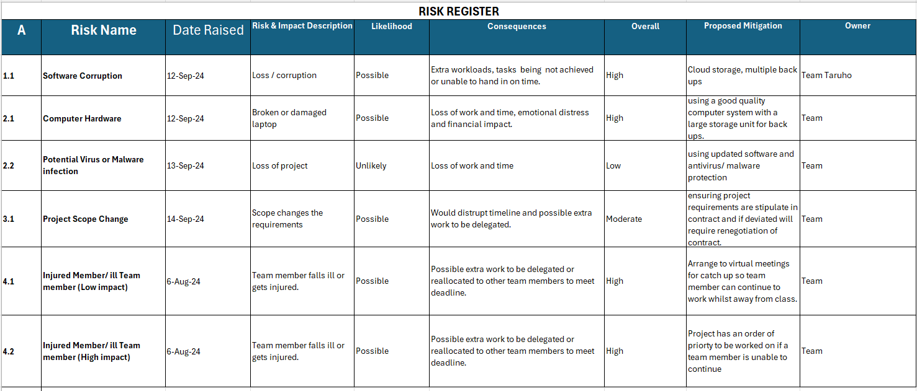

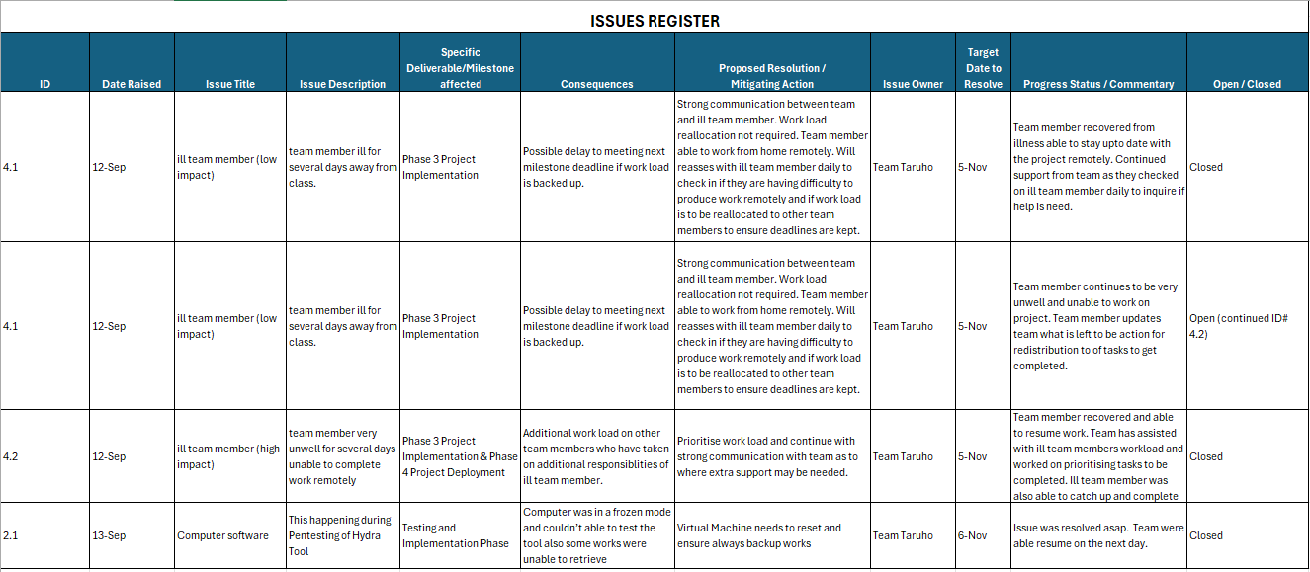

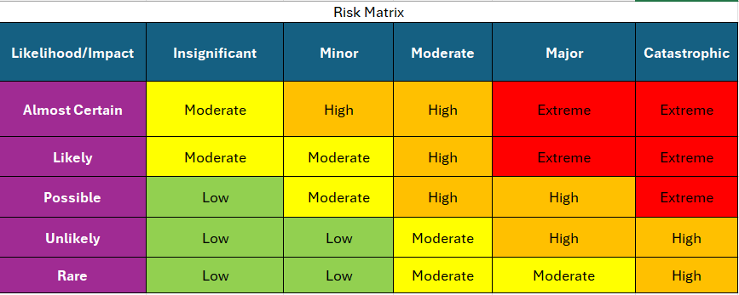

#### 18.4.2 Gantt Chart

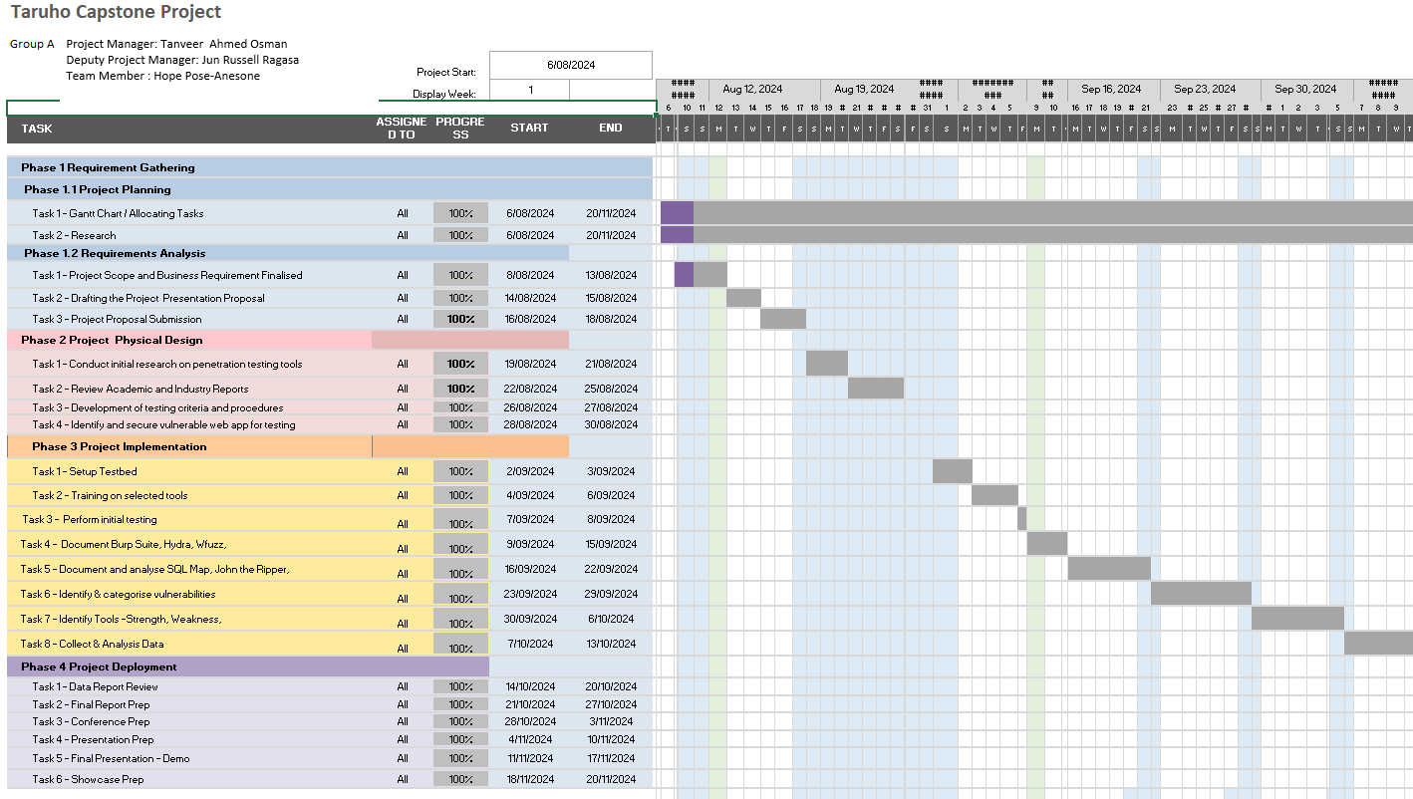

#### 18.4.3 Impact

Diversity shortfalls according to Digital Aoteroa Report 2021:

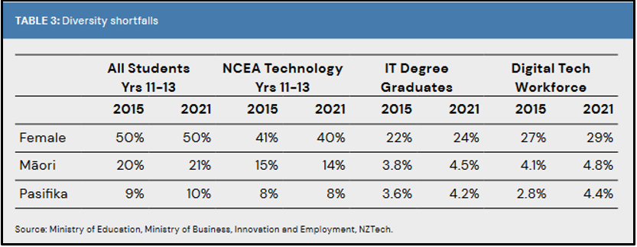

NZ Cybercrime Statistics according to National Cyber Security Centre:

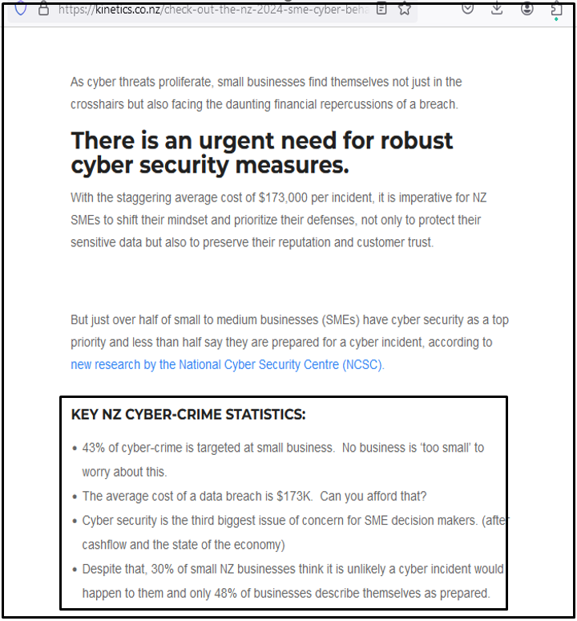

SME in Aotearoa overall cyber resilience performance according to NCSC Report:

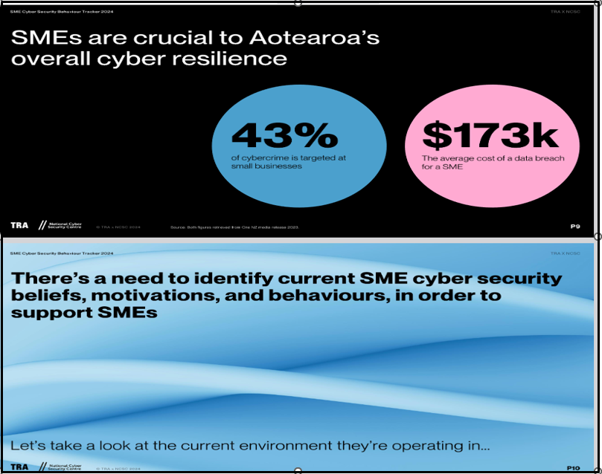

SME Contribution in NZ according to MFAT report:

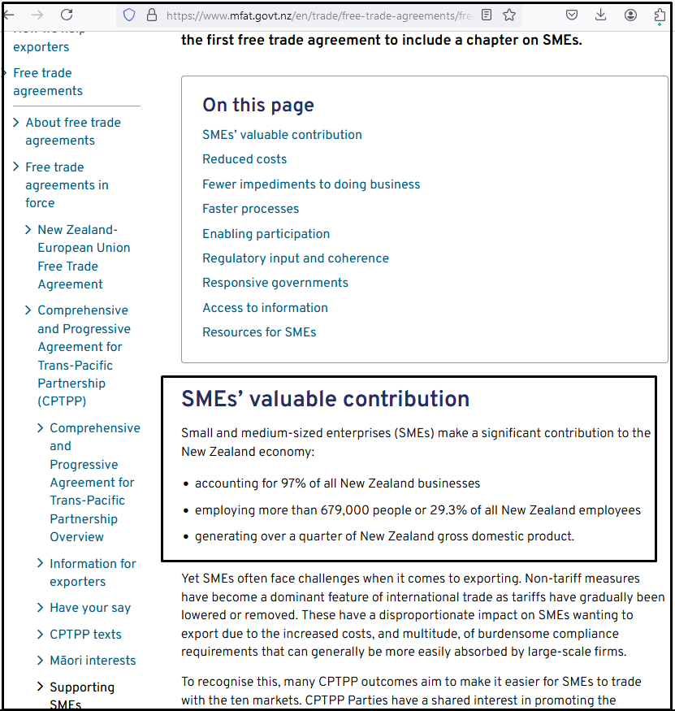

#### 18.4.4 Literature Review:

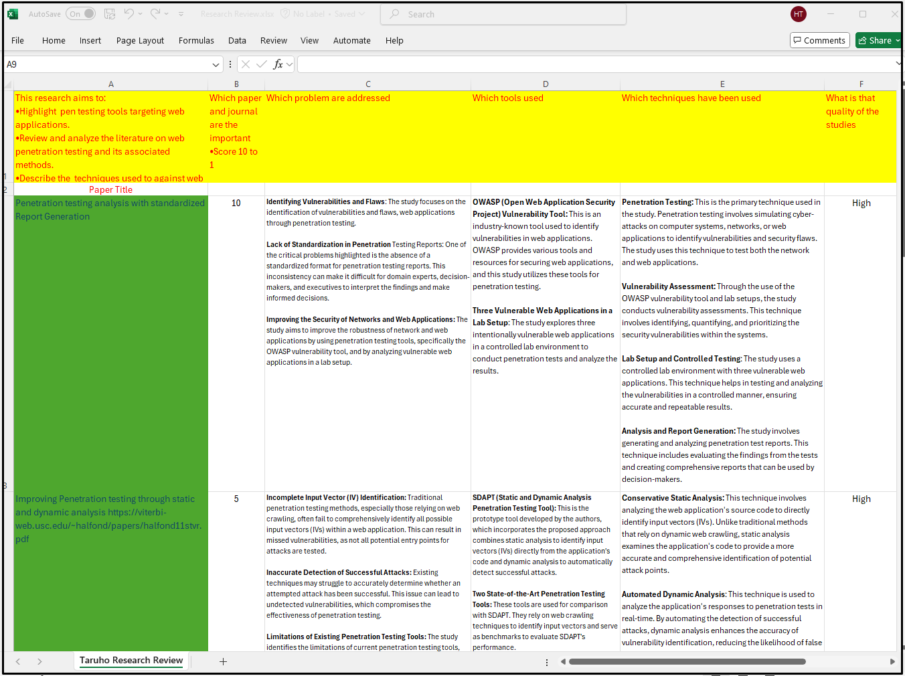

#### 18.4.5 Jira Board

